Subject: Rego University ’18, Leesburg, VA — Request to Attend
Event Date: April 22-25, 2018
Tuition Fee: $800 ($300 early-bird savings)
Dear [insert name of manager],
I’d like to ask for your approval to attend regoUniversity on April 22-25, 2018 at the Lansdowne Resort in Leesburg, VA.
This is the single most attended CA PPM training, networking, and knowledge-sharing event of its kind, with over 200 PPM community members in attendance, representing 100+ companies, government agencies, and institutions. CA PPM product experts and Agile and PMO/PPM thought leaders are on-hand to share best practices, new innovations, and offer hands-on training, while hosting over 75 empowering classes, labs, live-demos, one-on-one technical meetings, and round-table “birds of a feather” sessions.
The event offers 4 incredible days of best practice based training on Administration, PPM Roadmaps, Jaspersoft Report Development and Business Intelligence, GEL scripting, Portlets, Integration, Data Modeling, Project, Portfolio, Financial, Resource Management, and more. Here’s the Class Schedule.
This is a great opportunity for me to enhance my technical skills and expand my expertise in CA PPM, business analysis, and best practices in all the most significant PPM disciplines, as well as learn new ideas for improving our business processes.
Because this event is not-for-profit, Rego keeps the registration cost as low as possible. To provide a comparison, other education events of this duration typically cost over $3,600. Here is an approximate breakdown of conference costs:
<Insert your estimated expenses in the lines below. Travel costs vary and should reflect individual costs.>
Tuition - Registration Fee: $1,100
Early Bird discount pricing of $800 if registered prior to January 31, 2018

Airfare: $____ <Add flight expenses to Leesburg, VA).>

Transportation: $____ <Add transportation expense between the Washington, Dulles Airport and hotel (average cab trip from airport to hotel is $30).>

Meals: $____ All meals included, though you may want to supplement by $20/day

Hotel: $715 <Add hotel cost based on the options below; for the full conference, you would want to include at least a 3-night hotel stay. (Here is the link to reserve your room. regoUniversity 2018 This takes you to our room block with special prices for regoU).
Lansdowne Resort (3 nights @ $259) = $777 (plus taxes & fees)
Total Investment: $___ <Add estimated total.>
I look forward to the opportunity to network with over 200 PPM peers, connect and build relationships with attendees from top organizations and prospective partners, and learn from the brightest PPM product/practitioner expert guides in the industry.
I will be sure to submit a post-conference report that will include an executive summary, major takeaways, and a set of recommendations to maximize the return on our current investments in CA PPM. I can also share relevant information with key personnel throughout our organization.

Thank you for your consideration. I hope you are as excited about this opportunity as I am.

[YOUR NAME]
Enclosure: 5 Reasons to Attend

5 Reasons You Can't Miss This PPM Conference
It's time for regoUniversity! The CA PPM (Clarity) knowledge-sharing event of the year is quickly approaching, and we know you're eager for the details.
Mark your calendar for April 22-26, 2018 and join us at the Lansdowne Resort & Spa in Leesburg, Virginia. This destination hotel is eight miles from Dulles International Airport, just a quick hop from Washington, D.C., in the heart of wine country. Your free time can include the local vineyards, delicious food, and restorative views.
You probably know regoUniversity is the largest CA PPM-dedicated conference, and it stands above the crowd because of Rego's commitment to keeping it all about Project and Portfolio Management (PPM): PPM courses, PPM networking, and PPM best practices.
Register Here
If CA PPM (Clarity) is your tool of choice, then chances are good that you've either heard about regoU or been an attendee. And once an attendee, always an attendee. In fact, last year the conference started handing out annual collector pins to go on everyone's lanyards. So what's it all about?
Here are five reasons you can't miss this PPM conference.

1. regoU will help you shape CA PPM (Clarity) to your organization's process and vision
"Every year, regoUniversity continues to deliver. It always feels like I'm trying to drink from a fire hose while I'm there. I'm sure I'll be processing the information for weeks and months to come."
CA PPM (Clarity) isn't a casual investment. It's an incredible resource. And a lot of companies wish they had access to the power of this tool. Its end-to-end capabilities are truly astonishing, which is why it's considered best in class by independent industry analysts like Gartner.
But having access to a Magic Quadrant PPM tool and knowing how to effectively utilize it are different matters. Where do you start? How do you build a strong foundation? How can you make sure you don't roll out too much? What's critical, and what's nice to have? How do you train your people? How do you inform your executives? Now that you've accomplished "A," what's "B"?
At regoUniversity, we'll help you answer these questions.
Register Here

2. regoU will give you access to Rego's expert guides
"I don’t really know how to classify regoUniversity. It's the best training conference I’ve attended. There is nothing else like it. We had four people from our company attend this year, and regoU had the right classes for each of us."
At Rego Consulting we’ve trained more than 300,000 people in Project and Portfolio Management and guided more than 500 organizations through their PPM journeys, including 35% of Fortune 100 companies and 50% of Fortune 20 companies.
When you come to regoUniversity, regardless of your skill level or area of focus, you'll find the right content for you. We offer classes in technical beginner, technical advanced, governance/functional, basic use, functional training, and technical training. Check out the regoUniversity class schedule here.
Each regoU class is led by Rego expert guides who understand strategic PPM processes. They’ve worked in PMOs, managed and supported instances of PPM, and run large programs. How can you secure user adoption? How do you solidify executive sponsorship? What day-to-day support routines are necessary? How can you make sure you're collecting the right data?
At regoUniversity, we'll help you answer these questions.

Register Here

3. regoU is the best place to network with your peers
"I loved the Birds of a Feather lunch event and how we were able to gather by industry. I was able to meet people in the same industry as me, dealing with the same types of challenges. We were able to network and exchange contact information. And I'm sure I'll be contacting them!"
At regoU, you'll sit in classrooms, around round tables, and at Birds of a Feather with companies specific to your industry who have tackled the same challenges.
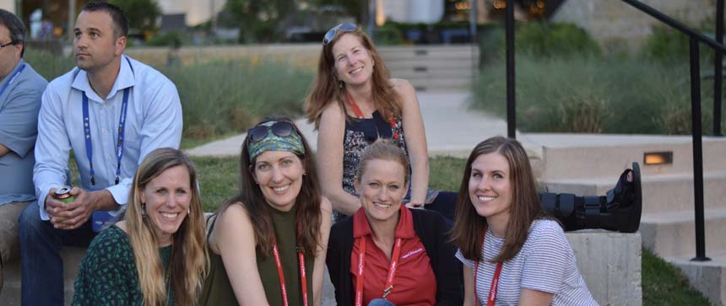
Last year over 100 companies were represented: technology, health care, automotive, tourism, entertainment, retail, and much more. During regoUniversity you'll get the opportunity to meet and network with people by industry, geography, company size, and even by favorite movie genres!
How does PPM work in health care? How do companies like yours handle demand? What are the steps to maturing financials? What's the roadmap to really utilizing portfolios?
At regoUniversity, we'll help you answer these questions.
Register Here

4. regoU is the best CA PPM event available in 2018
"I've attended all the regoUniversity events, and it's now become THE event to attend if you do anything with CA PPM. The sessions are informative, relevant, and cover just about anything you'd need from technical through functional, to administration and governance. Plus it's all about CA PPM—nothing else, and the price is amazing. 10/10"
Our attendees will tell you without hesitation, regoUniversity is THE one event of the year not to miss.
What's new in CA PPM 15.3? What should I know about the new UI? Can we use the OData connector to accent Jaspersoft or switch to Spotfire, Tableau, Power BI, or QlikView? How can we implement Advanced Resource Management? Is there a Project Scheduling package available? What are the best time tracking solutions? Are there pre-developed portlets?
At regoUniversity, we'll help you answer these questions.
Register Here

5. regoU is the most affordable Clarity conference
"I was really amazed by the price. It was intimate, well organized, well run, not too large, effective, etc. I really enjoyed it. I learned a lot!"
Whether you're just getting started or you're a CA PPM expert, regoU 2018 has hands-on training and education designed to engage you and help your organization continue to mature PPM. This year you can choose from two tuition options.

Main Event, April 22 – 25 — $800
Collaborate with your peers while enjoying Rego’s experience and knowledge-sharing. This is the core regoUniversity training experience, including the RM/PM track.

Main Event + 1 Day, April 22-26 — $1,200
With such a packed agenda, we added an extra day, so you can fit in all the reporting, process, and training classes you’re after. You'll want to take advantage of the Main Event + 1 to get the full RM/PM experience.

