TC Anywhere Userguide
Multi Factor Authentication

Download CensorNet App on smartphone (iOS)
1: Download “CensorNet App” in your Appstore (free of charge)
2: Accept the End User License Agreement
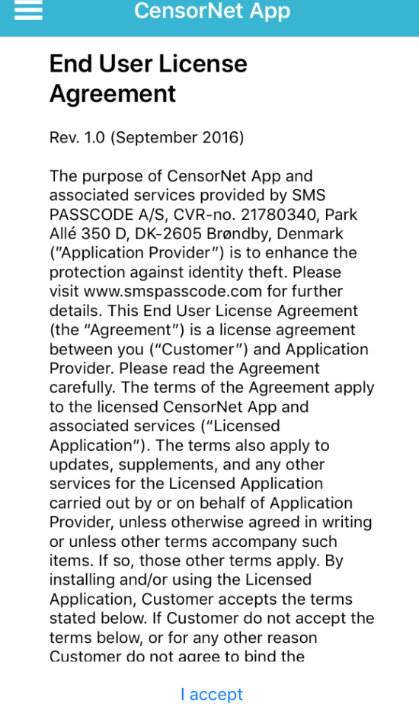

3: Enter your mobile phone number (remember to set your country code)
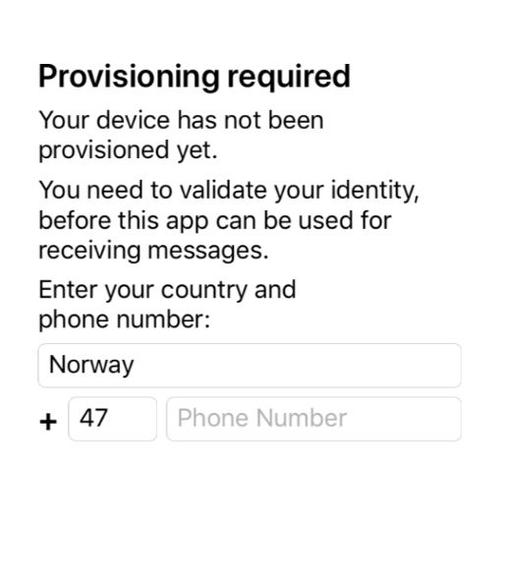
4: You will now receive a One Time Passcode by SMS
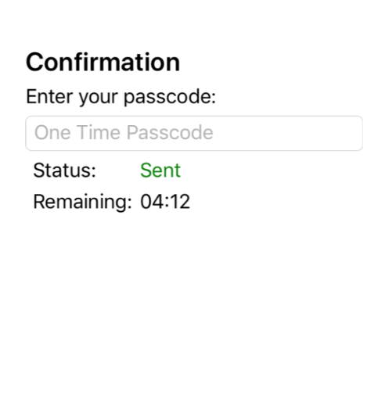
5: Your device is now ready for use
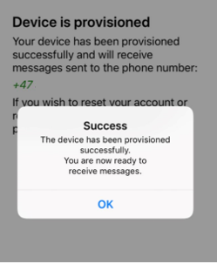

Login with One Time Password:
1: Go to your regular Citrix portal URL.
2: Logon with your TeleComputing Username and Password
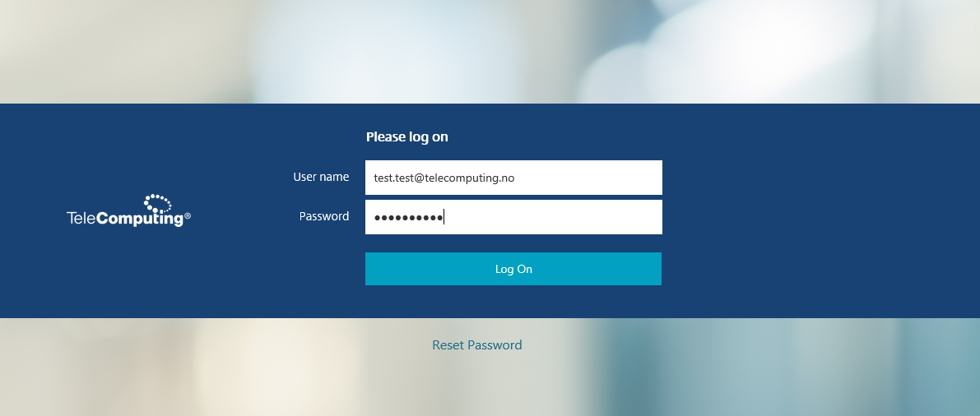
3: Use the Passcode received in the CensorNet App on your smartphone
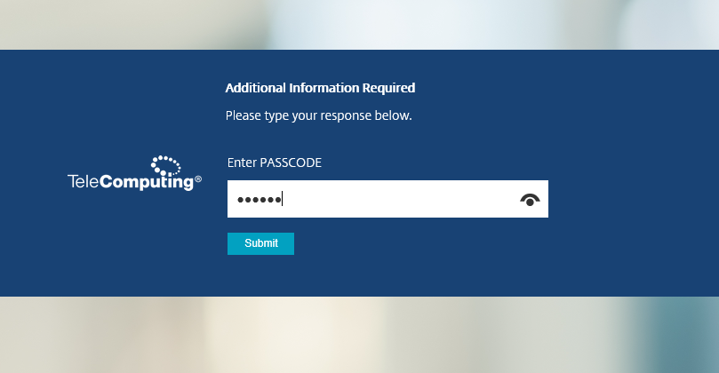
4: Choose your Company Desktop icon for logon
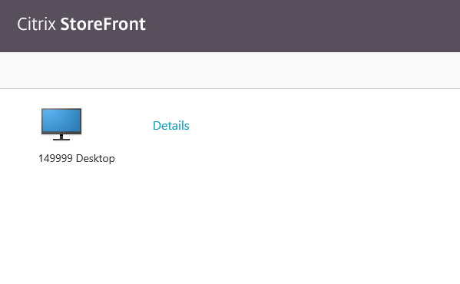

__________________________________________________________________________________

FAQ;
Don’t have a Smartphone?
- If you don’t have a Smartphone, and thereby don’t have the CensorNet App, you will instead receive Passcode and One Time Password (OTP) by SMS.
Can’t receive SMS?
- If you are not able to receive SMS on your phone, you will receive an One Time Password (OTP) on mail.
- We also offer a way for you to generate a OTP code in a App on your smart phone.
Userguide for configuration is available on our help pages: https://www.telecomputing.no/kunde.

If any questions, please contact TeleComputing Service Desk: (+47) 66 77 65 77

