2019 NC Reading Camp Enrollment Guide

Table of Contents

Responsibilities 1
Key Dates 2

Enrollment 3
Reading Camp Staff Setup: 3
Self Service Enrollment Instructions: 3

Reading Camp Student Setup: 4
Reading Camp Class Setup: 5 & 6
Reading Camp Staff Assignment Setup: 7
Reading Camp Student Assignment Setup: 8
Responsibilities
Key Contact: This contact oversees planning Reading Camp, which includes communicating new assessment procedures with staff, training for Burst (if necessary), and coordinating with your Amplify Educational Partnership Manager (EPM) and Read to Achieve Consultant.

District Enrollment Contact: This contact will need to transfer students and staff from their home school to the Reading Camp school for their district in mClass, create Reading Camp classes, assign teachers to Reading Camp classes, and add students to Reading Camp classes. This may be the same person as the Key Contact.

Key Dates
Date | Event
5/31/19 | Stop receiving PowerSchool files (sent nightly from DPI to mClass via Auto Self-Service Enrollment- SSE). These files will be disabled for all districts after May 31, 2019.
6/3/19 | Rollover of DPI Muni.
6/3/19 | Rollover of Jones and Granville Districts. This means that upon arrival at school on Monday, June 7th students will be rolled into the next school year. All data from school year 2018/2019 should be downloaded and printed by end of day Friday, May 31.
6/10/19 | Rollover rest of Districts - This means that upon arrival at school on Monday, June 10th students will be rolled into the next school year. All data from school year 2018/2019 should be downloaded and printed by end of day Friday, June 7.
TBD/As Needed * | Rollover of Burst and Amplify Reading Districts (final week of Reading Camp)
July (TBD) * | Amplify receives weekly enrollment files for select Year-Round schools
August (TBD) * | Start receiving PowerSchool files (sent nightly from DPI to mClass via Auto Self-Service Enrollment- SSE).
* Dates will be communicated and provided when they become available.

Enrollment
Reading Camp School Setup: The Reading Camp (RC) School will be reactivated for your district by Amplify at the time of your rollover. The naming convention used for each district is District Name_Reading Camp.

- Reading Camp Staff Setup: The District Enrollment Contact will need to transfer staff from their home school to the Reading Camp School under their district via a batch upload on Self Service Enrollment (SSE) using a spreadsheet. Help can be provided by contacting Amplify’s Customer Care Team by phone (800) 823-1969 or email (help@amplify.com).

Please remember to use the same exact information as what is listed in PowerSchool (this includes the UID in the “Primary Staff ID” field, the same teacher name, the same Access Level, and the same email address). This will ensure teachers are able to access their regular school AND the Reading Camp School.

Instructions: click this link for Self-Service Enrollment Instructions
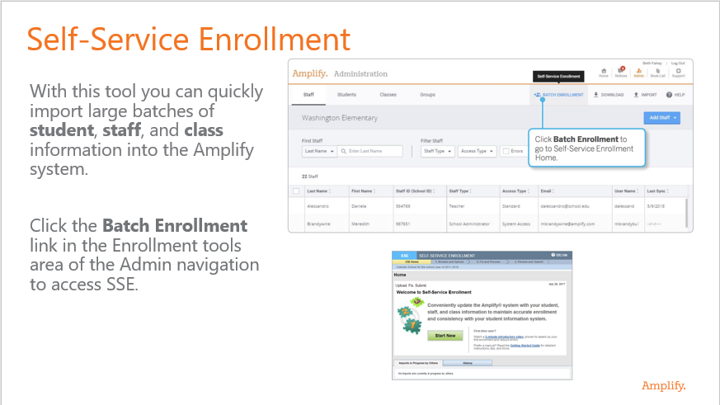
Note: Teachers will use their existing log-in credentials via Single Sign-On (SSO) to access their Reading Camp class.

- Reading Camp Student Setup: The District Enrollment POC will need to transfer students (slated for Reading Camp) from their home school to the Reading Camp School under their district and not by creating new students.
The District Enrollment Contact can transfer Students by performing the following steps or via batch upload on Self Service Enrollment (SSE) using a spreadsheet (see instructions on page 3). Help can be provided by contacting Amplify’s Customer Care Team by phone (800) 823-1969 or email (help@amplify.com).

- Click on a Student to edit.
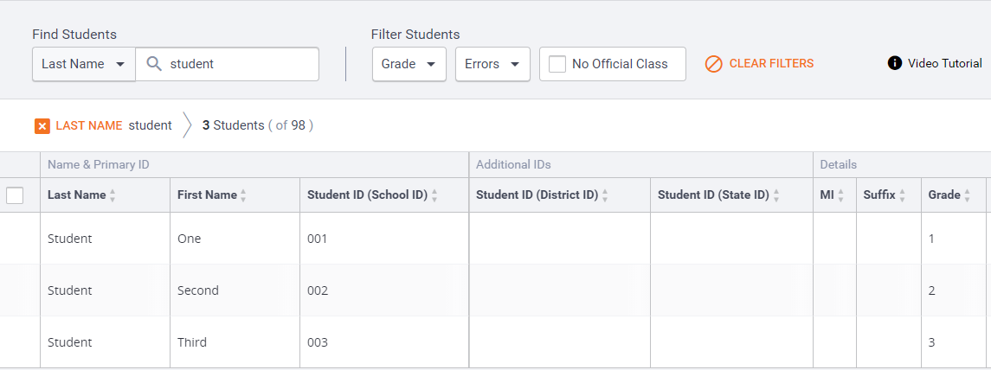

- Click Transfer Out.

- Select Reading Camp School. Click on Transfer button.
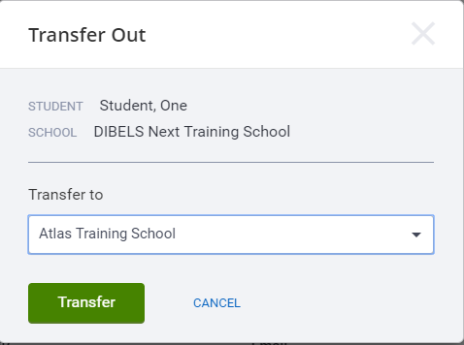
When the transfer is complete, a confirmation message displays.

- Click OK and then click X to close the dialog box. The Student Details panel updates to show the student's new information.

Note: Auto SSE from DPI PowerSchool files will be back in production after Reading Camps have concluded and in time for BOY to transfer students back to their traditional schools.
- Reading Camp Class Setup: Classes will need to be created before Reading Camp begins. The District Enrollment Contact should create classes under the Reading Camp school for their district.
The District Enrollment Contact can create Classes by performing the following steps or via batch upload on Self Service Enrollment (SSE) using a spreadsheet (see instructions on page 3). Help can be provided by contacting Amplify’s Customer Care Team by phone (800) 823-1969 or email (help@amplify.com).

- Click Add Classes
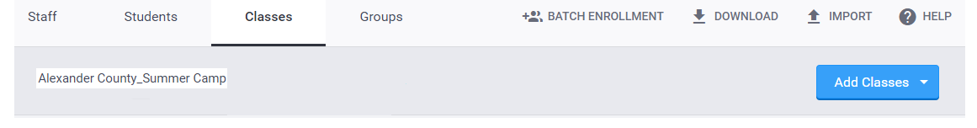
- Enter the following information in each of the fields below:
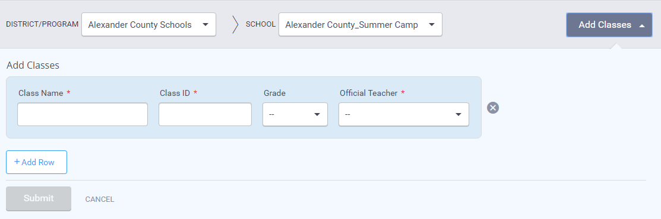
- Click +Add Row if you need to add multiple classes. You can add up to 10 classes at a time.
To add a large number of classes, consider using Batch Enrollment.

Class Name: Use the following naming convention:
For 1st Grade: 1051_RC_ {“School_Name” <or > ”Teacher Last Name_ First Name”}
example: 1051_RC_Lee_Elementary <or> 1051_RC_Teacher_Joe
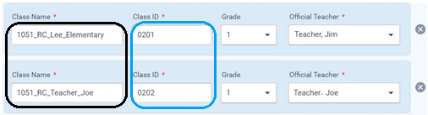
For 2nd Grade: 1052_RC_School Name <or> Teacher’s Last Name_First Name
For 3rd Grade: 1053_RC_School Name <or> Teacher’s Last Name_First Name
Class ID: Class ID cannot be duplicated when creating classes. Use your LEA # followed by 1, 2, 3, etc. subsequent order for Class ID when adding one or more classes.
example: 0201 {020 LEA # +1} (first class entered)
example: 0202 (020 LEA # +2} (second class entered)
example: 0203 (020 LEA # +3} (third class entered)

Grade: Select either 1, 2, or 3 from drop down menu.

Official Teacher: Select assigned teacher from drop down.

Example
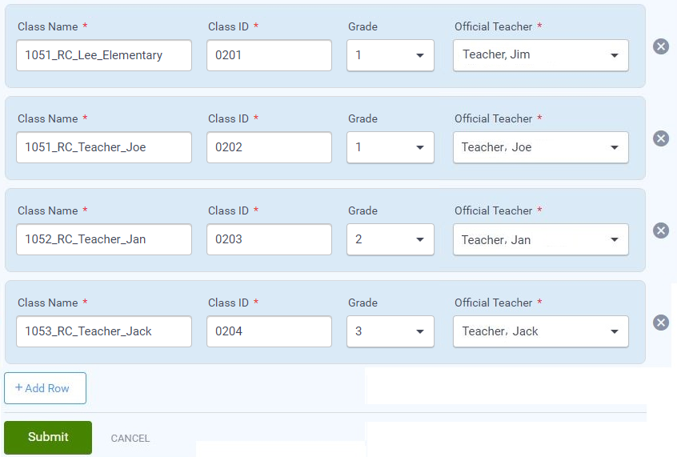

- Click Submit when all information in all rows has been added.

Example: a display should appear of all records that were submitted.
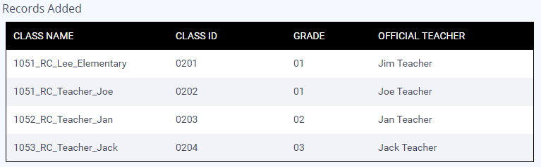

After creating Classes for your Reading Camp, assign staff and students to each class in the Class Details panel. You can also edit your class rosters whenever necessary from the Class Details panel. Video tutorial available.

- Reading Camp Class Assignment: The District Enrollment Contact will need to assign teachers to the Reading Camp classes they will be teaching.

The District Enrollment Contact can assign Staff to Classes by performing the following steps or via batch upload on Self Service Enrollment (SSE) using a spreadsheet (see instructions on page 3). Help can be provided by contacting Amplify’s Customer Care Team by phone (800) 823-1969 or email (help@amplify.com).

- Click on a Class to edit
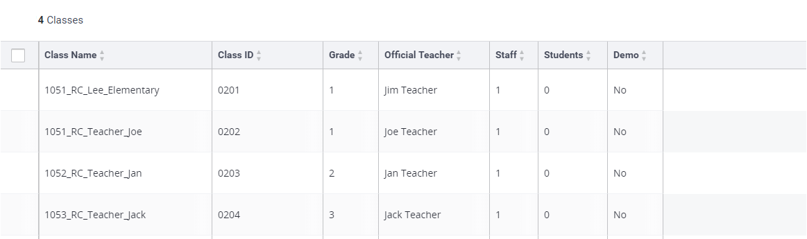

- Assign staff by clicking Assign Staff to open the Assign Staff section of the Class Details panel.

- Check the box beside the staff member to assign to class.
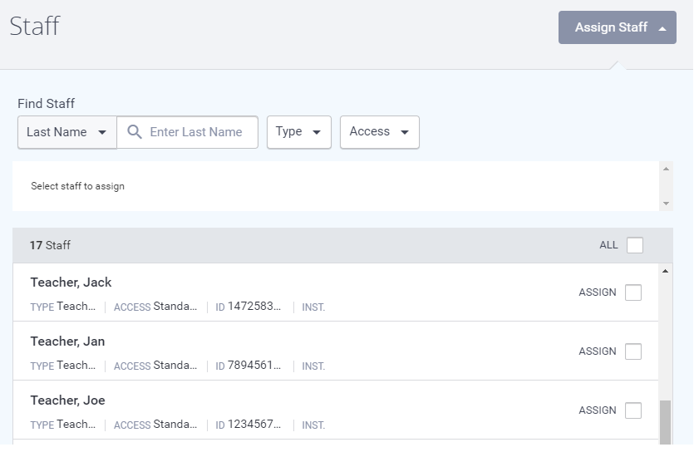

- Click “Save Changes” at the top of the Class Details panel before exiting the screen.

- Reading Camp Student Assignment: The District Enrollment Contact will need to assign students to the Reading Camp class they will be attending.

The District Enrollment Contact can assign Students to Classes by performing the following steps or via batch upload on Self Service Enrollment (SSE) using a spreadsheet (see instructions on page 3). Help can be provided by contacting Amplify’s Customer Care Team by phone (800) 823-1969 or email (help@amplify.com).
- Assign students by clicking Assign Students to open the Assign Students section of the Class Details panel.

- Check the box beside the student to assign to class.

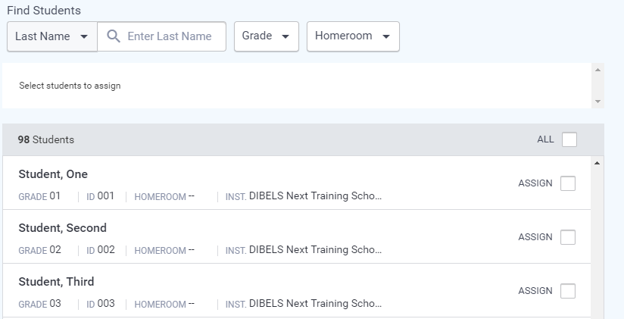

- Click “Save Changes” at the top of the Class Details panel before exiting the screen.

Support: If assistance is needed, please reach out to Amplify’s Customer Care Team by phone (800) 823-1969 or email (help@amplify.com).

