Ash Wednesday
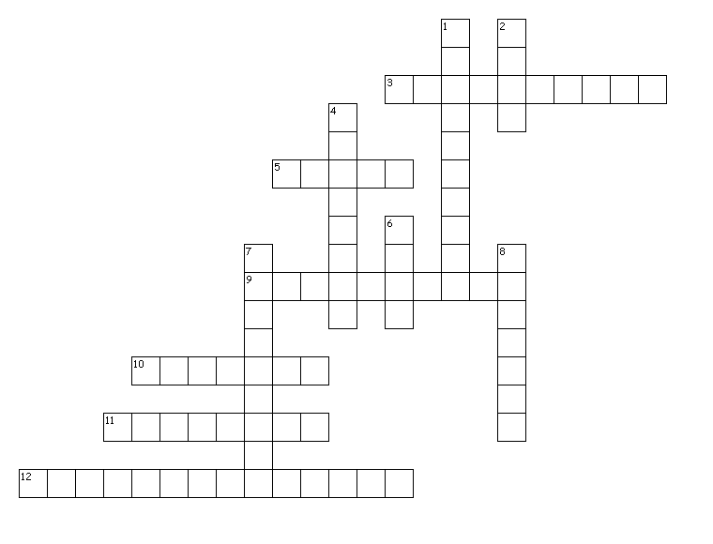
Across

3. The ashes used in this ceremony are made by burning the remains of the palms blessed on the ________ of the previous year. (4,6)
5. Ash Wednesday occurs _____ days before Good Friday.
9. ________ is required during Ash Wednesday.
10. ______is required during Ash Wednesday.
11. The signing is done with ashes because ashes are a biblical symbol of _______ and penance.
12. The priest, dipping his thumb into ashes previously blessed, marks the forehead with the ________. (4,2,3,4)

Down

1. Ash Wednesday is not a holy day of ________.
2. The minister or priest marks each worshipper on the forehead, and says remember you are ____ and unto ____ you shall return, or a similar phrase based on God's sentence on Adam in Genesis 3:19. (only one word)
4. The ashes also symbolize death and so remind us of our ________.
6. Ash Wednesday is the first day of ______.
7. Ashes are a symbol of penance made sacramental by the blessing of the Church, and they help us develop a spirit of humility and ________.
8. It is a season of ________, reflection, and fasting which prepares us for Christ's Resurrection on Easter Sunday, through which we attain redemption.

Designed in Puzzlemaker from DiscoverySchool.com

