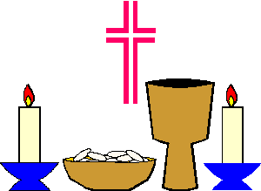 I Spy in St. Paul Church….

Altar Bells | Baptismal Fount |  | Candle Lighter
Candle | Candle Holder |  | Chalice
Chalice | Candle |  | Confessional
Host and Chalice | Incence |  | Lectern
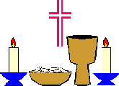  Sacred Vessels |  | Organ |  | Pew
Prie-dieu |  | Pulpit |  | Sacramentary
Sanctuary Lamp |  | Holy Water Sprinkler |  | Tabernacle
Vigil Light |  | 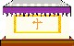  Altar |  | Stole

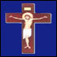
Jesus on the Cross

