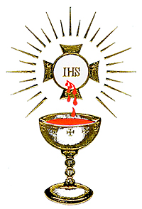
Eucharist

Follow the directions and fill in the blanks to find out what the message says below.

1. Jesus instituted the Sacrament of the Holy Eucharist at the Last Supper. Put a S if this is true. Put a C if it is not.

2. Receiving the Holy Eucharist is before Consecration. Put a O if it is true. Put a A if it is false.

3. A deacon may consecrate the bread and wine into the body and blood of Jesus. Put a M if it is true. Put a C if it is false.

4. The appearance of the bread and wine remain after the consecration. Put a R if it is true. Put a M if it is false.

5. We receive the body and blood of Jesus Christ in Holy Communion. Put a I if it is true. Put a U if it is false.

6. When Jesus said the words, “This is My Body” he was referring to the wine. Put a N if it is true. Put a F if it is false.

7. Transubstantiation is the complete change of substance. Put a I if it is true. Put a O if it is false.

8. Jesus is contained whole and entire in every single particle of the consecrated host. Put a C if it is true. Put a I if it is false.

9. Jesus is contained whole and entire in every drop of His Precious Blood. Put a E if it is true. Put a N if it is false.

The Holy Eucharist is a sacrament and a

___ ___ ___ ___ ___ ___ ___ ___ ___ .
1 2 3 4 5 6 7 8 9

