GDPR – Updates for the MobilePro app and cockpit

Introduction
This document outlines changes to the MobilePro app and the cockpit to support the changes to GDPR legislation anticipated to come into force from 25th May 2018.
We are making these changes to make it easier for you to become compliant with the legislation changes. It is important to note that using Gladstone products alone will not make your organisation GDPR compliant. You will also need to review your own practices in accordance with the GDPR.
For more information on GDPR you can visit
https://ico.org.uk/for-organisations/data-protection-reform/overview-of-the-gdpr/

Privacy Notice

App Factory Privacy Notice
Both the Apple App store and Google Play store provide a place for you to link to your Privacy Notice. This allows a potential app user to read your Privacy Notice before downloading your app. The app factory will be enhanced to allow you to add this URL.

In-app Privacy Notice
The app drawer, i.e. the panel that slides out when you click the menu bar top-left on the app home screen, will be extended to allow the user to view your Privacy Notice.
You can add your Privacy Notice in the cockpit within Account Settings->Privacy Notice. The text can be formatted to include the use of links. If you want, you can simply link to your website Privacy Notice for your app users to click through to. Before you do this, make sure your website Privacy Notice is mobile-responsive and readable on a phone.
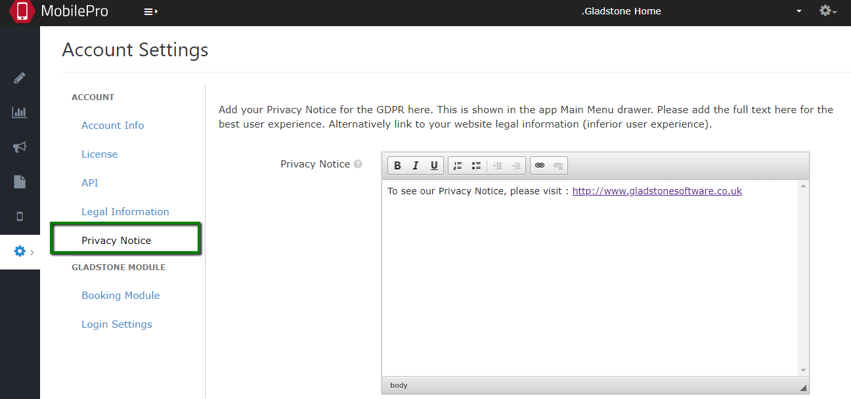

As a reminder, terms and conditions can also be added in Account Settings->Legal information to be similarly viewed by the app user from the app drawer menu.

Opt-ins

Existing opt-ins
The GDPR requires that opt-ins are specific and does not accept default opt-ins. The opt-ins on your iOS apps to date have all been specific positive opt-ins, so they will continue to be used. The opt-ins on your Android apps need to be reset – users will be asked for positive opt-in when they download the next update.

Auditing opt-ins
The GDPR requires that that there is evidence of when and how an opt-in was made so this will be recorded and can be provided to you on request.

Opt-in by News/Information Topic
The GDPR requires that we should differentiate between service messages and marketing messages. Service messages don’t need an opt in; they are legitimate interest processing and not marketing messages. We’re enhancing the Marketing opt-in in the app to add Topics, but this may be in a later release.

Deep-link to Opt-ins
Enhanced opt-ins will initially be provided in the app only. Customers will be provided with a deep-link for the app which can be used on web pages or in emails to link to the app opt-in section. This may be in a later release.

Lead Generation Enhancements
For customers who are using Lead Generation, it is already GDPR-friendly in that it doesn’t ask the referrer to give you, the gym, their friends’ details. Lead Generation lets members send their friends a personal message inviting them to get in touch with you, the gym. There will be a change to the prospects journey to get specific permission from the prospect to allow you to use their details to market to them.
Additionally, the “Imprint/ Privacy Policy” will be renamed to “Privacy Notice” and you will be able to add or link to your Lead Gen Privacy Notice.

Subject Access Requests

App Users
Initially, any requests to provide the personal information that is held on an app user must be requested through support.

Cockpit Users
Initially, any requests to provide the personal information that is held on a cockpit user must be requested through support.

Data Anonymisation

App Users
Initially, any requests to anonymise the personal information that is held on an app user must be requested through support.

Cockpit Users
Initially, any requests to anonymise the personal information that is held on a cockpit user must be requested through support.

