Proposed Article on New Chiller for St Joseph’s Medical Center – Community Campus
Title: New Chiller Save Hospital Big Time
By: William McMahon Jr PE, ECON Opportunities, Inc.
Submitted Date: May 6, 2016
When the old chillers were failing, no one knew the extent of the possible energy cost savings. The major concerns at first were keeping the 50 year old hospital comfortable during the upcoming cooling season and reducing the increasing maintenance costs of the original equipment.
It was late 2012 and St Joseph Medical Center’s Community Campus hospital (since merged with Penn State Health Network) was ready to replace two 200 ton steam absorption chillers and a cooling tower that had served the patients, doctors and medical staff since 1956. According to Glen Bailey, facility manager for all the hospital’s facilities, “ We needed to run the chiller plant and main steam plant year round and were worried we could not stand a very hot summer – even with a smaller chiller that had been added a few years before”.
After considering several options, the hospital chose to install two new Trane 200 ton centrifugal chillers and a new cooling tower in the same locations as the failing equipment – both in hard to access locations for construction purposes. This was also a difficult decision due to the lack of electrical capacity in the building, the need to maintain comfort in the process and large possible cost overruns.
The savings after the first year’s operations were impressive. Natural gas usage in the main boiler plant declined 57% for an entire year. Electricity usage, instead of rising with the new large electrical chillers, actually went down 9%. The total annual energy costs of the building went from $805,000 to $486,000 or a savings of $312,000 (40%). There will be almost no maintenance costs for the new chiller system for 5 years as these costs were part of the chiller contract. And the new equipment will last for another 30 to 40 years or more if properly maintained. Water use by the cooling tower is down by 50,000 gallons per year.
Charts showing historical and actual energy usage for both natural gas and electricity are shown on the following page.
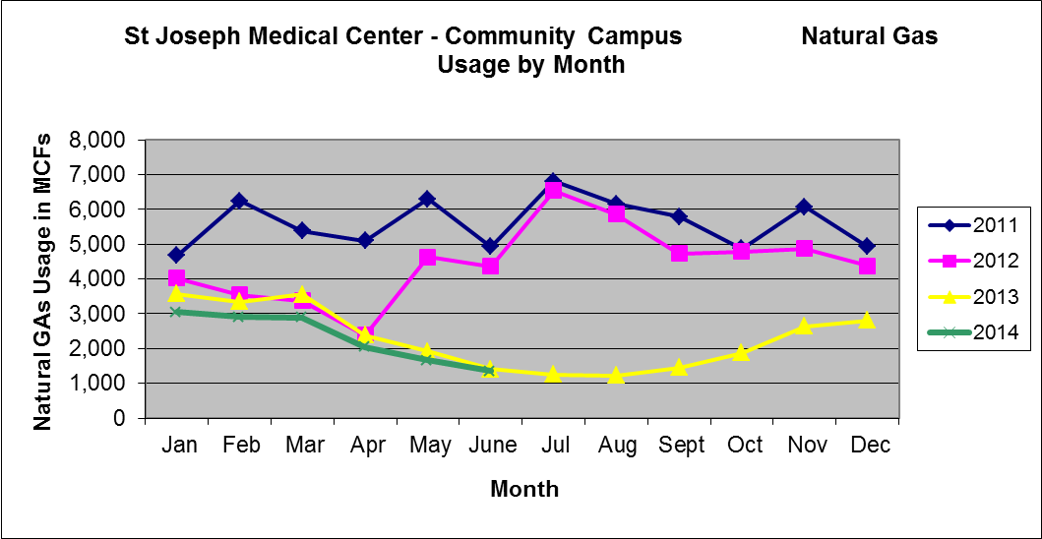

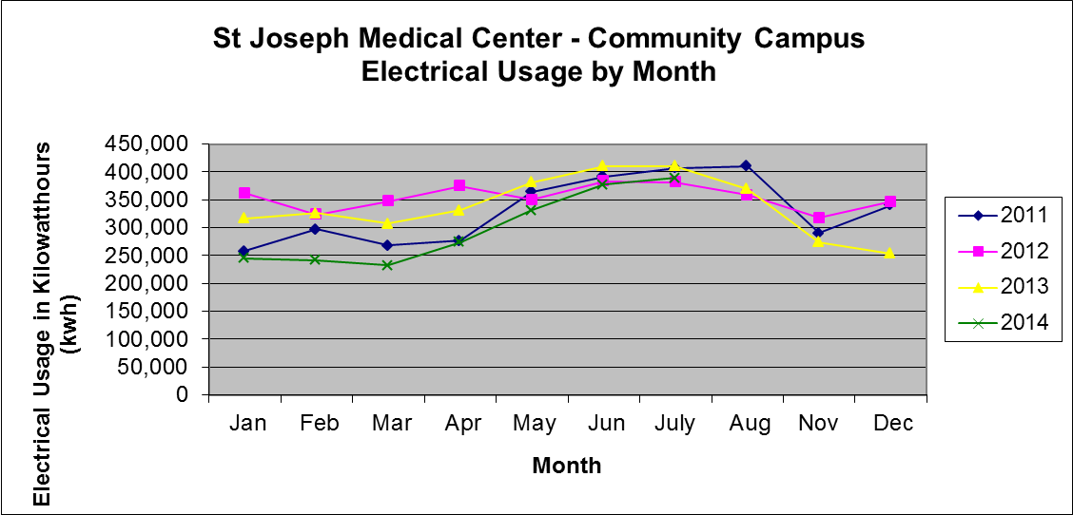
The final cost of the project, including new building controls, new pumps with variable frequency controls, and other improvements to the mechanical room and roof was approximately $1,000,000. It will pay for itself in three years.
The overall time to accomplish the project was three and one half months. Engineering began February 2013 and the new chillers started up in mid May 2013.
Comfort in the building is much improved in the summer. There are no longer fears of very hot days and the chillers can actually be turned off in the winter.
The team members that pulled off this feat are:
- Mechanical Engineering Design – EffectivEnergy Solutions LP, West Chester, Pa.
- General contractor and Equipment Supplier – Trane Corporation of Harrisburg, Pa.
- Mechanical Contractor – The Warko Group, Reading, Pa.
- Electrical Contractor – Pagoda Electrical of Reading, Pa.
- Demolition and Rigging – Johnson Corporation of Philadelphia, Pa.
- Engineering Design – Gribb Engineering (now Systems Design Engineering), Reading, Pa.
There were a number of interesting aspects of the project:
- Initial plans for the project were to use air cooled chillers. However, the final design saved more than one million kilowatt hours per year.
- Available electrical capacity in the building proved to be more difficult than first expected. A complete load by load analysis revealed scattered available capacities, allowed removal of unused equipment and relocations of circuits to save the project.
- The use of Variable Frequency Drives on the chilled water and condensing water pumps were the main cause of the lower electricity use.
- The recovery and sale of valuable metals in the old chillers resulted in a large reduction in the project’s cost.
- It took a 300 ton crane to install the new chillers from the closest road – 80 feet away.
- Noise in the neighborhood was greatly reduced with the new cooling tower.
- All of the major HVAC systems can be remotely monitored and controlled – giving more information to management and real time assurance that the building’s occupants are comfortable.
This project is not unusual. There are almost always greater energy and cost savings in larger, older buildings due to improved technologies and creative engineering.

