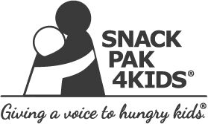

Contents of Snack Pak 2017-2018

- 2 Apple & Eve juice boxes
- 1 shelf stable white milk
- 1 shelf stable chocolate milk
- 1 Musselman apple/strawberry sauce squeeze pouch
- 1 Kelloggs NutriGrain bar
- 2 pouches of Kelloggs cereal
- 1 Austin peanut butter cracker pack
- 1 Cheez-It package
- 2 beef sticks
- 1 packet of Planter’s peanuts

We will be delivering each Wednesday morning with the exception of holidays.

