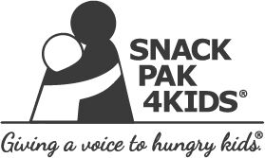

Contents of Snack Pak 2019-2020

- 1 Gatorade G-Zero
- 2 shelf-stable chocolate Fairlife milks
- 1 Musselman apple/strawberry sauce squeeze pouch
- 1 Kellogg’s NutriGrain bar
- 2 pouches of Kellogg’s cereal
- 1 Austin peanut butter cracker pack
- 1 Cheez-It package
- 2 SP4K Beef Stiks
- 1 packet of Pepperidge Farm Goldfish Pretzels
- 1 JIF-to-GO

We will be delivering each Wednesday morning with the exception of holidays.

