Capabilities Statement
AT A GLANCE:
DUNS# - 82-484-5846
CAGE CODE - 1PXDO
GSA CONTRACT # - GS-35F-0207X expires 2/10/22
NAICS CODES: 541512, 541519, 518210
SIC CODES: 7379, 7373
GSA Contact: Elle Vollerthum
evollerthum@enablingtechcorp.com
TESTIMONIALS - “Every person in the organization is focused on customer service and exceeding expectations. Beginning my second implementation with them and I know it will be successful. Looking forward Lync 2013 then building a project for Office 365.” - Tim Carlson, Combe
“The people are amazing to work with. Exceptionally knowledgeable and genuinely good people. The "Enabling Experience" continues from project conception, through implementation and carries over into ongoing support. By far the best technology partner I have the pleasure of working with.” - James Thompson, The Arsht Center

Leaders in Communication and Collaboration
Why Enabling Technologies Corp.?
- Microsoft US Intelligent Communications Partner 2018 Winner as well as Microsoft UC partner of the Year 2009, 2010, 2012 and 2015.
- When you work with ETC, you can always expect a predictable successful outcome.
- Focused and Experienced - We’ve done more UC deployments than anyone on the Planet
- We’ve implemented successful UC strategies for companies like General Dynamics, BNSF Railways & Kenneth Cole – we can help you too!

Company Background
Back in 1992 we recognized the scarcity of truly focused Systems integrators in the Unified Communications arena. Many things have changed since then but the need for expert integration services remains. For the past 26 years, Enabling Technologies Corp has focused our consulting practice on Communication and Collaboration solutions. We are Microsoft’s #1 Communications partner year after year and have designed, implemented, migrated and supported over 1700 Office 365, Lync/Skype for Business, Teams and SharePoint projects. We are now offering Cloud Security Planning, Migration and Support as well.

Example Clients –
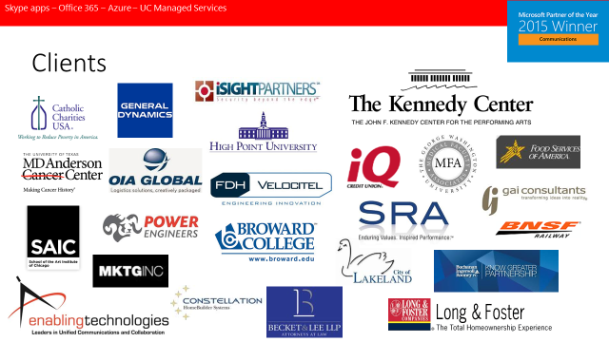

Please see our case studies at: http://www.enablingtechcorp.com/AboutUs/WhyChooseUs/CaseStudies.aspx

For more information please contact Elle Vollerthum: evollerthum@enablingtechcorp.com

