Enabling’s change management process was invaluable to the successful Office 365 and Skype for Business deployments. Enabling was instrumental in coordinating communications and training and leading the training classes, both online and on-site, which resulted in not only a high percentage of the staff attending the training but also the staff were completely prepared on Day 1 when we went live with both new platforms.
– Sr Director of IT Ops

In an intentional push to the Cloud, our client, a major sports association, had plans to deploy more than 11 technology solutions in 2017, inclusive of:
- Laptop Refresh
- Self-Service Password Reset
- Windows 10 to replace Windows XP
- Office 2016 to replace Office 2007/2010
- Office 365
  - Exchange Online
  - OneDrive for Business to replace Dropbox
  - Skype for Business to replace Avaya Phone Systems
  - SharePoint Intranet Sites
- Concur
- NetSuite
A Change Management Strategy to support high adoption was vital to employee morale, the culture within the organization and the transition to effectively use each of the above solutions.
____________________________________________________________

Challenge
Our client was faced with the challenge of finding a resource, with the time and availability, as well as a proven track record of delivering positive user experiences and high adoption. Lackluster user engagement was not an option with the volume of change taking place.
____________________________________________________________

Solution
Enabling’s Change Management Expert spent a week on site to kick-off a 12-month engagement with this client. Throughout the week our expert met with Sponsors for each of the above projects and met with key stakeholders within the organization, including: Executives to the CEO, Brand/Marketing, Internal Communications, Learning and Development and the Service Desk staff to obtain a holistic picture of the organizational culture, change readiness and to identify potential barriers to adoption.

Our expert knew that the traditional means for communicating change and delivering knowledge about the change were not enough to keep this organization engaged – Enabling had to get creative in the way we would prepare and support staff.

Enabling’s Change Management Program has a foundation like Prosci’s ADKAR methodology. We work with clients to plan, generate awareness and desire, provide skills and knowledge and reinforce change. This is exactly what we did with this client for each of the technology changes taking place. Skype for Business was one of the final and most significant changes taking place and as a result, required the greatest amount of creativity to spark engagement.

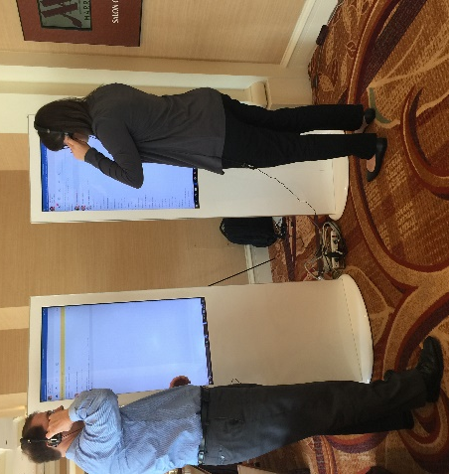
Here are just a few of the ways Enabling’s Change Management team drove awareness for Skype for Business:
- Hosting of two pilots to build a Champion Network, beginning 6-months in advance of cut-over
- Incorporation of a Device & Candy Bar with a test and learn lab
- Interactive kiosks at the organization-wide town hall
- Variety in training options provided
- Variety in communication delivery channels

Results
Here are just a few of the ways Enabling’s Change Management team drove awareness for Skype for Business:
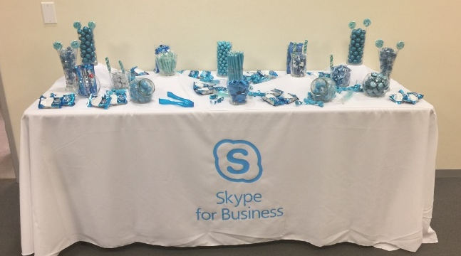
- The Champion Network was leveraged for the full 12-months and supported each of the technology changes. Their mission was to drive excitement and engagement organically, the audience was strategically selected based on those that provided a degree of influence within the organization, both positive and negative. The change management team had regular engagement to provide ongoing information, Q&A sessions, ideas, use-cases and best practices to this audience.
- The Candy Bar was themed in Skype-blue and placed in a high traffic area to entice users, upon approaching the Candy Bar users were given the opportunity to test headset devices so they were able to make an educated decision when the time for choosing a device came, they were also encouraged to try making test calls with one-another.

- Interactive kiosks were used to make a statement at the town hall event. This was the one-time we had access to almost 100% of users in a single location, our display was near the entrance to the town hall event. Users were again asked to try out Skype for Business and headset options and encouraged to ask questions. Everyone was provided a business card that displayed the training dates, times and a website and QR code to register for training.
- Training was provided by live-webinar, classroom, white-glove, video shorts and self-service learning tools.
98%

Of users leveraged some form of training.
95%

The level of satisfaction with Skype for Business post-deployment
<10

Less than 10 help desk tickets on the day of migration from Avaya to Skype

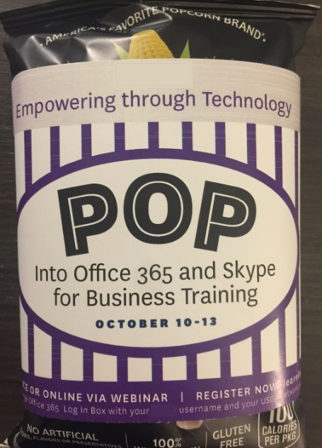
- Communication was provided through a variety of channels including:
  - Desk drop (popcorn, post cards, flyers)
  - Posters in high traffic areas
  - Mailers to the users’ home from the organization
  - Videos
  - Digital signage
  - Email
  - Via the Champion Network
  - Skype for Business ear buds/power packs

