Pictograms
OSHA requires eight of the nine possible GHS pictograms to be used in communicating hazards. The ninth pictogram, Environmental, is under the jurisdiction of the Environmental Protection Agency in the United States.
Pictograms and their corresponding hazards:
Health Hazard  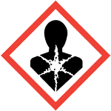  • Carcinogen  • Mutagenicity  • Reproductive toxicity  • Respiratory sensitizer  • Target organ toxicity  • Aspiration toxicity | Flame  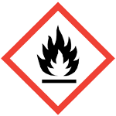  • Flammables  • Pyrophorics  • Self-heating  • Emits flammable gas  • Self-reactives  • Organic peroxides | Exclamation Mark  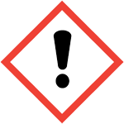  • Irritant (skin and eye)  • Skin sensitizer  • Acute toxicity (harmful)  • Narcotic effects  • Respiratory tract irritant  • Hazardous to ozone layer (non-mandatory)
Gas Cylinder  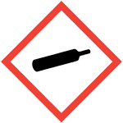  • Gases under pressure | Corrosion  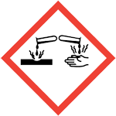  • Skin corrosion/burns  • Eye damage  • Corrosive to metals | Exploding Bomb  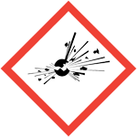  • Explosives  • Self-reactives  • Organic peroxides
Flame Over Circle  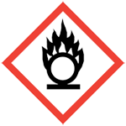  • Oxidizers | Environment*  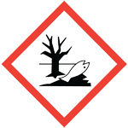  • Aquatic toxicity  *under EPA jurisdiction | Skull & Crossbones  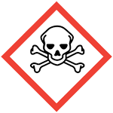  • Acute toxicity (fatal or toxic)

Sample Label
Pictograms
Product Identifier

OXI252
(disodiumflammy)
CAS #: 111-11-11xx
Hazard
Statements
Signal Word
Danger
May cause fire or explosion; strong oxidizer
Causes severe skin burns and eye damage

Keep away from heat. Keep away from clothing and other combustible materials. Take any precaution to avoid mixing with combustibles. Wear protective neoprene gloves, safety goggles and face shield with chin guard. Wear fire/flame resistant clothing. Do not breathe dust or mists. Wash arms, hands and face thoroughly after handling. Store locked up. Dispose of contents and container in accordance with local, state and federal regulations.
Precautionary
Statements
First aid
IF ON SKIN, HAIR OR CLOTHING: Immediately rinse any contaminated clothing and skin with plenty of water before removing clothes. Wash contaminated clothing before reuse.
IF IN EYES: Rinse cautiously with water for several minutes. Remove contact lenses, if present. Continue rinsing.
IF INHALED: Remove person to fresh air and keep him or her comfortable.
IF SWALLOWED: Rinse mouth. Do NOT induce vomiting. Immediately call poison center.
SPECIFIC TREATMENT: Treat with doctor-prescribed burn cream.
Fire
In case of fire: Use water spray.
In case of major fire and large quantities: Evacuate area. Fight fire remotely due to the risk of explosion.

Great Chemical Company
55 Main Street, Anywhere, CT 064XX
Telephone: 888-777-8888
Name, address and telephone number of the chemical manufacturer, importer or other responsible party

