Join Keep It Cool Campaign: Simple Action to Reduce Energy Waste

Have you noticed stores that keep their doors open while running the air conditioning on hot summer days? Has this bothered you? Now you can do something about it!

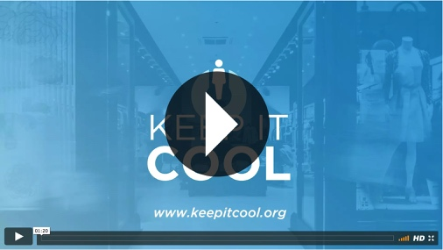
Join Keep It Cool, a national campaign mobilizing consumers to help convince retailers to close their doors and stop wasting energy. Participating is easy. All you have to do is spot front doors on shops, and use Facebook Messenger to drop a pin on a national map that tracks all of the stores identified with doors open or closed.

The campaign organizers will recognize shops that “Keep It Cool” with closed doors and reach out to educate retailers who allow energy to escape through their open doors.

“Our Keep it Cool campaign empowers consumers to anonymously have an impact on wasteful behaviors in their own neighborhoods. And it gives retailers the opportunity to do the right thing and showcase their green values. This is good for business, the community and the environment,” said Nate McFarland, director of communications at Generation 180, the nonprofit organizer of the campaign committed to advancing a cultural shift in energy awareness and clean energy adoption.

Retailers that run the air conditioning during hot summer months and open their doors to attract customers drive up costs, waste energy and increase pollution. Just the simple act of closing doors can reduce pollution significantly. On average, each store with a door open wastes about 4,200 kWh of electricity over the summer. Generating this much electricity releases about 2.2 tons of carbon dioxide – the same amount of pollution emitted by a diesel semi-truck driving from New York to Miami.

The success of Keep It Cool depends on you participating and sharing activities with your friends and social networks. Everyone who cares about the environment can join in the effort this summer to help make your community cleaner and smarter.
To learn more visit keepitcool.org and join the conversation by following @Gen_180 and #KeepItCool.

