Help Save Energy While Back to School Shopping
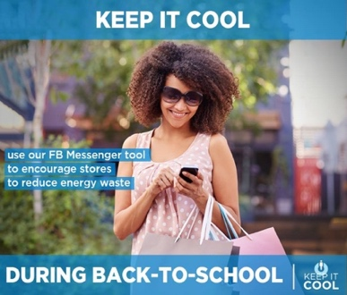

It is Back to School time and stores are attracting customers with big sales and open doors.
But during hot days with the air conditioning running, these open doors waste a lot of energy.

Now you can do something about it!

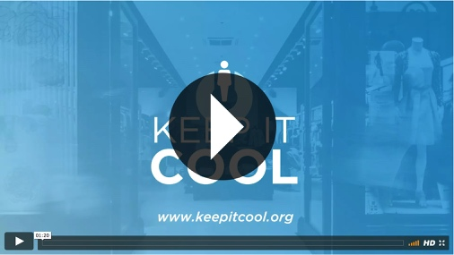
Join Keep It Cool, a national campaign mobilizing consumers to help convince retailers to close their doors and stop wasting energy. Participating is easy. All you have to do is spot front doors on shops, and use Facebook Messenger to drop a pin on a national map that tracks all of the stores identified with doors open or closed.

The campaign organizers will recognize shops that “Keep It Cool” with closed doors and reach out to educate retailers who allow energy to escape through their open doors.

“Our Keep it Cool campaign empowers consumers to anonymously have an impact on wasteful behaviors in their own neighborhoods. And it gives retailers the opportunity to do the right thing and showcase their green values. This is good for business, the community and the environment,” said Nate McFarland, director of communications at Generation180, the nonprofit organizer of the campaign committed to advancing a cultural shift in energy awareness and clean energy adoption.

Retailers that run the air conditioning during hot summer months and open their doors to attract customers drive up costs, waste energy and increase pollution. Just the simple act of closing doors can reduce pollution significantly. On average, each store with a door open wastes about 4,200 kWh of electricity over the summer. Generating this much electricity releases about 2.2 tons of carbon dioxide – the same amount of pollution emitted by a diesel semi-truck driving from New York to Miami.

Everyone who cares about the environment can join in the effort to help make your community cleaner and smarter.
To learn more visit www.keepitcool.org.

