Components
3.
2.
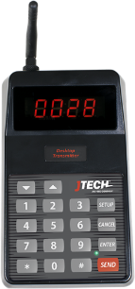
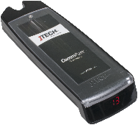
- Transmitter (ISTATION/TXGCIQ or NEO10 with power supply & antenna)
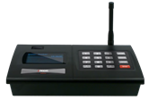
- CommPass Charging Base (CHCP with power supply)
1.
- CommPass Pagers (PGCPD1)

Equipment Setup
Step 1  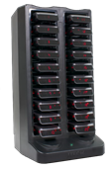  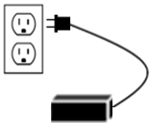  Connect the antenna to the transmitter. Twist to lock in place.  Charging Base Setup | Step 2  Plug the power supply into the transmitter and then into a standard 110-240v outlet.
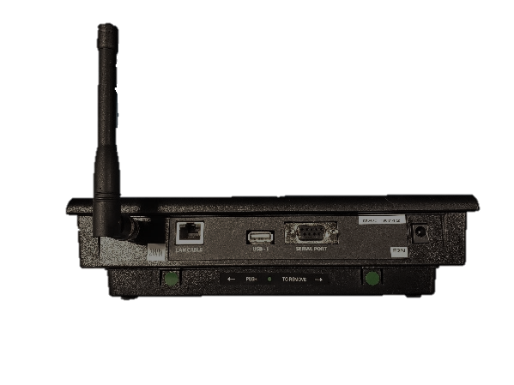
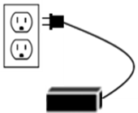
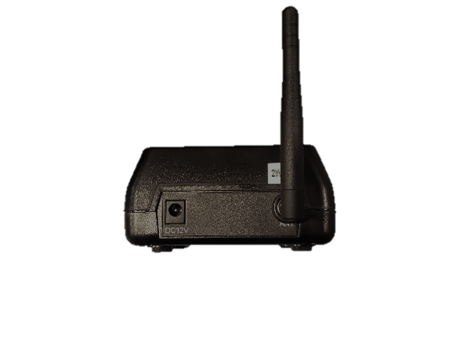
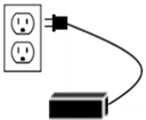
ISTATION / TXGCIQ
NEO10

Transmitter Setup
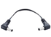
Jumper Cable (ACCHWIRE)

Step 2  Plug the power supply into the charging base and then into a standard 110-240v outlet.  For systems with more than 20 pagers (up to 60 pagers total), use the jumper cable to daisy chain the charging bases together. | Step 3  Add pagers to the charging base. You will see a BLUE light on each pager. This light indicates the charging status.  - “LO” indicates battery below 20%  - Flashing BLUE indicates pager is charging  - Solid BLUE indicates pager is fully charged.
NOTE: A surge protector is recommended for all Transmitters and Charging Bases.

System Operation

Handing out the pagers:
Give the guest a pager. Tell the guest that the pager will signal when they are needed. After the pager is finished sending the alert, it automatically goes back into standby mode, waiting for the next page. Pagers can be given out directly from the charging base (they will “demo” page each time they are removed from the charging base) or you can simply store them in a basket and hand them out. A fully charged pager will function all day without being recharged. You can reset a pager by inserting it into the charging base.

Paging the guest:
When the guest is needed, simply press the pager number on the transmitter keypad. Then press the “SEND” key. For example, press “1-SEND” and pager number “1” will signal.
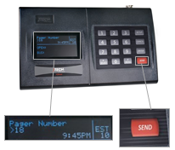 | 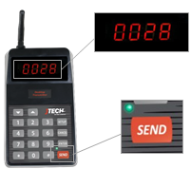 | 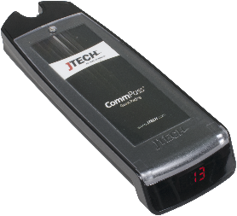  Pager will vibrate

Renumbering your pagers:
You must have a standalone transmitter to reprogram a JTECH digital pager. If your transmitter is integrated with a 3rd party software solution, you will need to use the ISTATION transmitter for this function. All programming commands are sent over the air and can only be programmed one pager at a time.
To change the number on a pager, follow the procedure below:
Once the pager is placed in the charger you only have 30 seconds to complete the process. If more than 30 seconds have elapsed, re-place the pager on the charging base.
- Ensure the charger is plugged in.
- Place one pager at a time on the charging base.
- From the transmitter, enter the OLD pager number, then press “ENTER”.
- When the display says, “Enter Message”, press “*/MENU” followed by the NEW 3-DIGIT pager number. The display will show either a “*” (star) or “[“ (open bracket).
- Press “SEND” – The new pager number will be displayed.
For example: Changing pager #6 to pager #27
- Place #6 on the charger.
- From the transmitter, enter 6 and then press the “ENTER” key.
- Press “*027” (Note: 3-Digit number is required) and then press the “SEND” key.

