Components
3.
2.
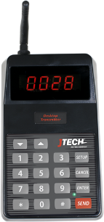
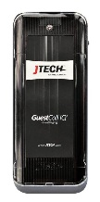
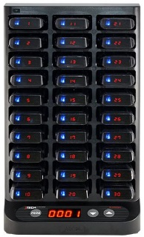
- Transmitter (ISTATION/TXGCIQ or NEO10 with power supply & antenna)
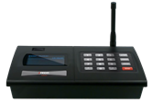
- IQ Charging Base (CHIQ with power supply)
1.
- IQ Pagers (PGIQD)

Equipment Setup
Step 1  Connect the antenna to the transmitter. Twist to lock in place. | Step 2  Plug the power supply into the transmitter and then into a standard 110-240v outlet.
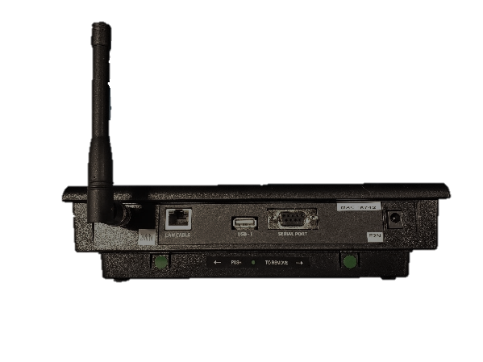
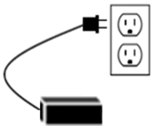
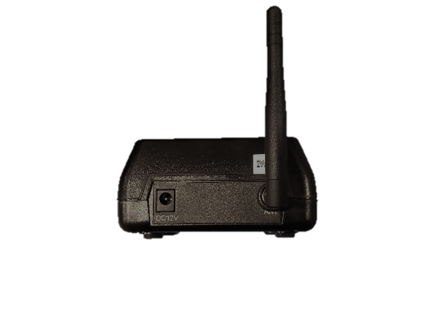
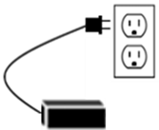
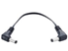
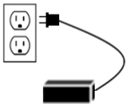
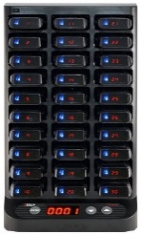
ISTATION / TXGCIQ

Transmitter Setup
NEO10
Jumper Cable (ACCHWIRE)

Charging Base Setup
Step 3  Plug the power supply into the charging base and then into a standard 110-240v outlet.  For systems with more than 30 pagers (up to 60 pagers total), use the jumper cable to daisy chain the charging bases together. | Step 4  Add pagers to the charging base. You will see a BLUE light on each pager. This light indicates the charging status.  - “LO” indicates battery below 20%  - Flashing BLUE indicates pager is charging  - Solid BLUE indicates pager is fully charged.
NOTE: A surge protector is recommended for all Transmitters and Charging Bases.

System Operation

Handing out the pagers:
Give the guest a pager. Tell the guest that the pager will signal when they are needed. After the pager is finished sending the alert, it automatically goes back into standby mode waiting for the next page. Pagers can be given out directly from the charging base (they will “demo” page each time they are removed from the charging base) or you can simply store them in a basket and hand them out. A fully charged pager will function all day without being recharged. You can reset a pager by inserting it into the charging base.

Paging the guest:
When the guest is needed, press the pager number on the transmitter keypad followed by the “SEND” key. For example, press “1-SEND” and pager number 1 will signal.
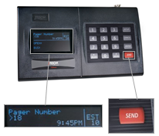 | 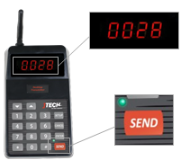 | 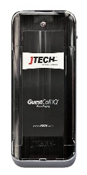  Pager will vibrate

Renumbering your pagers:
The starting position is indicated by the location of the .
To change the number on a pager, follow the procedure below:
- Press and HOLD the “PROG” button on the charger for 8 seconds.
- Charger will beep indicating that the reprogramming cycle has begun.
- You will see the pagers perform several functions as it applies each of the pager configurations. When the process is complete, all pagers will be in sequential order.
NOTE: All pagers will be renumbered with starting number that is displayed on the charging base.
Starting Number

