Components
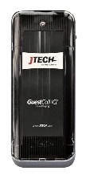
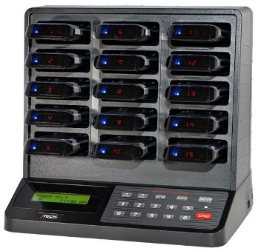
- Transmitter (IQAIO with Antenna and Power Supply)
2.
1.
- IQ Pagers (PGIQD)

Equipment Setup
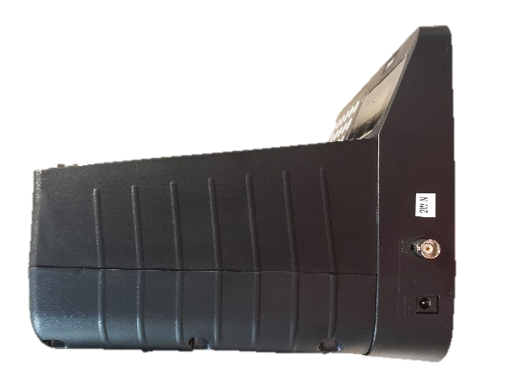
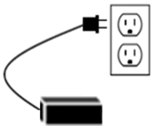
Step 1  Connect the antenna to the transmitter. Twist to lock in place. | Step 2  Plug the power supply into the transmitter and then into a standard 110-240v outlet.
NOTE: A surge protector is recommended for all Transmitters and Charging Bases.

System Operation

Handing out the pagers:
Give the guest a pager. Tell the guest that the pager will signal when they are needed. After the pager is finished sending the alert, it automatically goes back into standby mode waiting for the next page. Pagers can be given out directly from the charging base (they will “demo” page each time they are removed from the charging base) or you can simply store them in a basket and hand them out. A fully charged pager will function all day without being recharged. You can reset a pager by inserting it into the charging base.

Paging the guest:
When the guest is needed, press the pager number on the transmitter keypad followed by the “SEND” key. For example, press “1-SEND” and pager number 1 will signal.
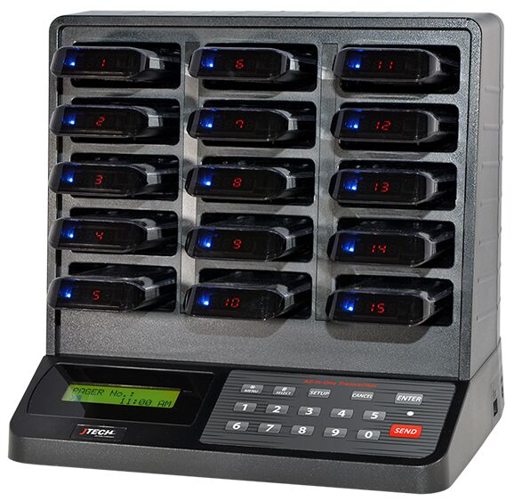 | 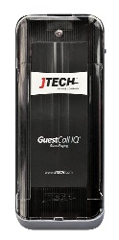  Pager will vibrate

Renumbering your pagers:
Be sure that all pagers are returned before performing this procedure.
To change the number on a pager, follow the procedure below:
- Press the “SETUP” key, followed by “1379”. After entering the 4-digits, press “ENTER”.
- Press the “*/MENU” button until you see “Program Pager #”, then press “ENTER”.
- Enter the 3-digit starting number you would like, then press “ENTER”. Your pagers will now be programmed in sequential order.
- Press the “CANCEL” key twice to exit the programming menu.
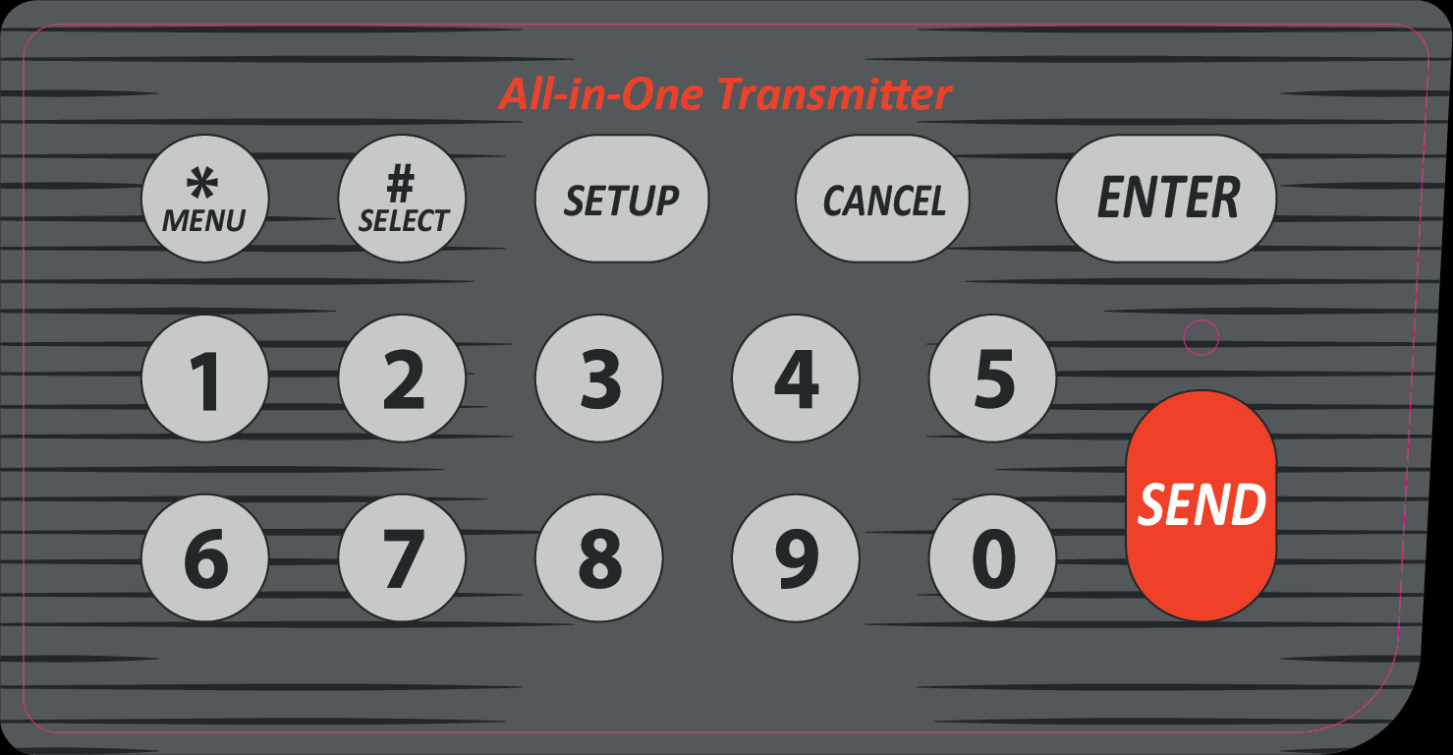
Note: The pagers will renumber starting at the top left slot (shown to the right).
1.
2.

