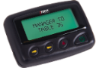
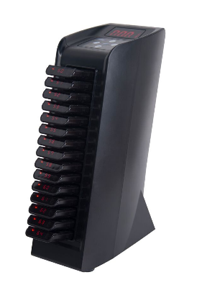
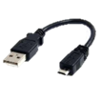
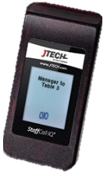
Components
4.
2.
1.
3.
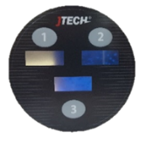
- Push Button Transmitter
Check
Manager
Service
- Alpha Pagers (RALPHA & STFIQ)
- Charging Base (with power supply – STFIQ Only)
- USB A to Micro USB Cable (Optional – STFIQ Only)
Bottom  Top  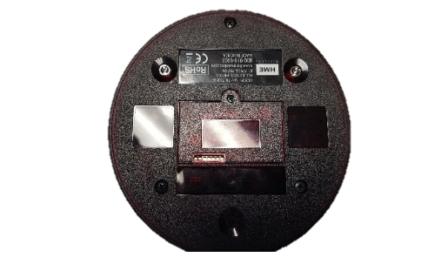  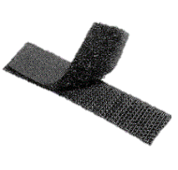  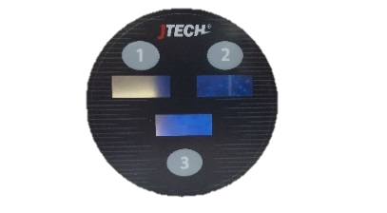  Velcro  CHECK  MANAGER  SERVICE | 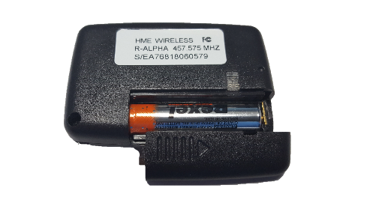  RALPHA Pager
Step 1  Place the Push Button Transmitter in a convenient location (Table, Counter) away from heat and humidity.  OPTIONAL:  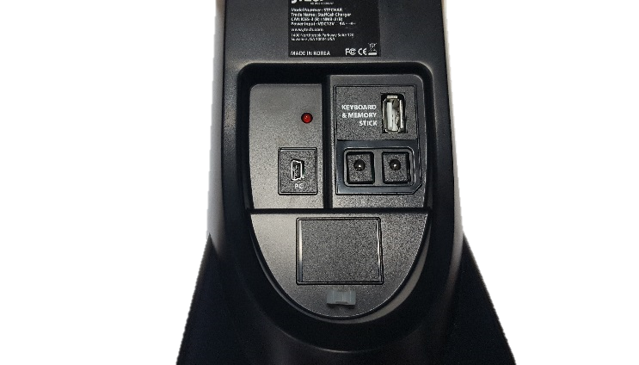  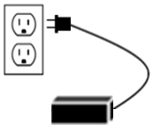  You can use Velcro (not included) on the bottom side of the Push Button Transmitter to secure it in place. The above diagram shows the suggested locations for Velcro as to not cover the battery door. | Step 2 - RALPHA  (Battery Installation)  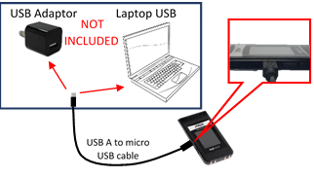  On the back, push the clear lock up to unlock the battery cover. Slide the battery cover off. Once opened, insert battery. Slide the cover back on and push the clear lock down to secure the battery cover in place.
Step 3 - STFIQ  Plug the power supply into the charging base and then into a standard 110-240v outlet. Insert all pagers into the charging base.  **A Surge Protector is recommended on all charging bases. | Step 3 - STFIQ  OPTIONAL (Without Charging Base):  Plug the cable into a USB port/charger (not included) and then plug the Micro USB into the side of the pager.

Equipment Setup

System Operation

Placing the Push Button Transmitters:
Place transmitters in a convenient location wherever you need them. You can simply set the transmitter on a counter or table or you can Velcro it down to secure it. These transmitters can still have their batteries replaced with properly installed Velcro on the bottom side of the transmitter.

Handing out the pagers:
Give the staff member a pager. Tell the staff member the pager will alert when they are needed. The default page for this system is programmed for the pager to vibrate for 8 seconds. After the pager is finished vibrating it automatically goes back into standby mode waiting for the next page. Hand the pagers out from the charging base (they will “demo” page each time they are removed from the stack) or you can simply store them in a basket and hand them out. A fully charged pager will function all day without being recharged. You can reset a pager by inserting it into the charging base.

Paging the alpha pager:
Push Button Transmitters come with 1 or 3 buttons. Press one of the buttons and the page will be sent to the corresponding pager. A red light will display for two seconds indicating a successful page.

Example:
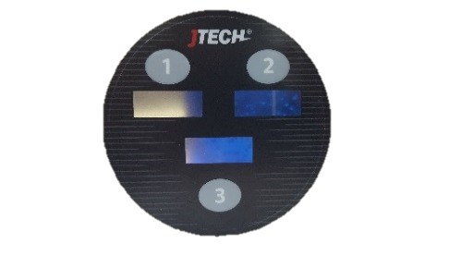
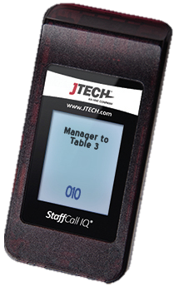
If you push the #3 button on Push Button Transmitter #3, the corresponding pager (Shown below) will display a message “Manager to Table 3”
CHECK
MANAGER
SERVICE

Push Button Transmitter Battery Replacement (Phillips Head Screwdriver Size 0):
On the bottom of the Transmitter, unscrew the battery door and remove. Once opened, remove the batteries and replace them with new AAA Alkaline batteries. Then replace the battery door and screw it into place.
