Components

- ISTATION Transmitter (with power supply & antenna)
- Charging Base (with power supply)
- Alpha Pagers (BSMTIQ, STFIQ, or BLTMESSAGE)
- USB to Micro USB Cord (STFIQ Only)

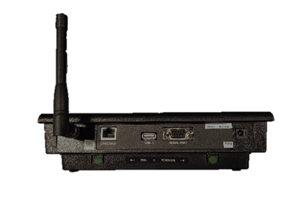
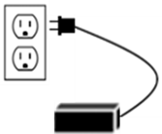
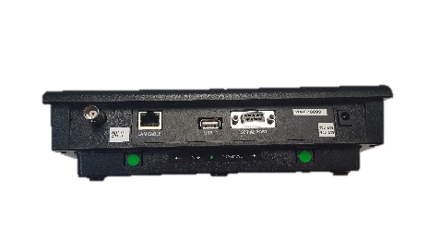
Step 1  Connect the antenna to the transmitter. Twist to lock in place. | Step 2  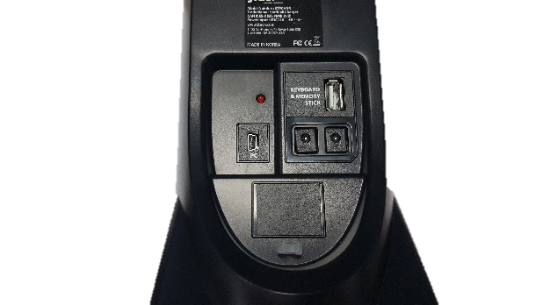  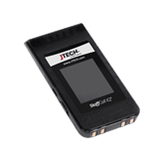  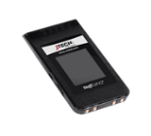  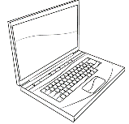  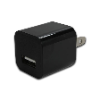  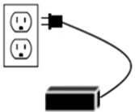  Plug the power supply into the transmitter and then into a standard 110-240v outlet.  StaffCall IQ Pager  USB A to micro USB cable  USB Adaptor  Laptop USB  NOT INCLUDED | Step 3  OPTIONAL:  Insert the USB connector from the keyboard into the back of the transmitter.

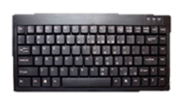
Equipment Setup
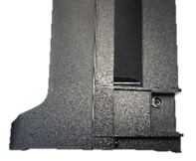  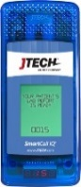  Smart IQ Pager  Smart IQ Charger | 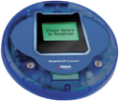  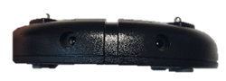  Coaster Pager  Coaster Charger
Step 4 - BSMTIQ  Plug the charger power supply into the charging base and then into a standard 110-240v outlet. | Step 4 - BLTMESSAGE & STFIQ  Plug the charger power supply into the charging base and then into a standard 110-240v outlet. Place pagers on charging base to charge. If you have more than 15 pagers, use the jumper cable to connect the charging bases. |  | Step 5 - STFIQ  OPTIONAL (Without Charging Base):  Plug the cable into a USB port/charger and then plug the Micro USB into the side of the pager.
NOTE: A surge protector is recommended for all Transmitters and Charging Bases.

System Operation

Handing out the pagers:
Give the guest a pager. Tell the guest that the pager will alert when they are needed. After the pager is finished alerting, it automatically goes back into standby mode waiting for the next page. You can give the pagers out directly from the charging base (they will “demo” page each time they are removed from the charging base) or you can simply store them in a basket and hand them out. A fully charged pager will function for a full day without being recharged. You can reset a pager by replacing it in the charging base.

Paging the guest:
When the guest is needed, simply press the pager number on the transmitter keypad followed by the “SEND” key. For example, press “11-SEND” and pager number 11 will signal. The default message will be displayed on the pager.

To send an alpha message:
From the transmitter or keyboard, press the “Pager Number” followed by the “ENTER” key. Using the keyboard, enter the alpha message followed by the “ENTER” key. For example, press “11-ENTER-AlphaMessage-ENTER” and pager number 11 will signal and display the message AlphaMessage.

SmartCall Special Feature (Optional):
This system can send up to 10 custom pre-programmed messages.
Example messages:
*1 – Sample Message 1
*2 – Please return to the host.
*3 – Your order is ready.
*4 – Patient in recovery room
*5 – Surgeon is still working.
*6 – Everything is going well.
*7 – Return to the waiting room desk.
*8 – Call waiting on the line.
*9 – Surgery pickup is here.
*10 – Appointment is here.

To send a pre-programmed message:
From the transmitter, press the “Pager Number” followed by the “ENTER” key. Select the message code (*1-*10) that corresponds to the message you want to send then press the “SEND” key. For example, press “1-ENTER-*3-SEND” and pager number 1 will signal and display the message “Your order is ready”.

NOTE: To change the pre-programmed messages you will need to log into the SmartCall website below:
https://hmeapps.com/smartcall25/

