Components
2.
3.
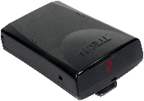
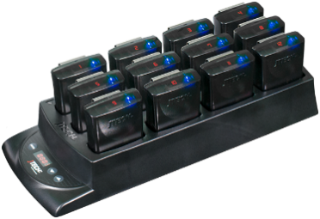
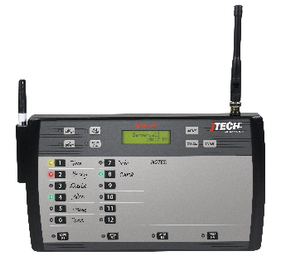
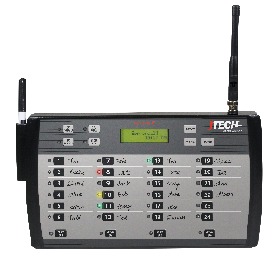
- ServerCall Transmitter (with power supply & antenna)
- Rugged Pagers
24 position
1.
- Rugged Charging Base (with power supply)
12 position

Equipment Setup
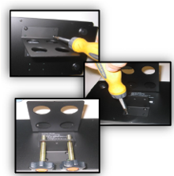 | 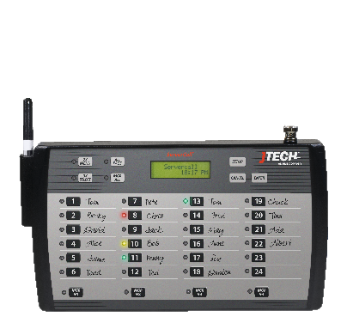 | 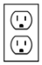  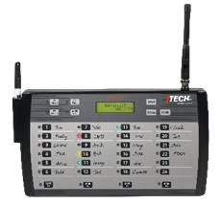
Step 1  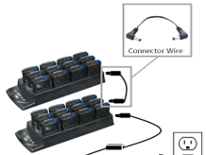  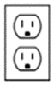  Mount the transmitter to the cook line using the included brackets. Bracket can also be used as a stand by reversing its position on the back of the transmitter. | Step 2  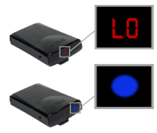  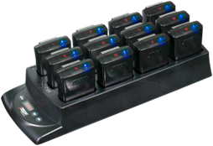  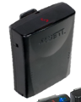  Connect the antenna to the transmitter. Twist to lock in place. | Step 3  Plug the power supply into the transmitter and then into a standard 110-240v outlet.

Step 4  Compile charger bases and connector wires if applicable. Plug the power supply into the charging base and then into a standard 110-240v outlet. | Step 5  Add pagers to the charging base. You will see a BLUE light on each pager. This light indicates the charging status.  - “LO” indicates battery below 20%  - Flashing BLUE indicates pager is charging  - Solid BLUE indicates pager is fully charged.
NOTE: A surge protector is recommended for all Transmitters and Charging Bases.

System Operation

Transmitter setup:
- Server is assigned a pager for the shift. Write the server name next to the pager number with a grease pencil (included).
- When needed, press the number that corresponds to the server’s name.
- When the server returns to pick up the order, press the number again to cancel the page.
By default, servers will be paged 3 times before the page is escalated to a manager*. Each page is indicated by a colored LED on the transmitter.
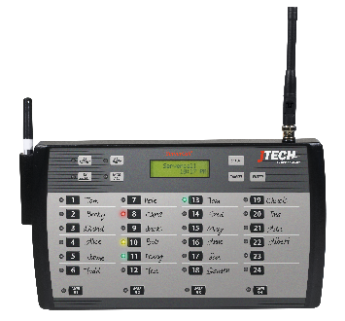 | 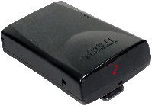 | - To renumber the pagers, with ALL the pagers in the charging base, PRESS and HOLD the “PROG” button on the charger for 8 seconds.  - Charger will beep twice indicating the reprogramming has begun.  - The pagers will renumber starting at the location indicated by the on the charging base.  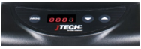
By default, all messages are sent as a SINGLE vibration. To send 2x or 3x vibration patterns, press the corresponding button on the transmitter prior to selecting the server’s number.
- Green – 1st page has been sent to server
- Yellow – 2nd page has been sent to server
- Solid Red – 3rd page has been sent to server
- Flashing Red – Page not canceled, manager has been notified
*When using with a manager’s messaging pager, the manager will receive a page with the number of any server who has not cancelled their page.

ServerCall Paging System with optional Cancel Panel:
- Mount the Cancel Panel on the expo line in the kitchen.
- Connect the Cancel Panel to the ServerCall transmitter using the Ethernet cable (included).
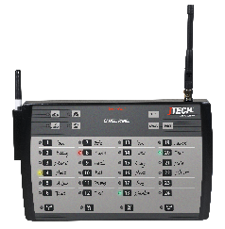
- When the server returns to pick up the order, the server will cancel the page on the Cancel Panel
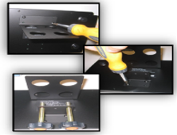 | Ethernet  cable | 