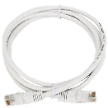
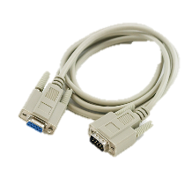
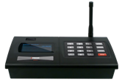
Components
2.
3.
- ISTATION Transmitter (With power supply & antenna)
1.
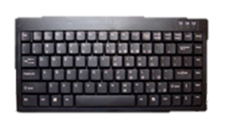
- Ethernet Cable
4.
- DB9 Cable (Optional for POS Integration)
- USB Keyboard (Optional)

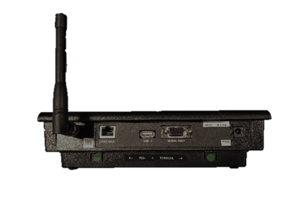
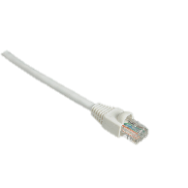
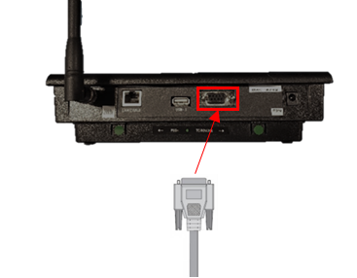
Equipment Setup
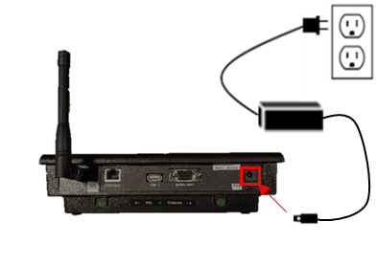
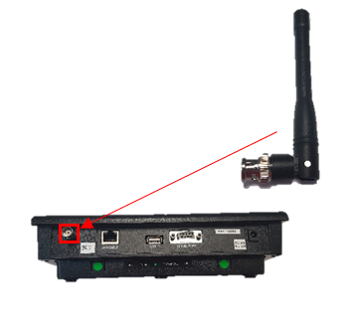
Step 1  Connect the antenna to the transmitter. Twist to lock in place. | Step 2  Plug the power supply into the transmitter and then into a standard 110-240v outlet. A surge protector is recommended for all Transmitters and Charging Bases. | Step 3  Plug one end of the Ethernet cable into the back of the transmitter and then the other end into your network.
Step 4  OPTIONAL (For POS Integration):  Connect the serial cable to the serial port on the back of the ISTATION  and then tighten the screws. | Step 5  OPTIONAL:  Insert the USB connector from the keyboard into the back of the transmitter.
Optional items are not included unless purchased before shipping.

System Configuration
Please contact your IT department for assistance in setup.

To enter Network Programming Mode
- Press the “SETUP” button.
- Enter the password “6629” followed by “ENTER”.
- Once the password is accepted, the display will show “Admin Setup”
- Use the following buttons to configure your transmitter.
- “*/MENU” key to scroll through the different menu options.
- “#/SELECT” key to toggle between options.
- “ENTER” to edit the menu and save the new settings.
- “CANCEL” to exit the system programming menu.

Static IP Setup
To enter the IP Address provided by your IT, follow the procedure below:
- At the “IP Address” screen, press the “ENTER” key.
- Enter the twelve-digit IP, then press the “ENTER” key.
- Press the “CANCEL” key to exit the system programming menu or “*/MENU” to scroll to the next menu.

DNS Setup
To enter the DNS Server IP provided by your IT, follow the procedure below:
- At the “DNS Server IP” screen, press the “ENTER” key.
- Enter the twelve-digit IP, then press the “ENTER” key.
- Press the “CANCEL” key to exit the system programming menu or “*/MENU” to scroll to the next menu.

Client Code and Token Setup
If you need your Client Code and Token, please contact support at 800-321-6221.
If you already have the Client Code and Token for your account, follow the procedure below:
- At the “SMS Text Messaging” screen, press the “#/SELECT” key to turn “ON”.
- Press the “ENTER” key.
- At the “SMS Company Code” screen, use the keyboard to enter your 6-digit Client Code, then press “ENTER”.
- At the “SMS Company Token” screen, use the keyboard to enter your 15-digit Token, then press “Enter”.
- Press the “CANCEL” key to exit the system programming menu or “*/MENU” to scroll to the next menu.

System Operation

Sending a direct SMS Message from your transmitter:
To send a direct SMS Message enter the 10-digit phone number on the transmitter, then press “ENTER”. Use the keyboard to type the desired message, then press the “ENTER” key. For example, type “8003216221-ENTER-Your table is ready. -ENTER” to send the phone number 800-321-6221 the message Your table is ready.

