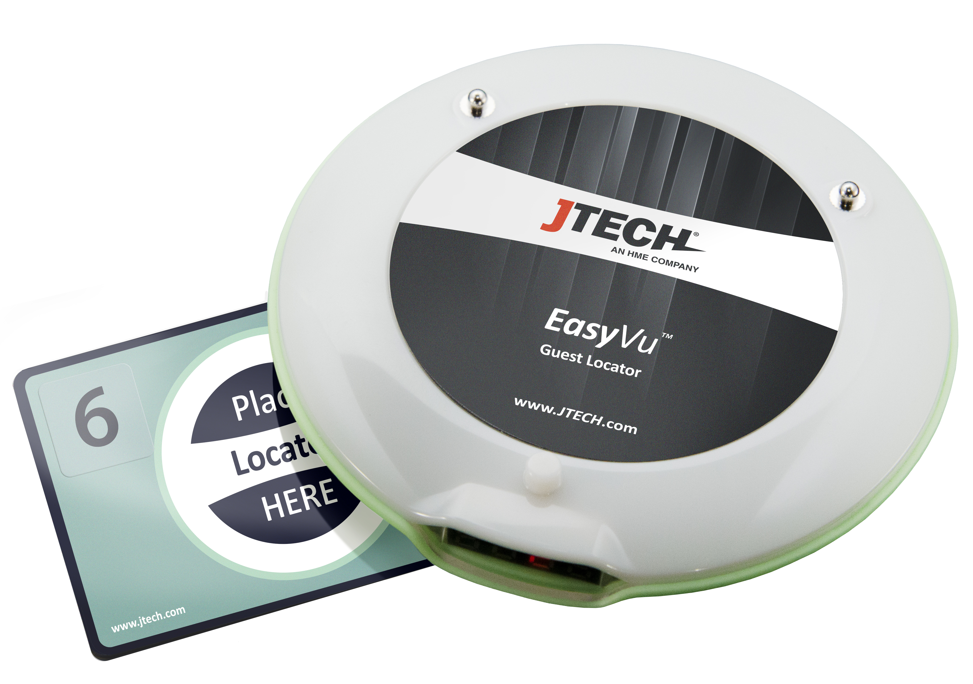
EasyVu™
Model Numbers: J1801, J1802, J1803
User Manual Date: 02/16/2018

Contents

Introduction
- EasyVu System Overview
- EasyVu Workflow
- Special Features of EasyVu 2.1
- Transmission/Reception Distances
- Safety Precautions

Component Installation
- List of Components
- System Configuration and Connections
- Rear View of Gateway
- Basic Installation
- Gateway Installation
- Connection Detail

EasyVu Software Installation (Windows 10)
- Preparation: USB Driver Update
- Preparation: Inbound Rule Setting for Windows OS
- Preparation: Firebird Database Installation
- EasyVu Client Installation
- EasyVu Server Installation

EasyVu Software Settings and Features
- Server Settings and Features
- Client Settings and Features

Using EasyVu
- Table Tag Writer
- Test Mode
- Multiple Gateways — Component Installation
- Multiple Gateways — WizVSP Installation
- Multiple Gateways — ConfigTool & VSP
- Multiple Gateways — Network Connection Detail

Introduction

EasyVu System Overview
The EasyVu System is designed to help restaurants manage their customers more effectively. As customer location information is quickly sent to the servers, food can be served before it gets cold. Prompt serving also improves the service flow of the restaurant, increasing the level of customer satisfaction.

EasyVu Workflow 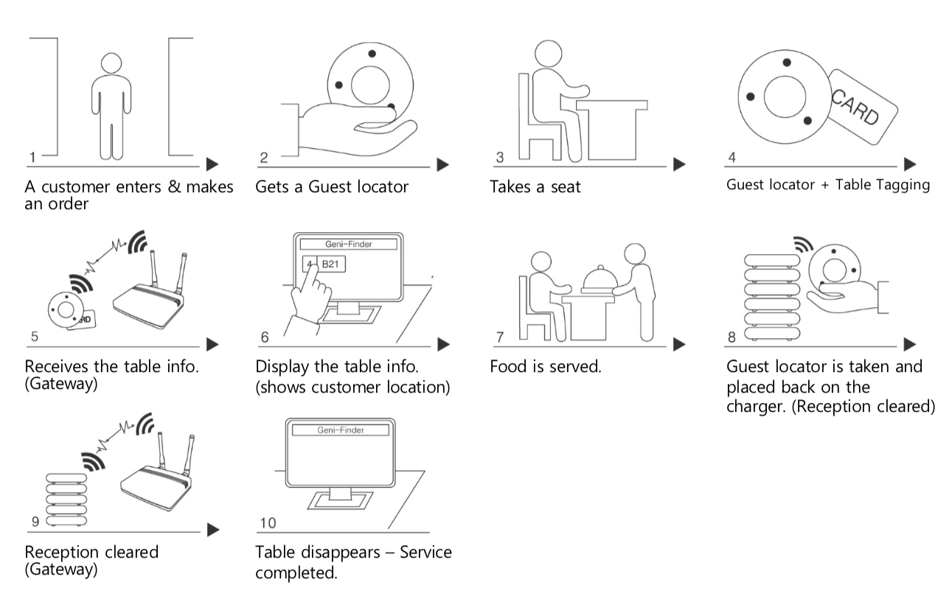

Special Features of EasyVu 2.1
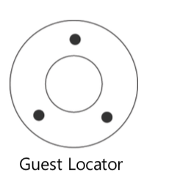
- Flashing red light alert.
- Stacks on charger for charging and setting the Guest locator ID.

Transmission/Reception Distances
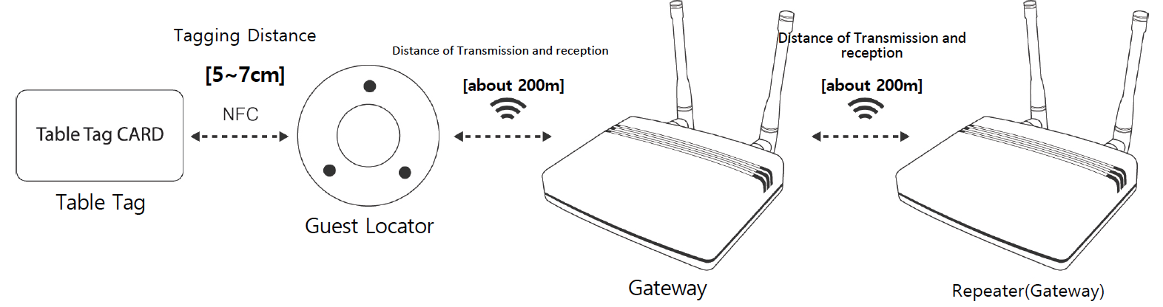

- The operating range may vary depending on the user environment.
- The EasyVu system does not operate on metal tables. A shielding material must be placed
under a Table Tag Card.

Safety Precautions
Avoid Exposure to Foreign Substances
- Avoid introducing foreign substances into products that could deteriorate or damage them.
Do Not Use if a Component is Not Functioning Properly
- If a component is not operating as expected, contact our A/S service team.
Avoid Operating in Extreme Temperatures
- Operate products within the specified ambient operating temperature range of -14°F ~ 131°F
(-10°C ~ 55°C).
Never Repair Products Yourself
- Never disassemble or repair a product yourself. Repair or service must be performed
by an authorized repair facility.
Avoid Physical Impacts to Products
- Failure to do so may result in accelerated wear, breakage, or malfunction of the product.
Do Not Drop Products
- Doing so may result in serious damage to the product.

Component Installation
List of Components
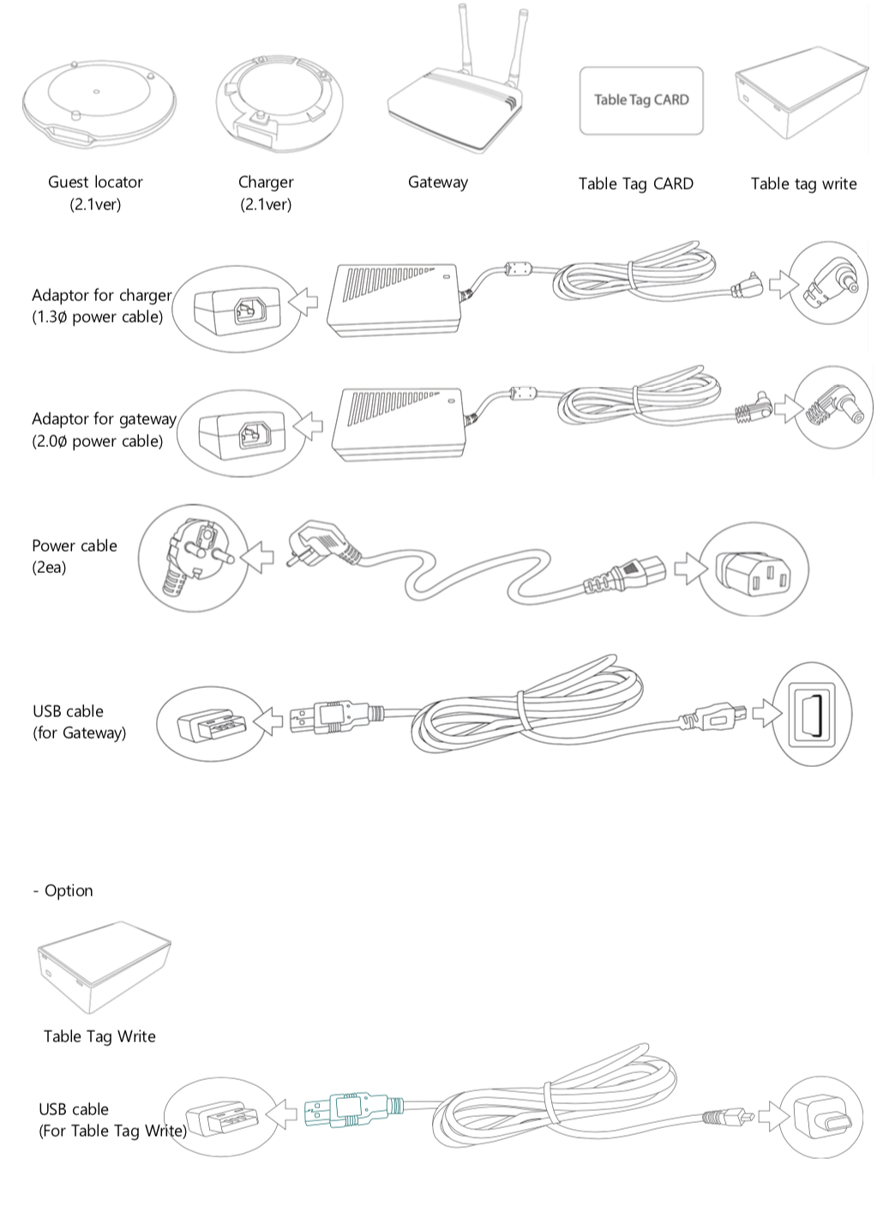
System Configuration and Connections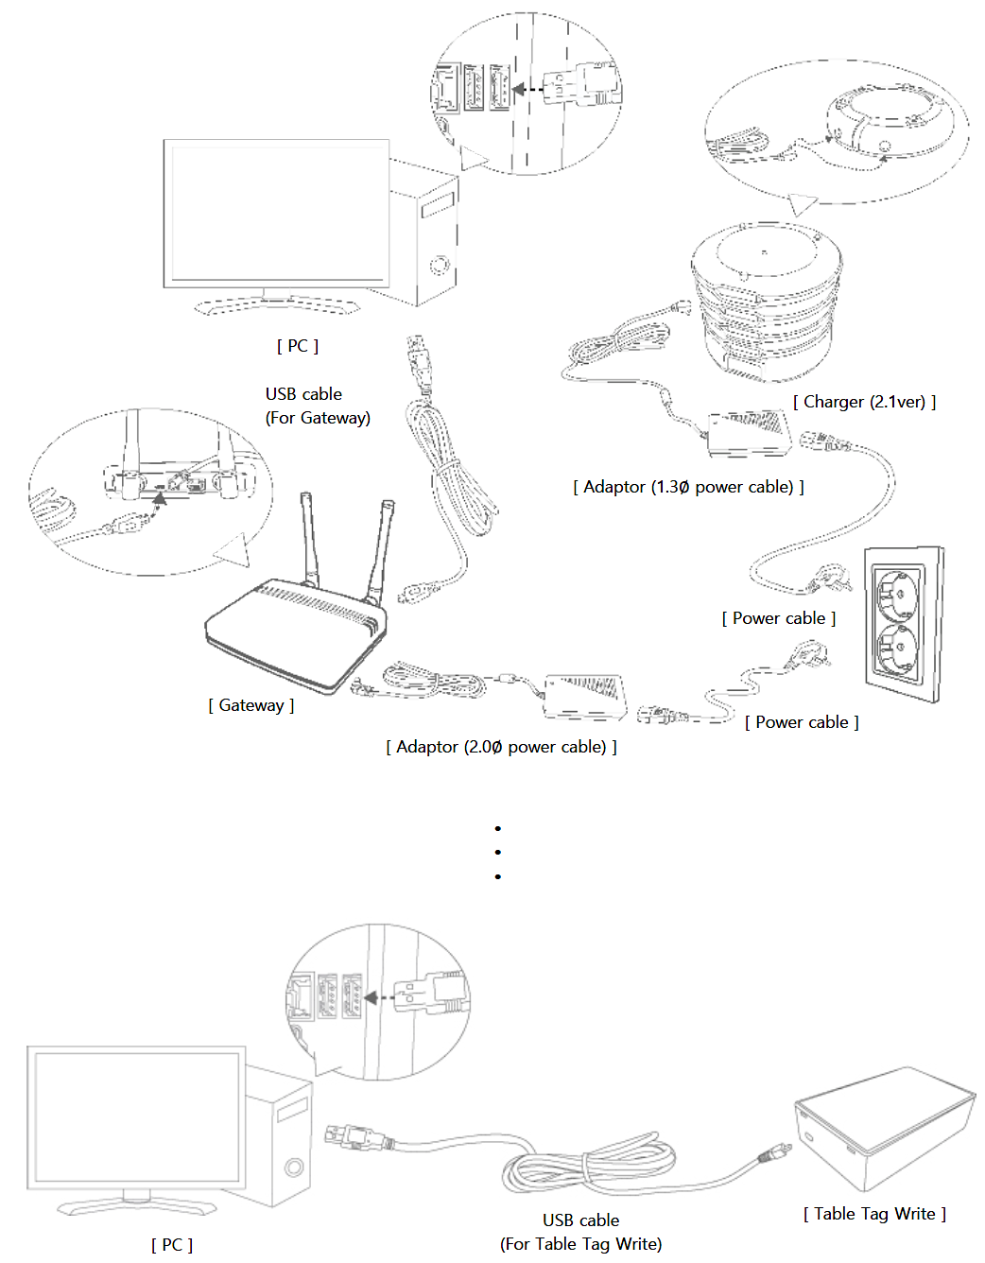
Rear View of Gateway
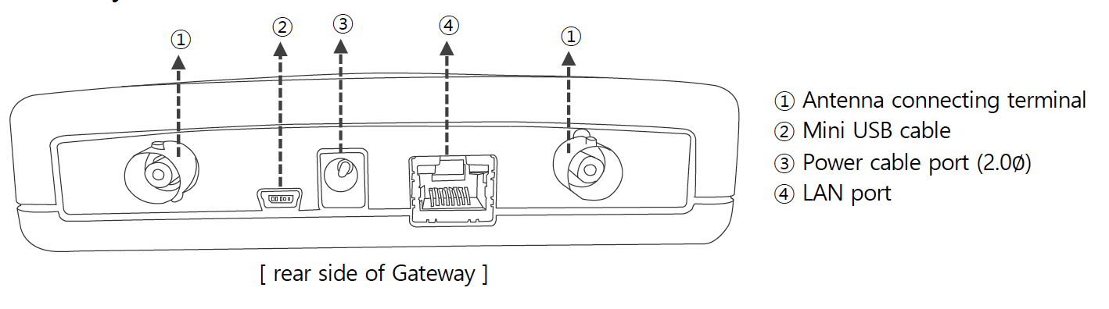

Basic Installation
Charger v2.1
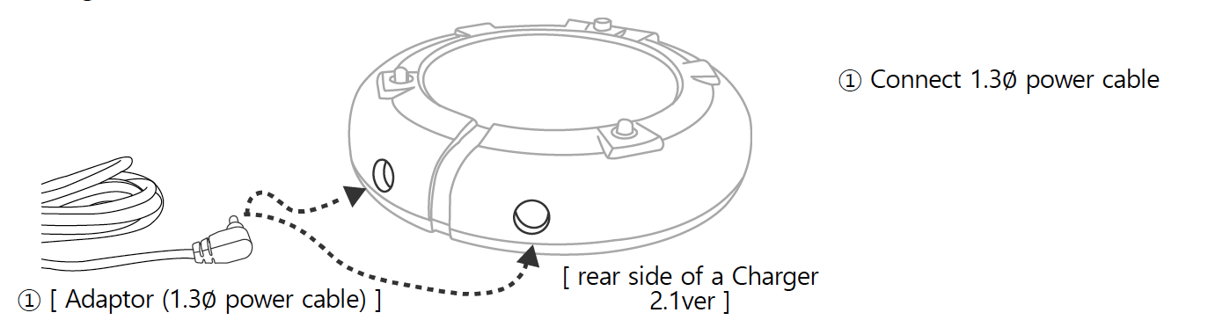

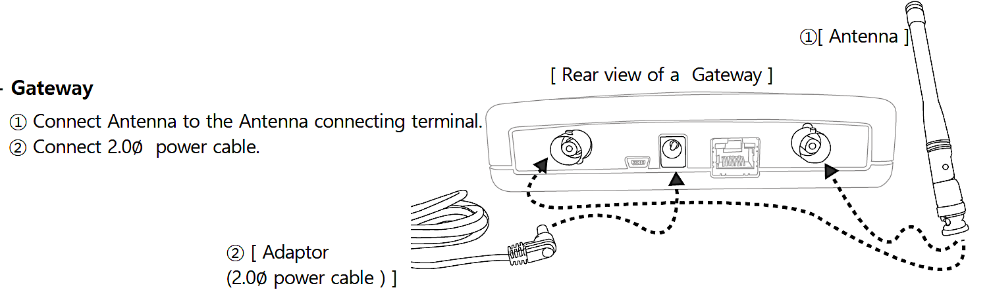

Connection Detail
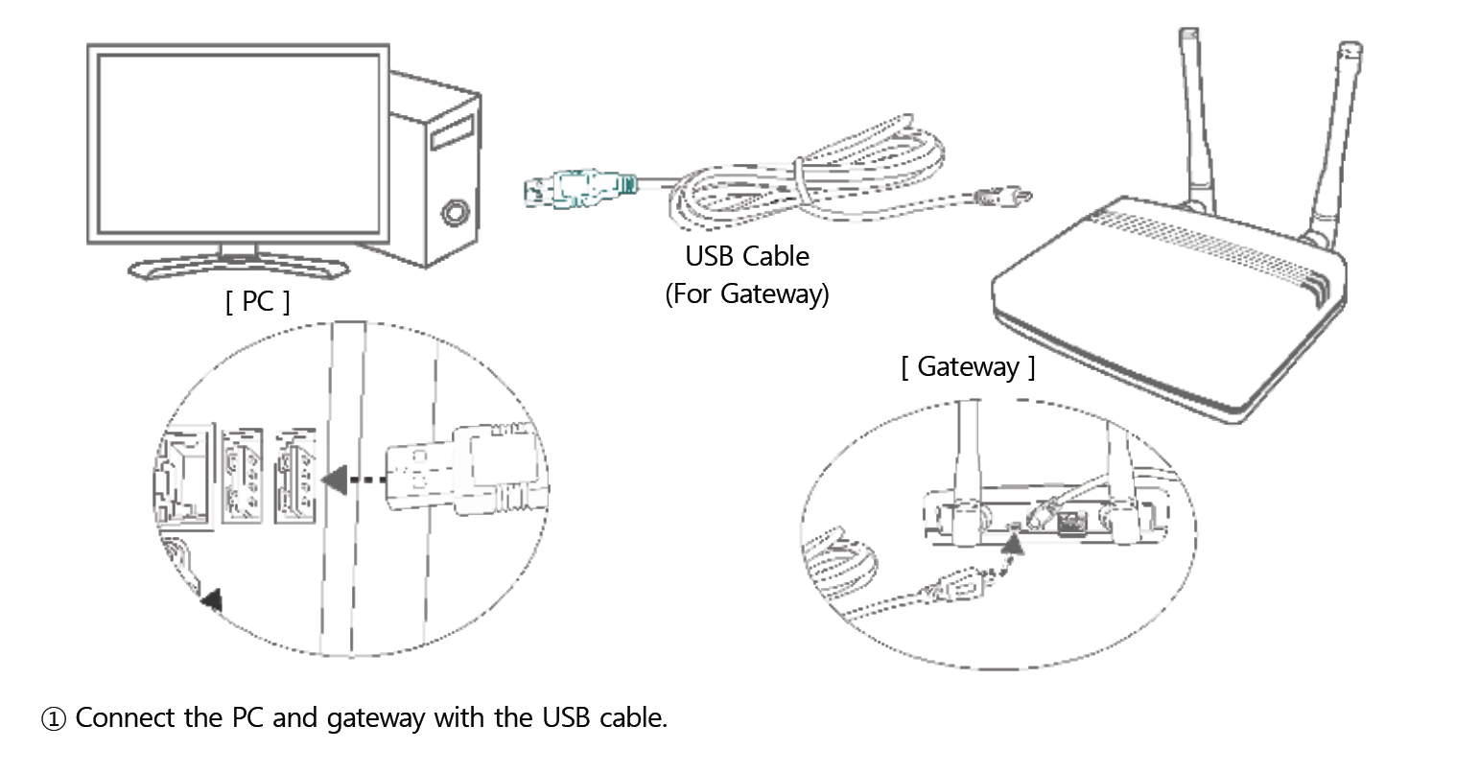

EasyVu Software Installation (Windows 10)
Preparation: USB Driver Update – 1
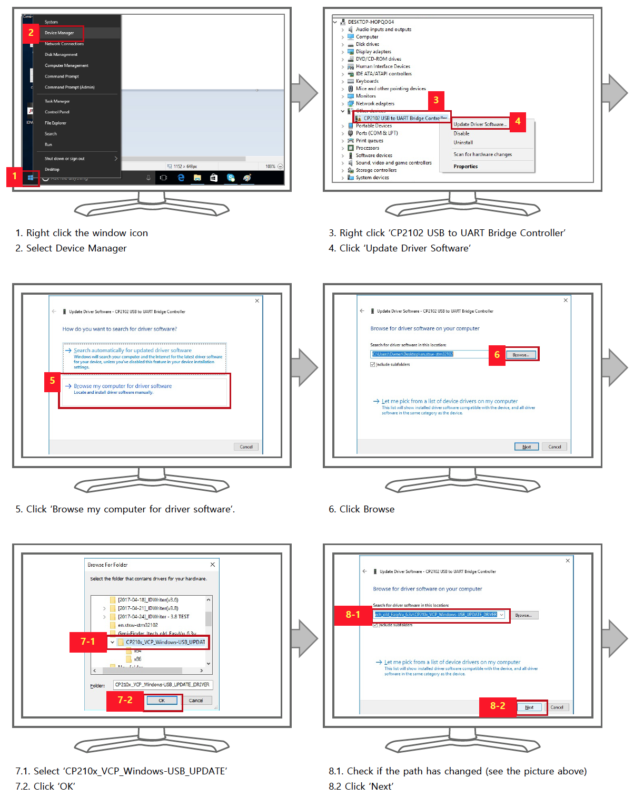

Preparation: USB Driver Update – 2
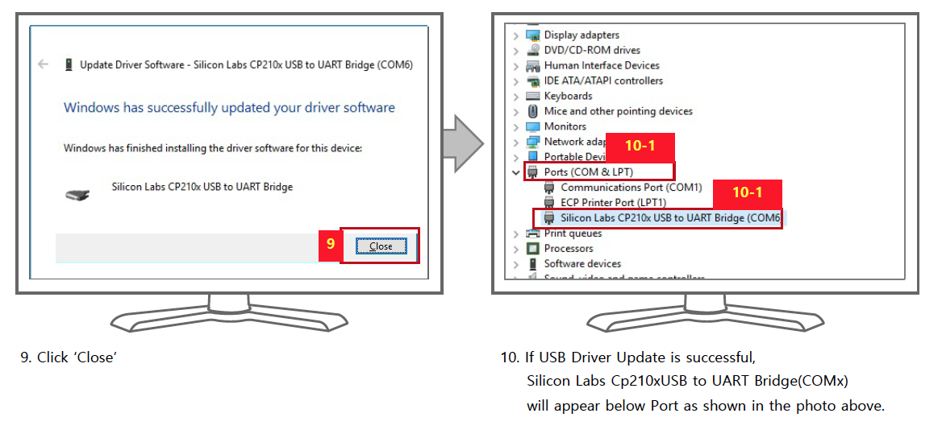

Preparation: Inbound Rule Setting for Windows OS – 1
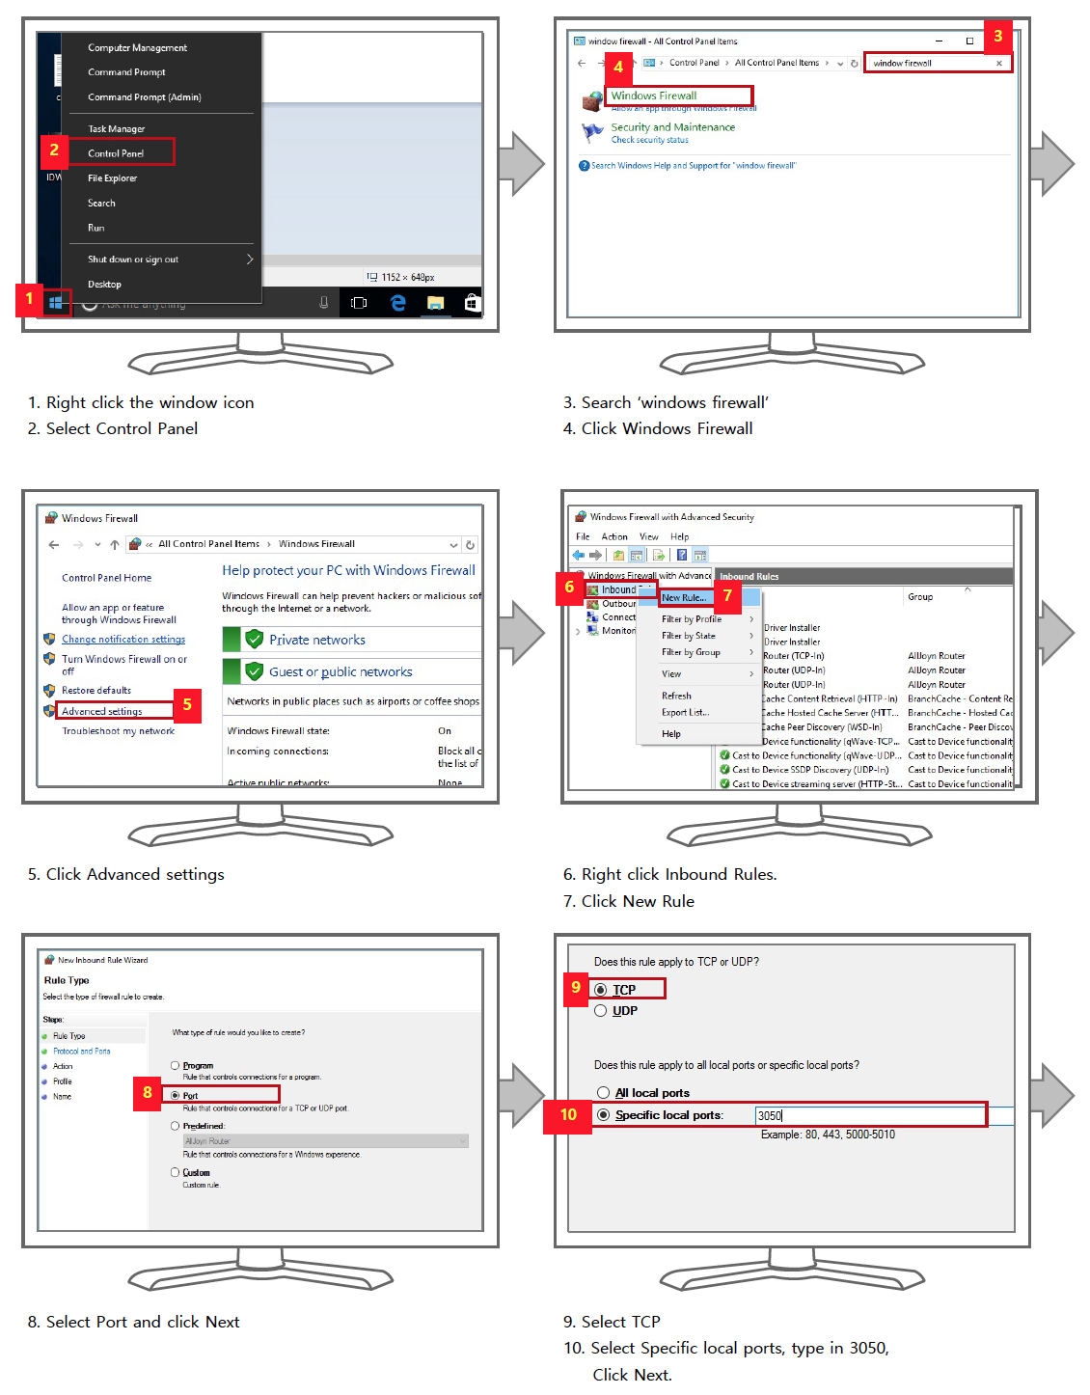
Preparation: Inbound Rule Setting for Windows OS – 2
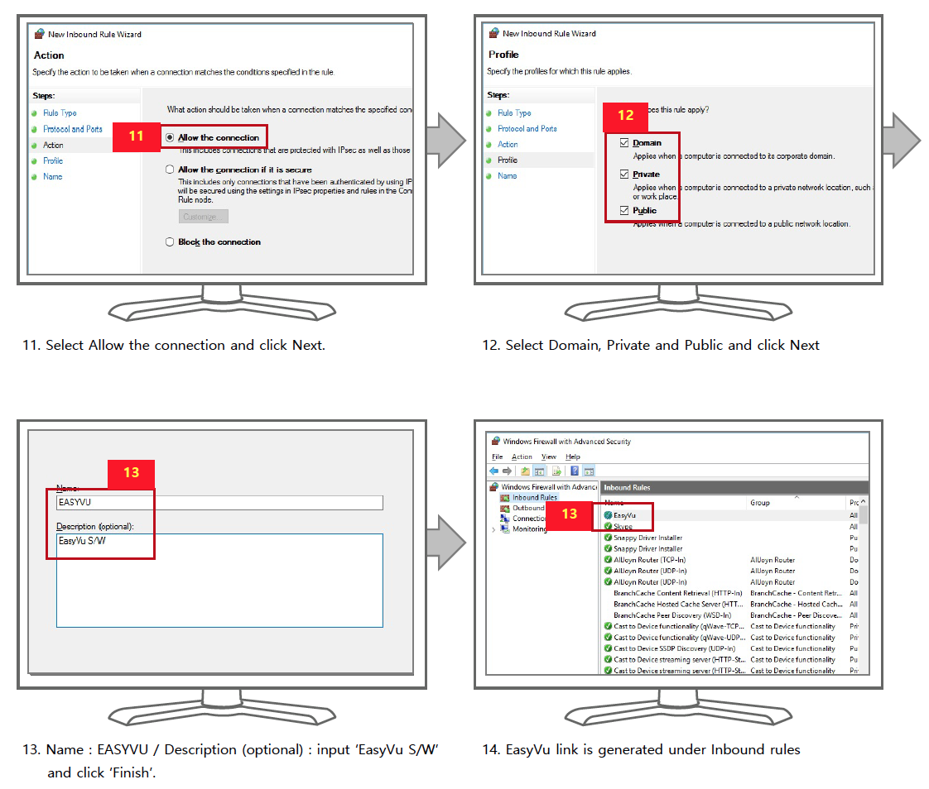

Preparation: Firebird Database Installation – 1
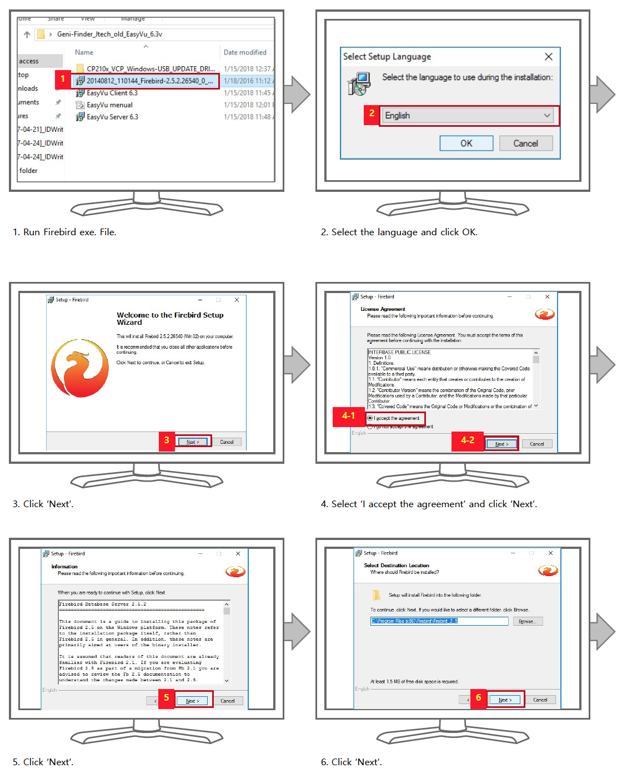

Preparation: Firebird Database Installation – 2
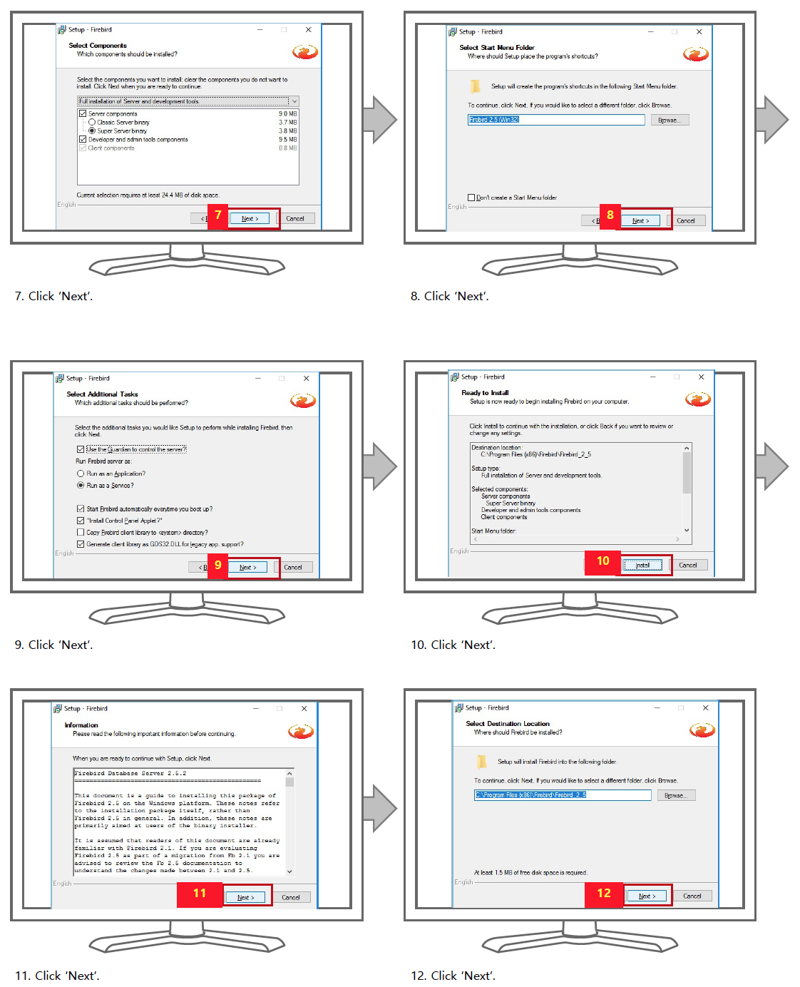

EasyVu Client Installation
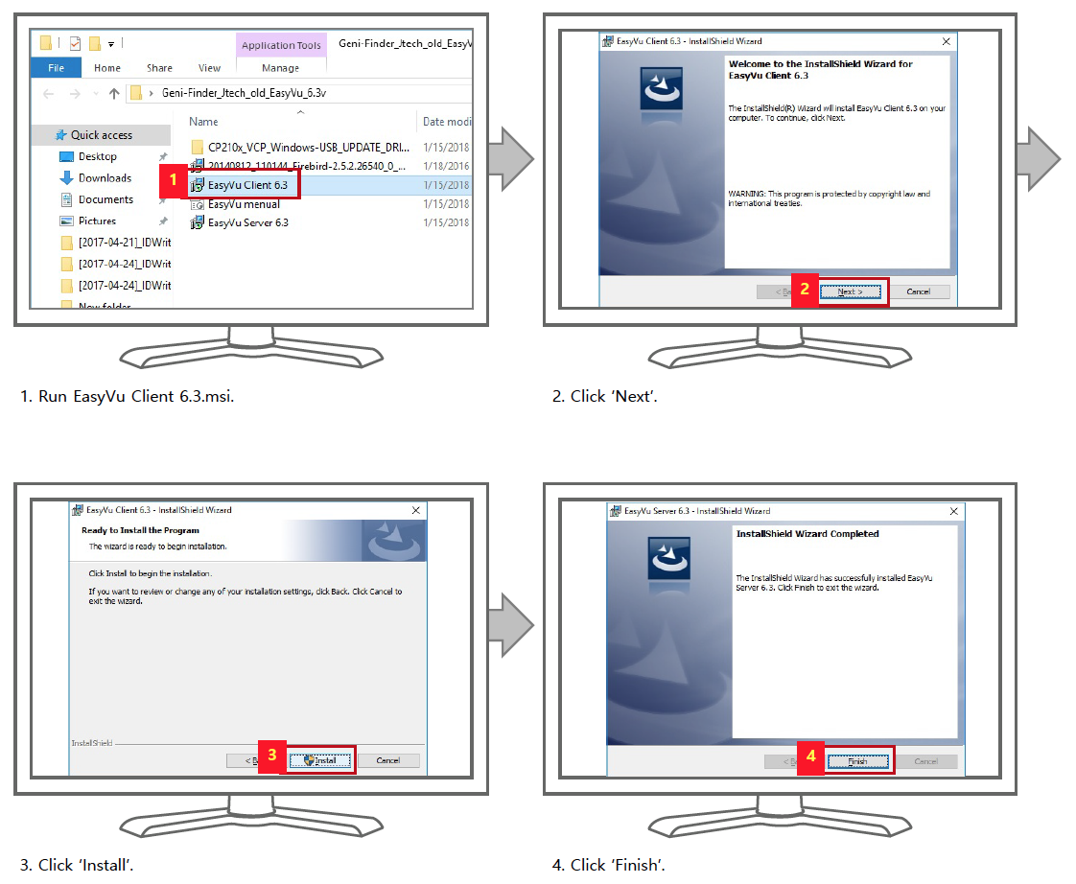

EasyVu Server Installation
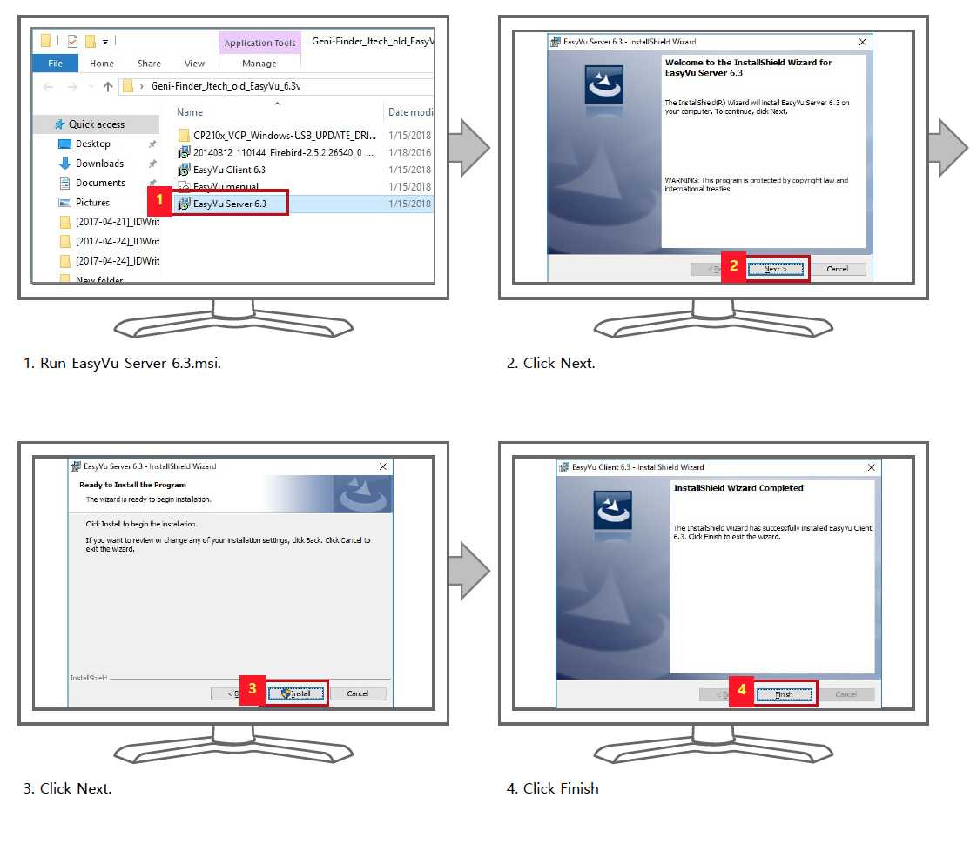

EasyVu Software Settings and Features
EasyVu Server Settings and Features
Run EasyVu Server and Set EasyVu COM-PORT
- Go to Device Manager in Control Panel > The COM-PORT is shown as in the picture below.
- Select the same Port Number as that of “Silicon Labs CP210x USB to UART Bridge.”
- Click ‘Start.’
- If the COM-PORT number is correct the Start button will change to ‘STOP. ’
- The Server is activated.
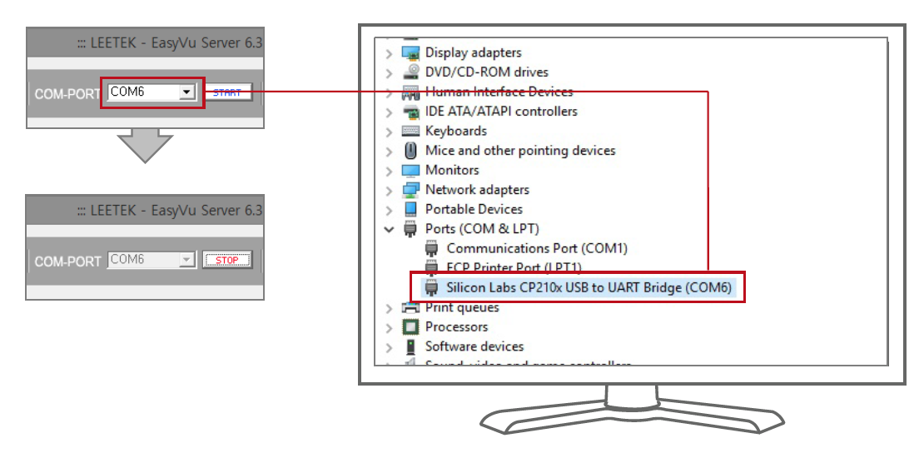

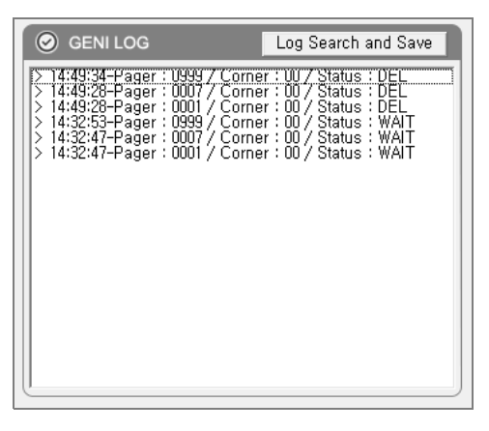
GENI LOG
All activity of the Guest locator and Gateway is displayed in real-time.

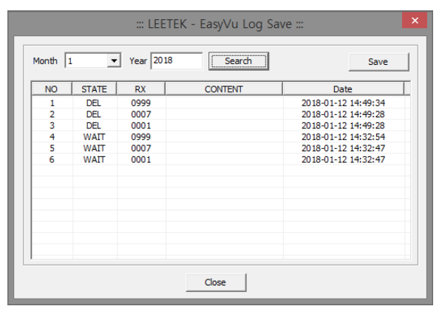
Log Search and Save
Log data can be searched by date and saved in Excel file format.
- Select the month and click ‘Search. ’
- Click ‘Save.’

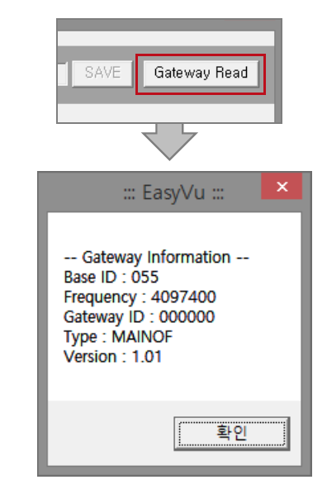
Gateway Read
- Gateway information can be read
by clicking ‘Gateway Read.’

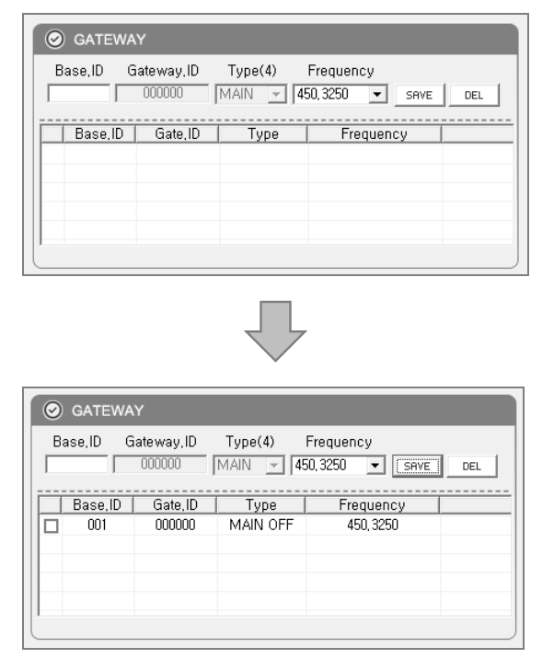
Input Base ID (3 Digits) and Gateway ID (000000) in the ‘GATEWAY & INDIVUDUAL SET’ Section
- The Base ID is written on the rear label of the Gateway.
- Select the corresponding frequency (refer to rear label of Gateway).
- After confirming that what you entered matches the Gateway’s presets, click ‘SAVE.’

Adding Additional Frequencies
- Go to C Drive (C:)→ Program Files folder → LEETEK folder → Geni Server folder
- Open “Geni.Finder.frequency” file in Geni Server folder.
- Enter additional frequencies and save the file under a different name on Desktop.
- Move the file to Geni Server file and replace the old file with the new one.
- You will find the additional frequencies in the file and Server S/W.

Individual ID Change
- Place the Guest locator on the Charger.

- Press [Ctrl]+[↑] to activate ‘INDIVIDUAL ID-CHANGE’ section
- Type in the new individual ID and click .

Other Features of ‘INDIVIDUAL SET’ Menu
- ICON-LIST ALL DELETE: Changed the status of all Guest locator that are not on a charger to ‘Delete.’
- GROUP CALL: Sends ‘Call’ message to all Guest locators that are not on a charger.
- GROUP SLEEP: Changes status of all Guest locators that are not on a charger to Sleep Mode.
- LOG CLEAR: Deletes all log records on Server.
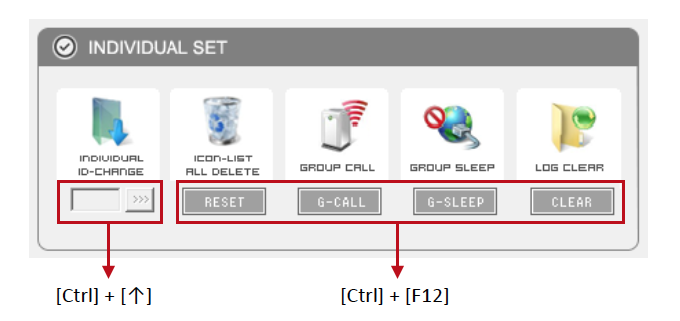
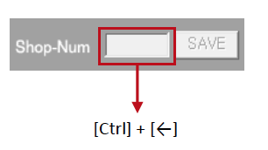
Input of Shop-Num Shown in the Log File (‘C:ÄLEETEK_GENI_DBÄLOG’)
(Example: 20180112-001-Pager => ‘001’ Represents ‘Shop-Num’)
- Press [Ctrl] + [←] to activate Shop-Num entry window.
- Enter the new shop number and click ‘Save.’

EasyVu Client Settings and Features
Initial Client Software Setup

Client S/W can be installed on the same PC where the Server S/W is installed — or on a different PC — following the steps below. Please note: If Client S/W is installed on a PC other than where the Server S/W is installed, you must install "Firebird-2.5.2.26540_0_Win32“ first.
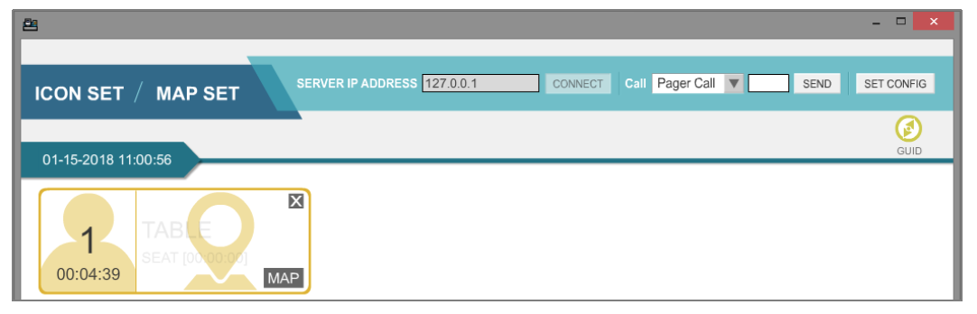
- Confirm the Server IP address using Server S/W.
- Click the Client S/W shortcut icon. (Note: For PCs using Windows 8 or below, Adobe® Flash® Player needs to be installed – please follow the instructions in the pop-up window.)
- Input the SERVER IP ADDRESS in Client S/W and click ‘Connect.’
- If the IP address is correct, and the network connection between Server S/W and Client S/W is good, the ICON and MAP SET tab will be activated.
- The Guest locator can now be given to customer, once the order and payment have been completed.
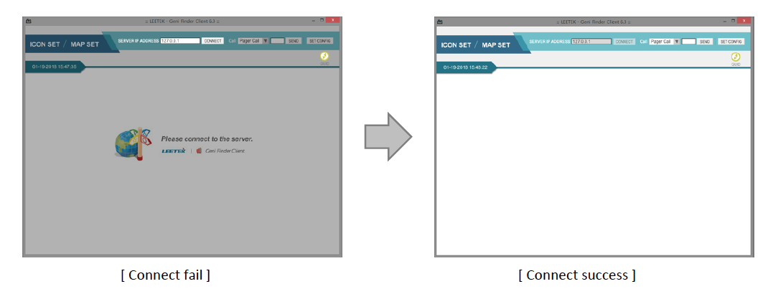

Additional Client Software Features
- When the Guest locator is taken off the charger base, the Guest locator sends a ‘Start’ signal to the Gateway. The Gateway then sends the signal to the PC, and information from the corresponding Guest locator is displayed in Client S/W as a yellow ‘Wait’ icon.
- When the Guest locator detects the Table tag, it flashes twice with a beeping sound.
- The Guest locator sends location information to the Gateway, which the Gateway sends to the PC. The yellow ‘Wait’ Icon then changes to a green ‘Seat’ icon.
- When the food is ready to be served, the staff takes the food to the location indicated on the Client S/W, collects the Guest locator, and places it back on the charger.
- When the Guest locator is returned to the charger base, it sends a ‘Clear’ signal to the Gateway.
- The Gateway receives that signal and sends it to the PC, so that the green ‘Seat’ icon disappears.
User Guide for Client Software
Click the ‘GUID’ icon for additional software feature information.
GUID Button

Paging Guest Locator Options, and Changing the Icon Color of Client Software
- Click ‘SET CONFIG’ on the top right.
- PAGER ALERT: Alert type and alert time can be set differently.
- SET COLOR: Colors presenting different duration time can be changed.
- Icon View Sort type: ‘Pager number’ (ASC, DESC), ‘Waiting Time’ (ASC, DESC)
- Icon option:
- ‘ALL’ shows all orders.
- ‘No Take Out’ shows dine-in orders only.
- ‘Take Out’ shows take-out orders only.
- Foodcourt options: Set corner can be set to 00 ~ 99. 01~50 for standard type, or 51~99 for
to-go orders.
- If the Set Corner is set at 00, information for all corners from 01~99 becomes available.
- Click ‘SAVE’ when done.

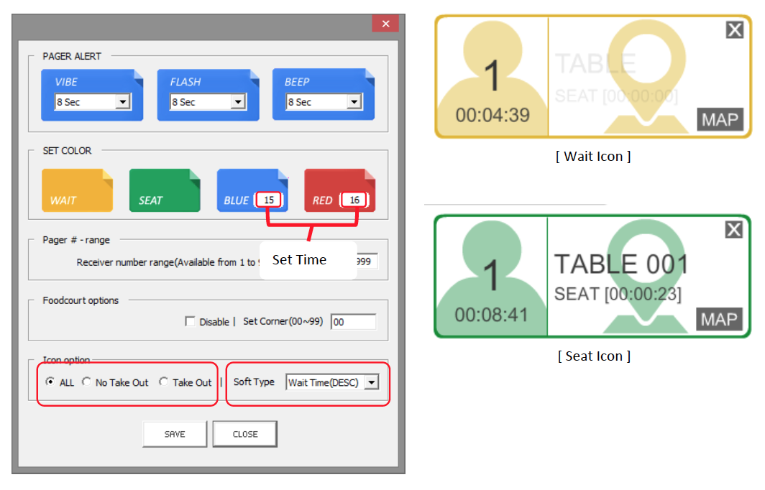

Using EasyVu
Table Tag Writer – 1
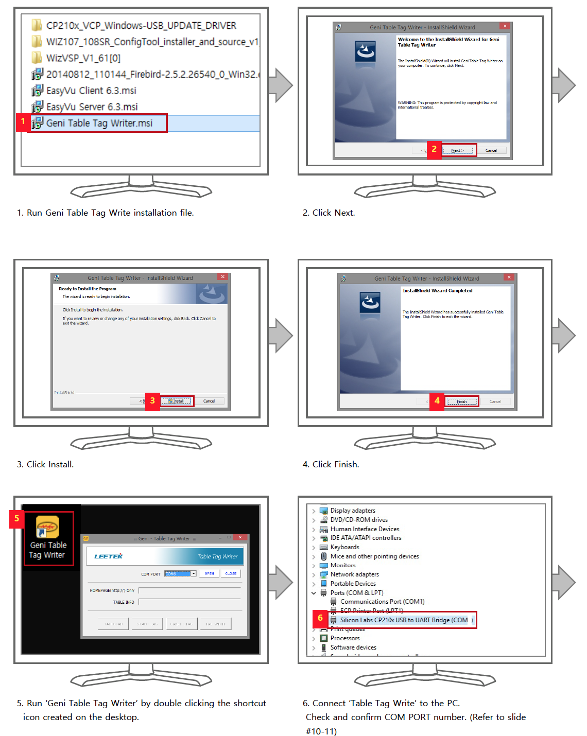

Table Tag Writer – 2
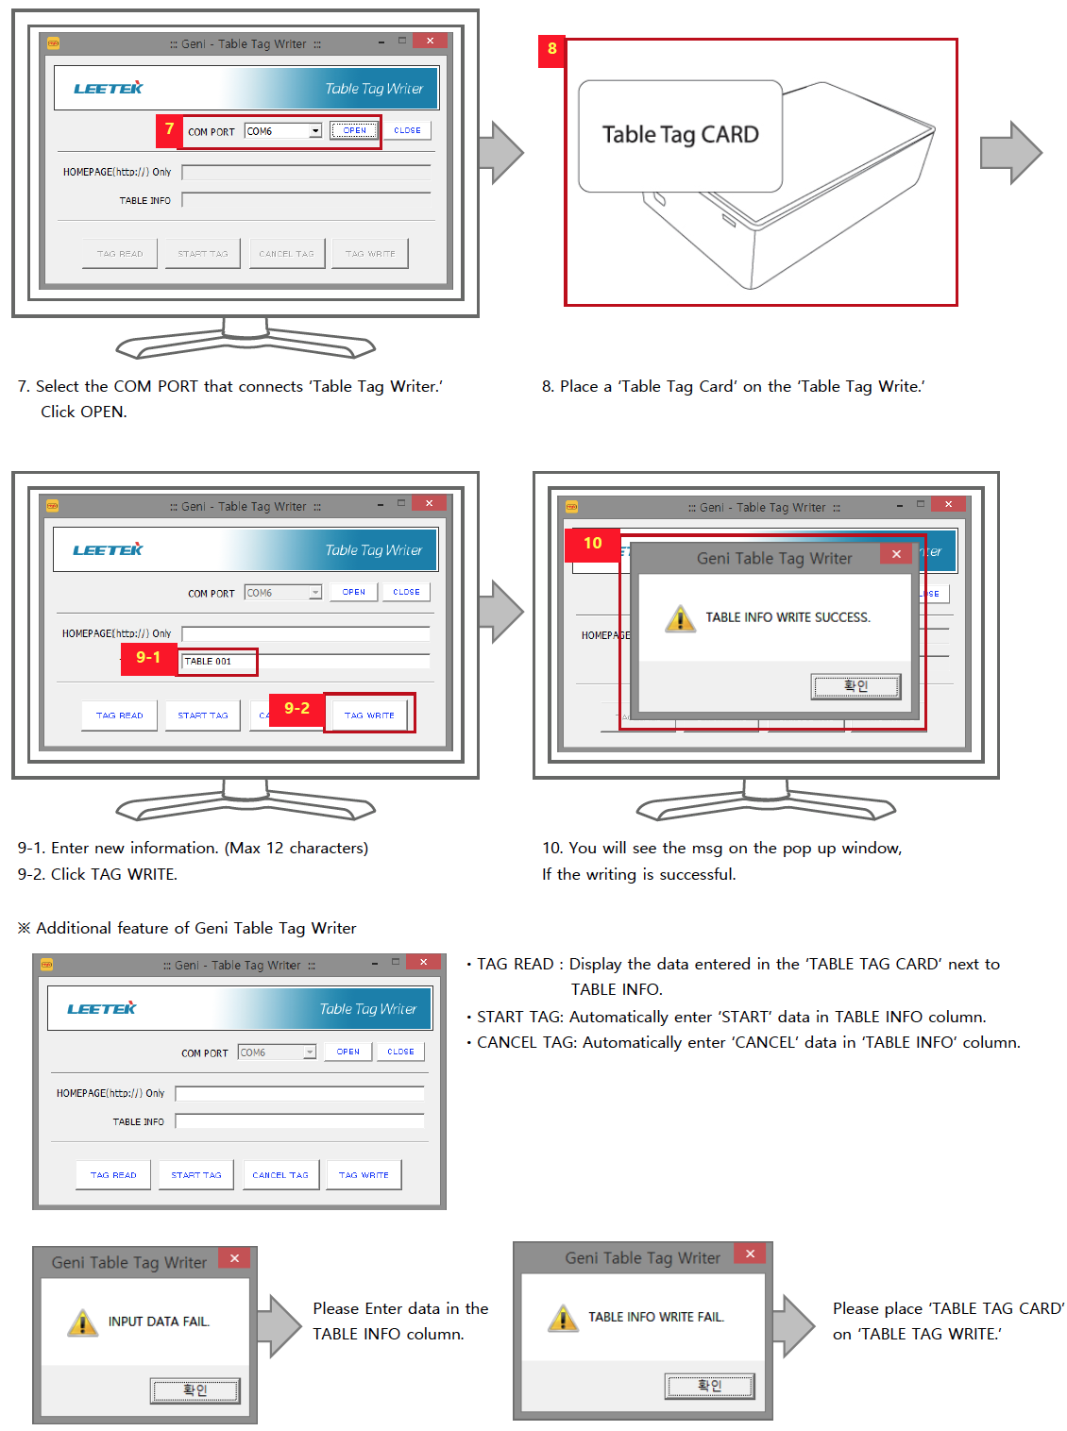
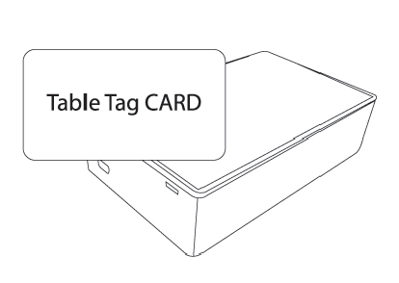
Test Mode
To Test If Gateway and Guest Locators Are Connected Within an Allowable Distance
- Using “Table Tag Write” (refer to the previous Table Tag Writer section), write ‘TEST’ on Table Tag.
- Place the Guest locator on the Table Tag Card (Written: TEST).
- EasyVu Client displays ‘TEST.’ The Guest locator FND also reads ‘TEST.’
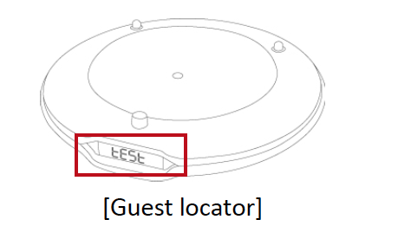
- If the Guest locator and Gateway are connected, the word ‘TEST’ on the FND of the Guest locator disappears.
- If communication with the Gateway fails, the Guest Locator FND will keep showing ‘TEST.’
- If communication is successful and the Guest locator FND stops showing ‘TEST,’ the test can be repeated for other Guest locators.

Multiple Gateways — Component Installation
Additional Components
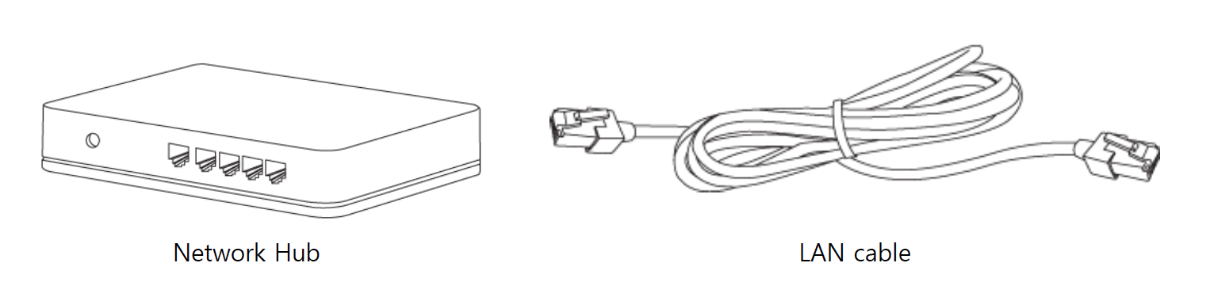
- In a multiple Gateway system, Gateways are connected to PC by the Hub, and the USB Port connection used in the single Gateway system is not necessary.

How to install
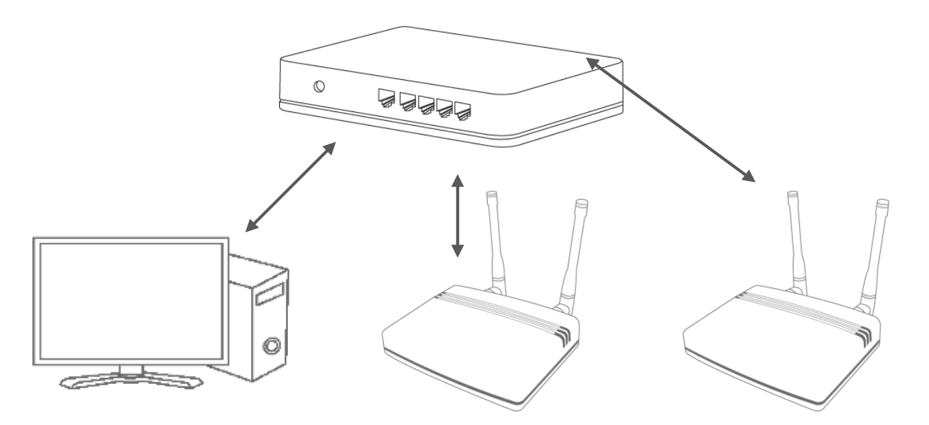
- Connect the Network Hub to a power outlet.
- Connect the PC internet LAN cable to the Hub.
- Connect Hub and Gateway1 with a LAN cable.
- Connect Hub and Gateway2 with a LAN cable.
- Connect Hub and PC with a LAN cable.

Multiple Gateways — WizVSP Installation — 1
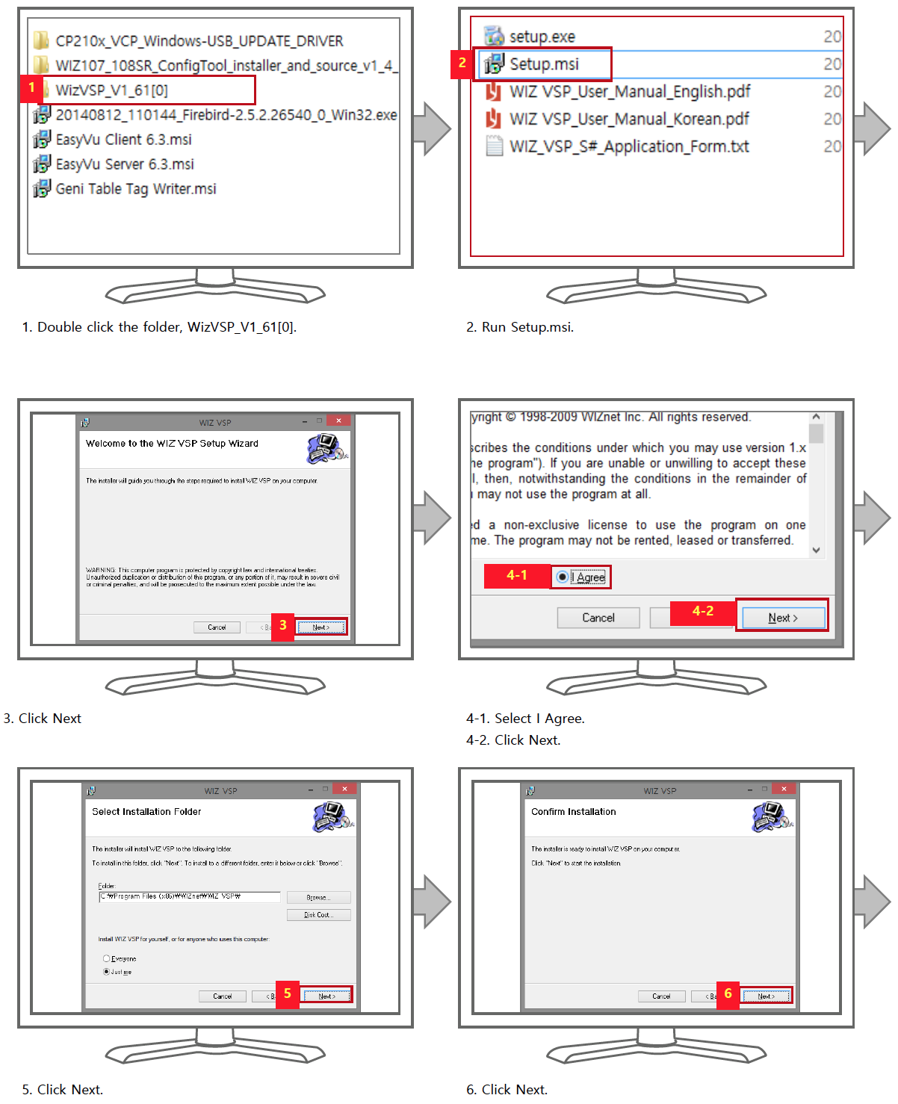

Multiple Gateways — WizVSP Installation — 2
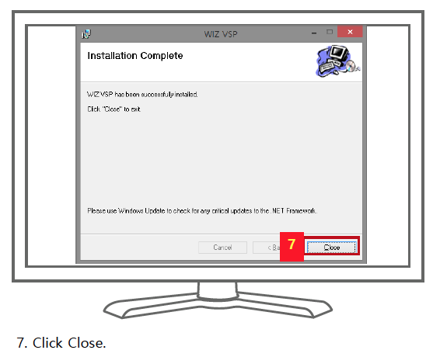

Multiple Gateways — ConfigTool — Installation
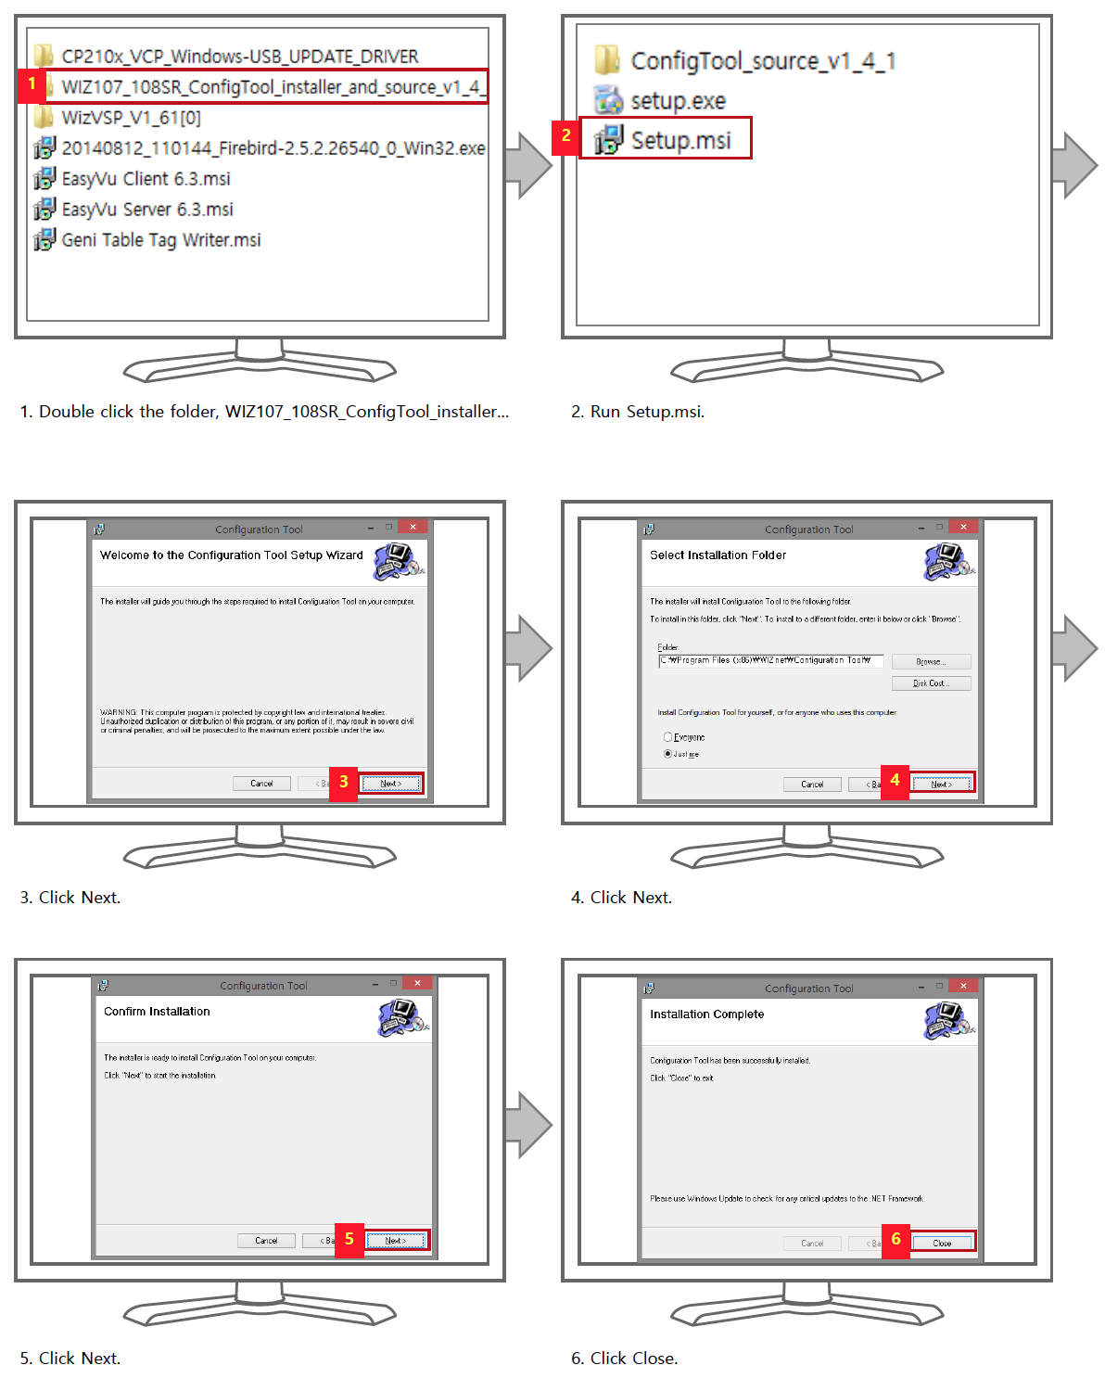
Multiple Gateways — ConfigTool & VSP — 1
Please refer to the final Network Connection Details section of this manual to obtain information for these settings.
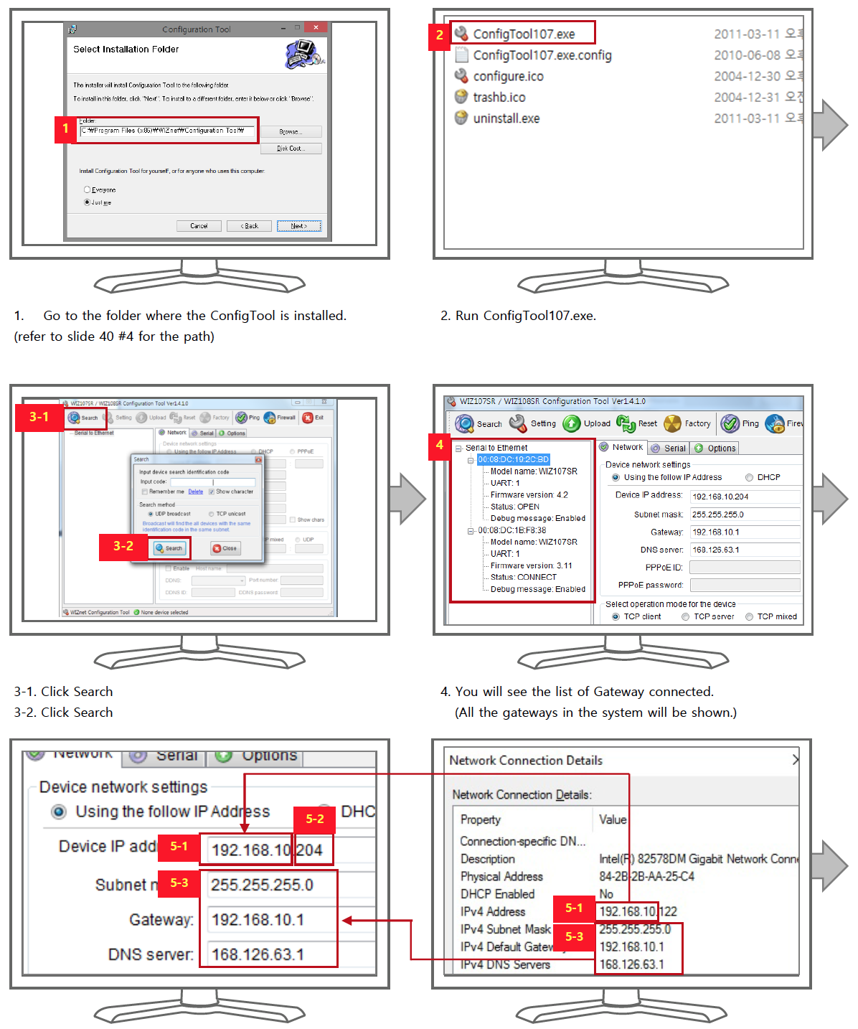
- 5-1: Enter first eight digits of ‘IPv4 Address’ shown in ‘Network Connection Details’ in the ‘Device IP address’ column.
- 5-2: Enter any 3 digits next to the 8 digits in 5-1 (the three digits must start with 2 – for example 2XX).
- 5-3: Enter ‘IPv4 Subnet Mask,’ ‘IPv4 Default Gateway,’ and ‘IPv4 DNS Servers’ shown in Network Connection Details in ‘Subnet mask,’ ‘Gateway,’ and ‘DNS server’ columns respectively.
Multiple Gateways — ConfigTool & VSP — 2
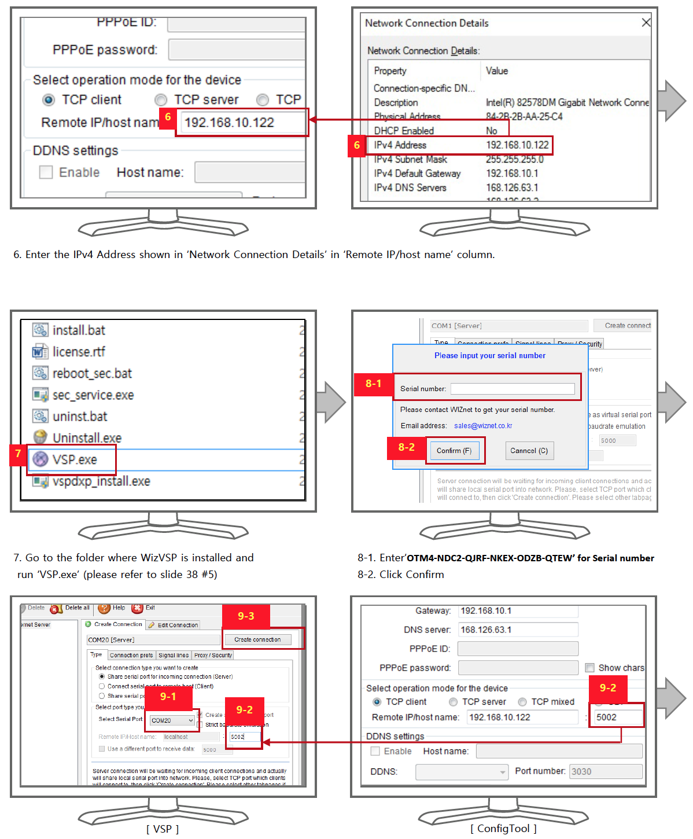
- 9-1: Select any number larger than 10 for ‘Select Serial Port.’
- 9-2: Set VSP and Remote IP/host name of ConfigTool be the same.
- 9-3: Click ‘Create Connection.’

Multiple Gateways — ConfigTool & VSP — 3
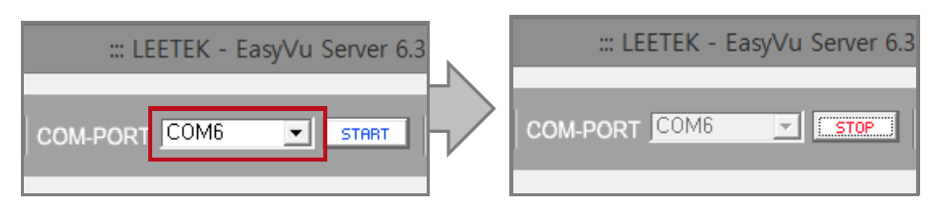
- Run EasyVu Server.
- Select the same COM-PORT for the Server as that of VSP.
- Click ‘START.’

Multiple Gateways — Network Connection Details
