GuestCall® Paging
w/Rugged Pagers

Model Number: J1703, J1704
User Manual Date: 8/23/2017
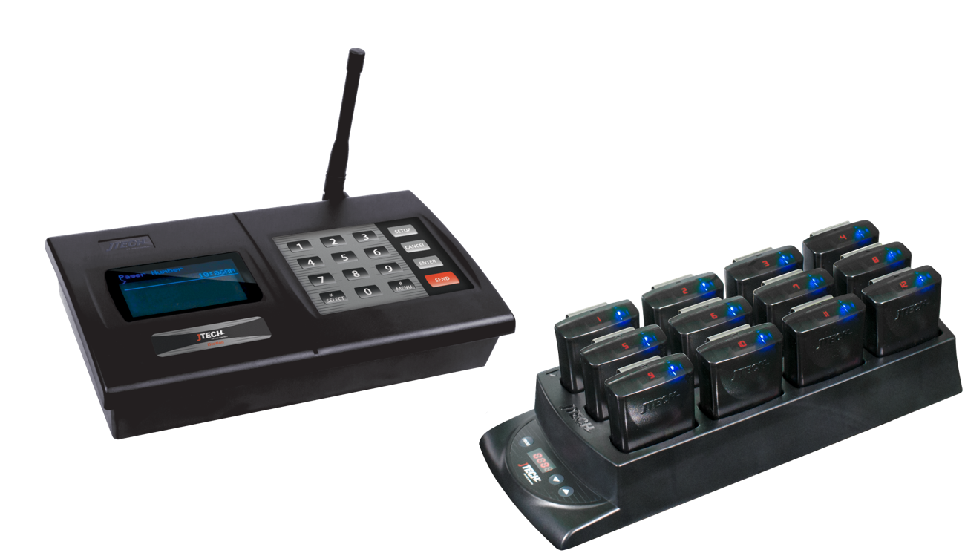

Components
Your GuestCall® paging system is comprised of three key elements:
- The JTECH Desktop Transmitter
  - Applies to models: IQ Base & ISTATION
- The Rugged Belt Pagers
- The Rugged Pager Charger

Quick Setup

- Lock the antenna to the connector on the transmitter by placing the antenna on the connector and twisting left to lock in place.
- Plug the power supply into the transmitter and then into a standard 110-240v outlet. A surge protector is recommended.
- Compile charger bases and plug charger power supply into charger and then into a standard outlet. Surge protection is recommended for charging bases.
- Add pagers to charger slots. You will see a BLUE light on each pager. This light indicates the charging status.
  - ‘LO’ on the number display: Battery is below 20% charged and SHOULD NOT currently be used.
  - Flashing BLUE: Pager is charging and CAN BE available for use.
  - Solid BLUE: Pager is fully charged.
  - Allow 4 hours for a complete charge of the pagers.

System Use

Distributing a Pager
- Remove a pager from the charger.
- The pager will flash and vibrate to preview what the alert will look like for the guest.
- Hand the pager to the guest, stating that the pager will go off with they have been paged.

Paging a Guest
- To page a guest, enter the 1 to 3-digit pager number into the transmitter and press SEND.
- The pager will alert until it is returned to the charger.

Setup is Complete
If you have any additional questions, please contact us at the addresses below.

System Configurations

System Default Configuration
The paging system was set to default settings listed below prior to shipment.
- Current time is set.
- Out of Range is set to OFF
- Audible (voice alert) is set to OFF

To enter programming mode, on the transmitter, press SETUP, use password 1379 and press ENTER.
Use the */MENU button to scroll and the # / SELECT button to choose the menu option.
Once you have saved your changes, press CANCEL until you return to the main PAGER # screen.

Set Current Time
- Scroll to SET CURRENT TIME.
- Set Hours, Press ENTER.
- Set Minutes, Press ENTER.
- Press SELECT for AM/PM.
- Press ENTER to save.
- Press CANCEL to exit.

Turn Pager Off
This system has an “ALL SLEEP” function that turns off all battery pagers (for example, manager pagers) at once automatically.
To turn this feature on:
- Scroll to the Turn Pager Off menu screen.
- Press the ENTER key to edit the time to turn the pager off.
- Set the hour then press ENTER key.
- Set the minutes and press ENTER key.
- Use the #/Select key to select AM or PM.
- After the correct time is set, press ENTER key.

Search Pagers
This feature causes ALL pagers (that are not on the charging rack) to signal at once. This feature is useful when you are closed and would like to locate any misplaced pagers around your restaurant. To search for missing pagers, scroll to the Search Pager? Menu and press the ENTER key. Transmitter will send signal to all pagers every 12 seconds. Any pager not in the charging rack will signal (beep or voice).

Default Number of Vibes (“Alert Time”)
This will allow you to change the number of cycles the pager will flash and vibrate.
- Scroll to DEFAULT # VIBES, press ENTER.
- Select the number of vibrations for that transmitter location, press ENTER to save.

Out of Range
With this feature, the pagers will signal (beep or voice) when taken out of range of the transmitter to inform the guest that they are too far away and will miss their page. The alert will automatically stop when they step back within range.
Turning the Out of Range On/Off
- Remove all pagers from the charging unit or unplug the power supply that is connected to the first charging rack.
- At the Out of Range menu, press the #/Select key to turn the out of range ON or OFF.
- Press the ENTER key.

Creating Pager Groups
This feature allows the user to create a group to combine 2 or more pagers. Once the group is created, user can page the pager using the group number. When a group page is sent, the Transmitter will page each pager sequentially.
The Transmitter can hold 20 different dynamic groups. Groups may have mixed pager types.
To Create a Pager Group
- Scroll to Add Pager to Group menu then press ENTER.
- Enter the Group Number followed by ENTER key.
- Enter the pager number you want to add to this group.
- Select the type of pager.
- To add more pagers to the same group, repeat procedures 1-4.
To Remove a Pager from a Group
- Scroll to Remove Pager to Group menu then press ENTER.
- Enter the Group Number followed by ENTER.
- Enter the Pager Number you want to remove from this group.
- Select the pager type.
- To remove more pagers from the same group, repeat procedures 1-4.

Range Test
Turning this feature on and walking around with your pagers will give you an idea of the range of your transmitter. Transmitter will send a signal to the pagers for this range test. Pagers will light up each time that the pagers receive the message from the transmitter.
When testing range, use 3 pagers to ensure that you have the most accurate reading. When you have reached a point where ALL 3 pagers do not receive 2 consecutive pages then you are out of range.
Performing Range Test
- Scroll to RANGE TEST.
- Press ENTER key. Transmitter will send page to all pagers every 10 seconds.

Smart Charger Re-Programming
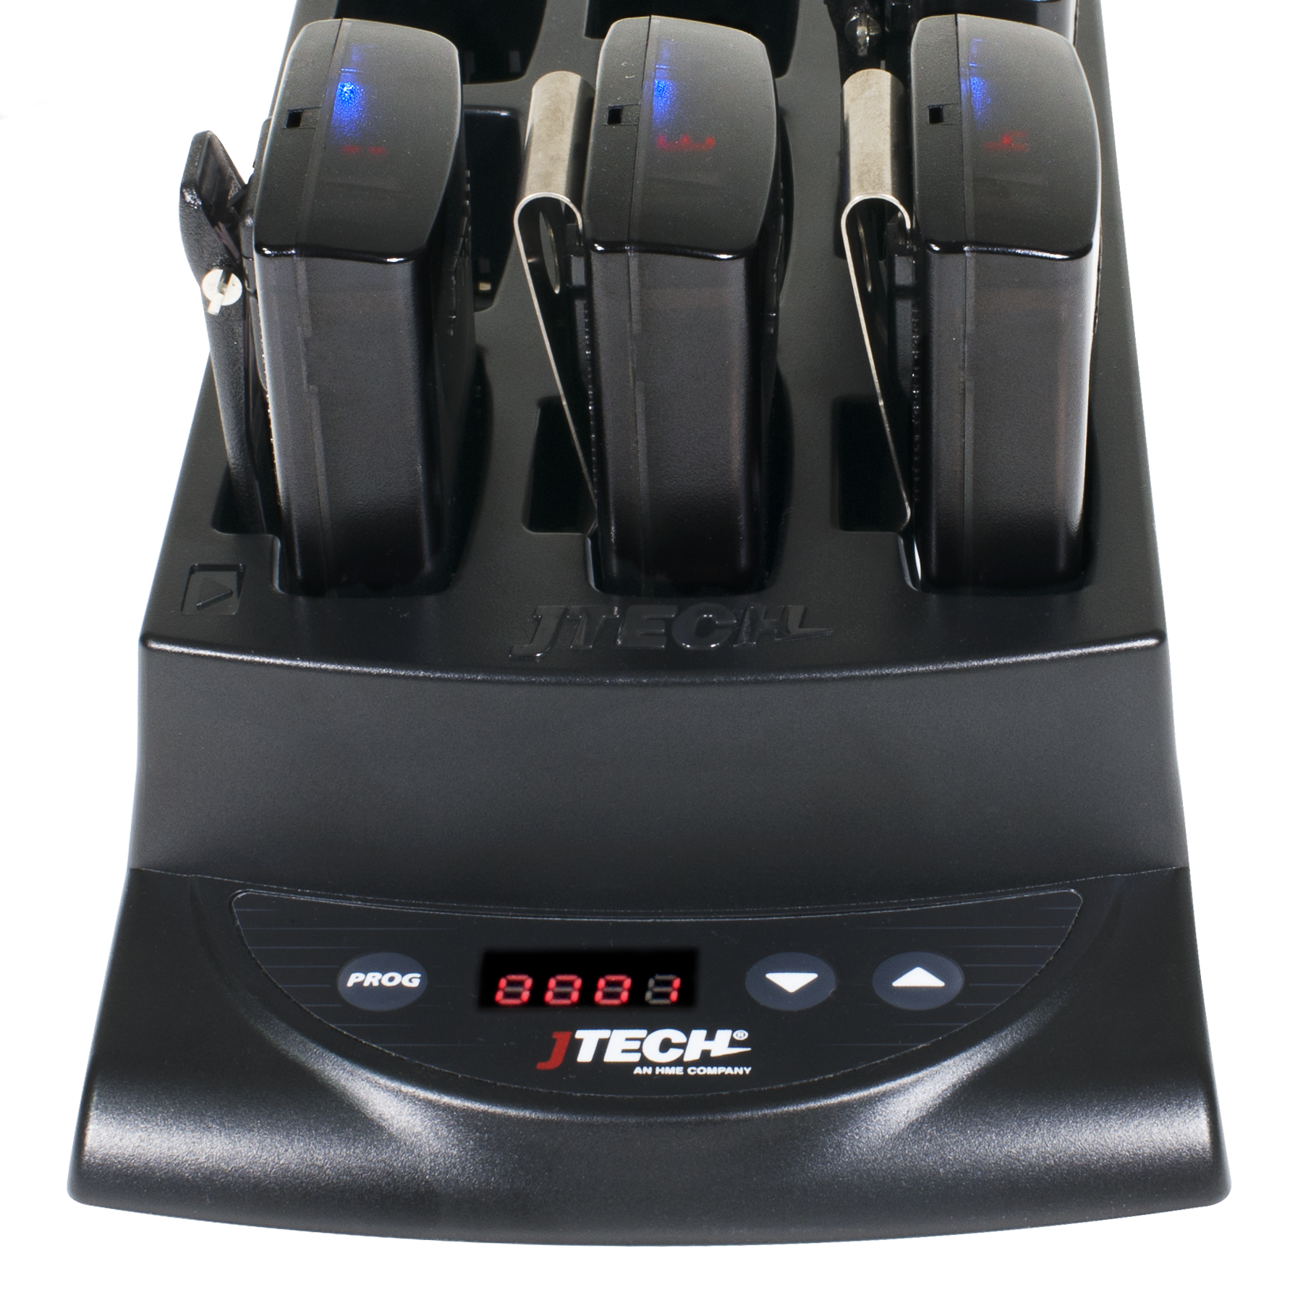
With the Smart Charger, you can renumber pagers back into sequential order as well as ensure that all pagers have the same configuration.

Program Pagers
The pagers will be set to the programming applied prior to shipping as well as renumbering the pagers into sequential order.
- First position, indicated by the location with the , will be renumbered to the number shown on the charger’s display
- Pagers will renumber based on their position in the charger, image at right.
- To activate the programming cycle.
  - PRESS and HOLD the PROG button on the charger for eight (8) seconds.
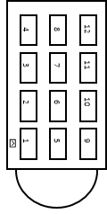
  - Charger will beep twice indicating that the cycle has begun.
  - You will see the pagers perform several functions as it applies each of the pager configurations. When the process is complete, all pagers will be in sequential order.
- NOTE: Replacements for lost pages will arrive with the number 888 on the display.

Replacement of Lost Pagers
Replacements for lost pagers will arrive with the number 8 8 8 on the display.
- Place new pagers into the charger in any location and use the PROG function listed above to have them work with your existing system.

Connecting with Host Concepts™ Waitlist Application
(Applies to ISTATION transmitter only)

Paging with Host Concepts™ Waitlist Application
Users of Host Concepts can page JTECH branded pagers directly within the application by adding an ISTATION connected transmitter to the Wi-Fi network that Host Concepts is connected to, such as a Guest Network in the restaurant.
To enter networking mode, on the transmitter, press SETUP, use password 6629 and press ENTER.
Use the */MENU button to scroll and the # / SELECT button to choose the menu option.
Once you have saved your changes, press CANCEL until you return to the main PAGER # screen.

Assign Static IP Address
- Scroll to the IP ADDRESS menu screen.
- Press the ENTER key to edit the field.
- Enter the IP ADDRESS desired using all 12 digits; i.e. 010.010.031.005
- Set the address then press ENTER key.
- Scroll to the SUBNET MASK menu and press ENTER key.
  - SUBNET MASK must match the address for the Wi-Fi router Host Concepts is connected to.
- Set the address then press ENTER key.
- Scroll to the GATEWAY IP menu and press ENTER key.
- Set the GATEWAY IP to match the address for the Wi-Fi router Host Concepts is connected to.
- Set the address then press ENTER key.
- Press CANCEL to Exit.

Assigning Pagers and IP Address in Host Concepts.
- Access your account via www.hostconcepts.com.
- Once you have logged in, select PAGERS from the menu on the left-hand side.
- Enter pagers in the fields. CommPass pagers would be entered as Numeric.
- Enter the IP Address assigned in the above steps under STATION IP ADDRESS.
  - Do not use leading 000’s as above; i.e. 10.10.31.5
  - Ensure that Local Paging Enabled is checked.
- Click SAVE SETTINGS

Frequently Asked Questions

The pagers flash and vibrate when first removed from the charger. Should this happen?
Each pager when removed from the charger will display one demonstration page.

I have lost some pagers; how do I replace them?
Online at http://www.jtech.com/support
Select the Pager Repair/Renumbering Form or contact us at wecare@jtech.com or via phone at 800.321.6221.

What is the expected battery life? Can I buy replacements?
JTECH batteries should last up to 2 years with proper use. Try charging the pager before considering replacement batteries. If after 4 hours the pager charging light still displays amber, contact JTECH to order replacement batteries.
You can also use the battery from a working pager to test a non-working pager. If the pager works with the second pager, replace the battery.

What is the process if I need to repair a pager?
- Obtain a repair form from the JTECH website, http://www.jtech.com/support
- Ship pagers needing repair with a copy of the form to the address listed below.
- Make sure your company information is on all correspondence including the outside of the shipping box.
- Ship in a traceable manner. Insure the package.
JTECH is not responsible for packages lost in transit. Please save the tracking number.
Shipping address:
JTECH, an HME Company
1400 Northbrook Parkway #320
Suwanee, GA 30024
ATTN: Repairs

FCC Licensing Information (Applies only to users in the United States)
JTECH paging systems operate on radio frequencies that are regulated by the Federal Communications Commission (FCC). In order to transmit on these frequencies, you are required to have a license issued by the FCC. Under current FCC policy, you may operate the equipment under JTECH, an HME Company, a/k/a HME Wireless’ FCC license described below:
Licensee: HME Wireless, Inc., d/b/a JTECH an HME Company
Call Sign: WQKJ800
Area of operation: United States nationwide, including Hawaii and Alaska, and United States Territories
Frequencies (MHz): 457.525, 457.550, 457.575, 457.600, 467.875, 467.900, 467.925
Control point: 1400 Northbrook Parkway, Suite 320, Suwanee, GA 30024
If you require a copy of the license, you can contact JTECH, an HME Company, or obtain one from the FCC web site (www.fcc.gov). You may, however, want to apply for your own FCC license. Whether you use JTECH, an HME Company’s, FCC license or obtain your own, you are responsible for complying with the FCC rules and requirements applicable to the JTECH paging system, particularly those that deal with private land mobile radio services. See 47 CFR Part 90.
Changes or modifications not expressly approved by JTECH, an HME Company, may void the user’s authority granted by the FCC to operate this radio and should not be made. To comply with FCC requirements, transmitter adjustments should be made only by or under the supervision of a person certified as technically qualified to perform transmitter maintenance and repairs in the private land mobile and fixed services as certified by an organization representative of the user of those services. Replacement of any transmitter component (crystal, semiconductor, etc.) not authorized by the FCC equipment authorization for this radio could violate FCC rules.
International Licensing Information
(Applies only to users outside of the United States)
JTECH paging and radio systems operate on radio frequencies that are regulated by international treaties. In order to transmit on these frequencies, you are required to have a license issued by the licensing authority in the country of operation. To obtain information on licensing, you should contact the relevant licensing authority in the country in which you are operating.
Note: Use of these products outside the country where it was intended to be distributed is subject to local government regulations and may be prohibited.

Radio Compliance (Applies only to users in the United States)
THESE DEVICES COMPLY WITH PARTS 90 AND 15 OF THE FCC RULES, AS APPLICABLE. OPERATION IS SUBJECT TO THE CONDITION THAT THE DEVICES DO NOT CAUSE HARMFUL INTERFERENCE. MODIFICATION OR CHANGES NOT EXPRESSLY APPROVED BY THE MANUFACTURER COULD VOID THE USER’S AUTHORITY TO OPERATE THE EQUIPMENT.
IMPORTANT NOTE: To maintain compliance with Radio Frequency exposure guidelines, the transmitter and antenna must be at least 8 inches (20 centimeters) from any person.
Your radio generates radio frequency electromagnetic energy during transmission mode. The radio is designed for and classified as “General Population” and may be used in any location as long as the separation distance listed above is maintained.
To ensure that your exposure to radio frequency electromagnetic energy is with the FCC allowable limits for occupational use, always follow these guidelines. Use ONLY authorized accessories with the equipment. Use of unauthorized accessories can cause the FCC Radio Frequency Exposure compliance requirements to be exceeded.

