April Members of the Month
Our April Members of the Month are power partners Caitlin Keane and Kyle Hurstik. These two have been members of our Nook climbing community for several years. They are extremely dedicated to their craft and rarely miss one of their weeknight training sessions here at the Nook. Their dedication, drive, and passion for climbing is contagious and we thank them for inspiring our community to keep on crushing!
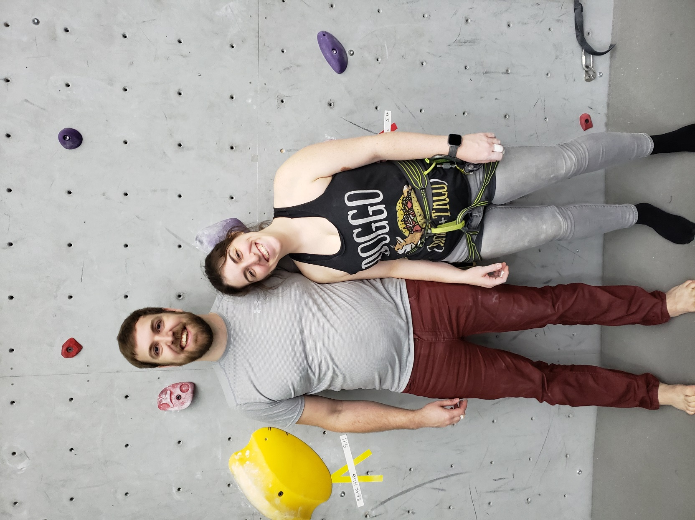
Caitlin Keane
Years you've been climbing?
I started rock climbing in May of 2012, so almost 8yrs with some breaks due to injuries, or overbooking my time.
Who introduced you to climbing?
My friend Karen, she wanted to do it his program called Women who Rock but didn't want to go alone. I thought it would be a good opportunity to overcome my fear of heights.
Where were you introduced to climbing?
Drexel University
Best thing about climbing compared to other sports?
I get more confidence, I like the community better, and it's just more fun to me, even when I'm struggling or failing.
Do you play any other sports?
I run in some races but not competitively, otherwise non-sport exercise activities are what I do besides climbing (yoga, Pilates, hiking, swimming and paddle board in the summer.)
Places you've been climbing, Indoor and outdoor?
Indoor- Drexel's Dragon Gym, Philly Rock Gym Coatsville Pa, Vertical Limit/Downingtown Rock Gym in Downingtown Pa, Climbnasium Mechanicsburg Pa, Earth Treks Md, Spooky Nook, Central Rock Gym CT, Vertical Endeavors Il, I know I'm forgetting some, but I don't remember where.
Outdoor- Safe Harbor, Governor Stables, the Gunk's, Red River Gorge, Smith Rock, Red Rock Canyon
Favorite Climb?
This is hard, I liked Brown Eyed girl and Plate tectonics because they were my first 10leads outside, but I really liked this 10c in Kentucky that requires a whale flop onto a platform at the beginning.
Favorite style of climbing?
Sport is my favorite though I hope to dabble in Trad and Aid climbing someday.
Why you've chosen spooky nook as your gym?
They have great leading even if I'm a chicken on some of the routes lol! The routes are challenging but fun which is good and Spooky is way easier to get to.

Favorite part about Spooky Nook?
The leading, especially the nine that's set near the arch. I know I wimp out but when I get in them I usually feel good even if I fall and scream and flail.
Best climbing trip memory?
My Red River Gorge first outdoor 5.10 lead was very exciting, and I was very proud about that. Then hot tubbing back at the cabin. Otherwise I enjoyed the Trad route we climbed in Red Rock Canyon, where we found out halfway up the second rope was 10 meters too short lol. It was thrilling but fun.
Best accomplishment?
I think where I am at with Lead climbing is my best accomplishment now. I can fly up easy routes outside now with almost no fear.
Best whipper story?
I don't have many good ones. Most were in the gym where I fall and flail my legs and scream and scare everyone around me. I need to fall more lol.
Future trips?
Hopefully we make it back out to Red River gorge this year, a trip to Yosemite would be amazing, Colorado basically anywhere is farther down the line. This spring and summer will include plenty of trips to the Gunk's and Safe Harbor, and maybe some New River Gorge. Maybe Europe climbing trips sometime and getting in a climbing trip to Malta would be nice!
Dream Trip?
Going to Yosemite and being a good enough climber for big wall climbing is definitely a dream of mine.

Kyle Hurstik
Years you've been climbing?
12 years of climbing regularly
Who introduced you to climbing?
Gym teacher; my high school had a climbing wall which was used as part of PE.
Where were you introduced to climbing?
High school gym class
Best thing about climbing compared to other sports?
Its more about camaraderie and challenging yourself
Do you play any other sports?
Cycling
Places you've been climbing, Indoor and outdoor?
Indoor - Stone Summit, Atlanta Rocks, Earth Treks (Baltimore, Timonium, Golden CO), Vertical Endeavors Illinois, Momentum Denver
Outdoor - Safe Harbor, Birdsboro, Seneca, New River Gorge, Gunks, Rumney, Red River Gorge, Linville Gorge, Foster Falls, T-wall, Devils Lake, Red Rocks, Yosemite, Wind River, Tetons, Smith Rock, Squamish, Bugaboos, Banff, Big/Little Cottonwood
Favorite Climb?
North West Ridge on Pigeon Spire in the Bugaboos
Favorite style of climbing?
Sport
Why you've chosen spooky nook as your gym?
I used to climb at Climbnasium but I wanted a gym that put more emphasis on rope climbing and had lead climbing options.
Favorite part about Spooky Nook
The climbers. There's always someone I know there and always meeting new people.
Best climbing trip memory?
Hanging out at Miguel's on a very cold but very busy weekend with strangers, friends and people we met at the crag the past few days all jammed into the original attached pavilion. Everyone getting full on pizza and passing around a box of Franzia while cheering on the staff bringing out food and people challenging them into pull-up contests.

Best accomplishment?
I'd been eyeing up Amarillo Sunset at the Red River gorge for years. Finally, I got on it one trip and fought my way up it and clipped the chains. I was the only person in my group that go up the route. I'd climbed other 11b's before but that one meant the most to me, it’s such a striking line.
Best whipper story?
At Birdsboro I was struggling up a route. Got to the last bolt but was too pumped to get the clip. When I came off I pulled up my belayer making for an extra-long whip. With rope stretch I ended up about one foot off the ground.
Future trips?
Gunks, Back to Red Rocks in the Fall
Dream Trip?
Ama Dablam

