clare controls 7519 Pennsylvania Ave, Sarasota, FL 34293
Clare approved lifestyle images
Builder Stock Images
Clare has identified these lifestyle images as fitting for any builder to use on their website, email content, documentation and more. All images can be purchased from: https://www.istockphoto.com/

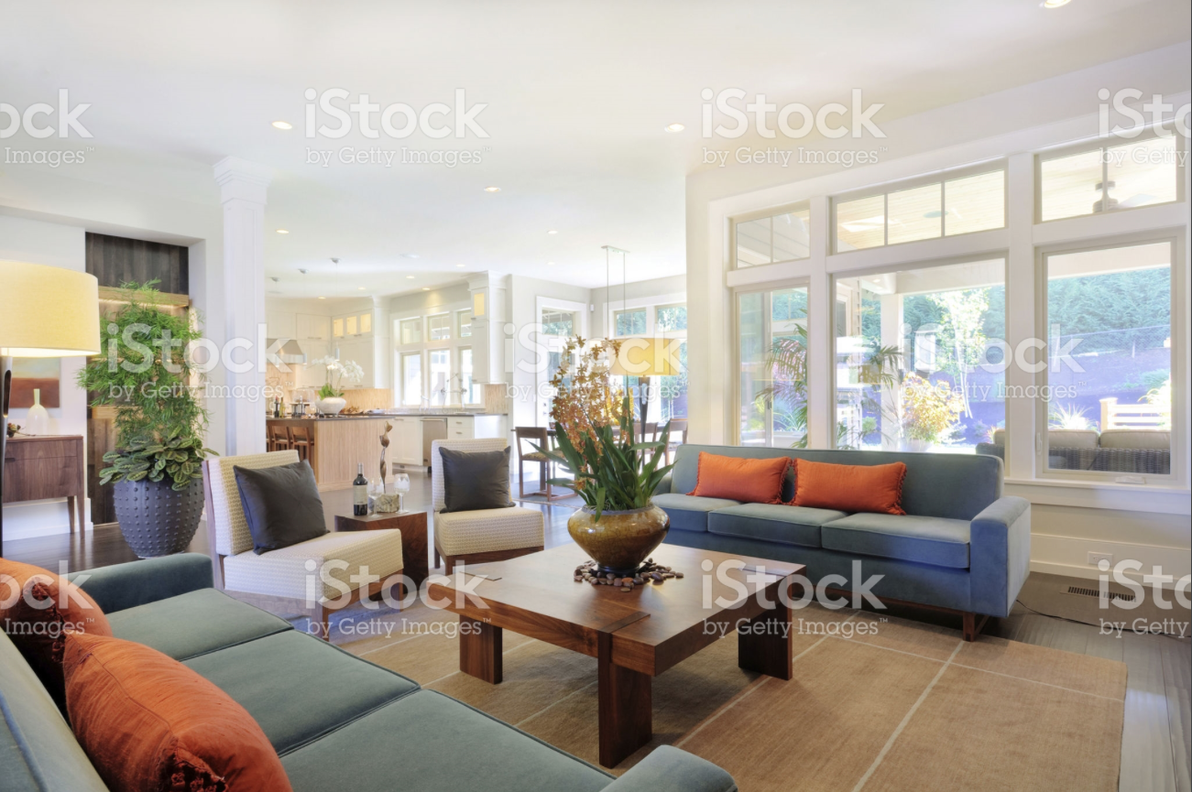

https://www.istockphoto.com/photo/furnished-living-room-in-luxury-home-gm186627551-28524846
Price: $12
File Type: .png
Largest size: 4365 x 2909 px (14.55 x 9.70 in.) - 300 dpi - RGB
Stock Photo ID: 186627551

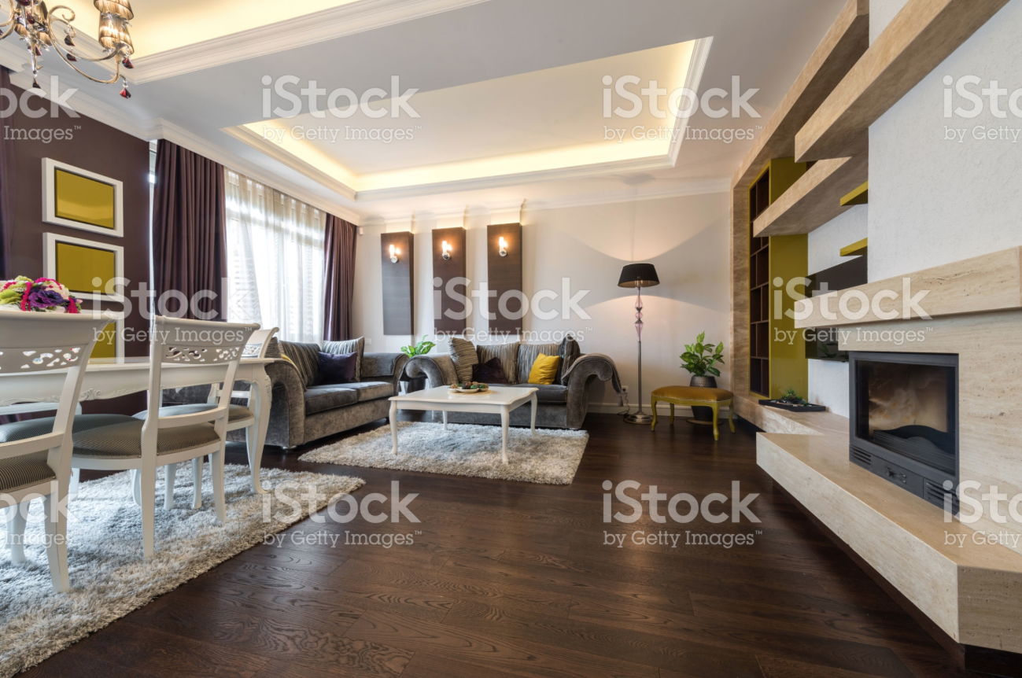

https://www.istockphoto.com/photo/interior-of-a-bright-living-room-gm505292234-83607151
Price: $12
File Type: .png
Largest size: 7360 x 4912 px (24.53 x 16.37 in.) - 300 dpi – RGB
Stock Photo ID: 505292234

https://www.istockphoto.com/photo/businessman-using-mobile-phone-at-train-station-gm515473470-88536667
Price: $33
File Type: .png
Largest size: 8660 x 5773 px (28.87 x 19.24 in.) - 300 dpi - RGB
Stock Photo ID: 515473470

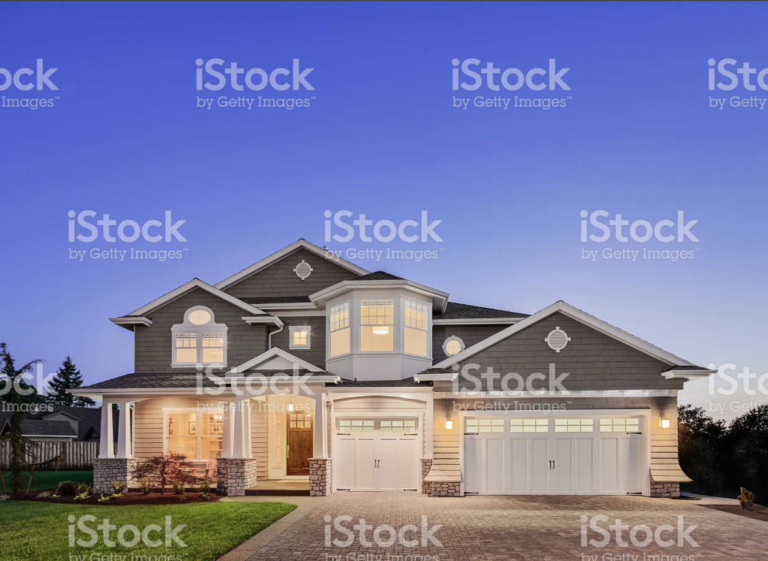

https://www.istockphoto.com/photo/beautiful-exterior-of-new-luxury-home-at-twilight-gm524085051-51489268
Price: $12
File Type: .png
Largest size: 3510 x 2553 px (11.70 x 8.51 in.) - 300 dpi - RGB
Stock Photo ID: 524085051

https://www.istockphoto.com/photo/family-in-hallway-returning-home-together-gm613765326-106005957
Price: $12
File Type: .png
Largest size: 5078 x 3385 px (16.93 x 11.28 in.) - 300 dpi - RGB
Stock Photo ID: 613765326

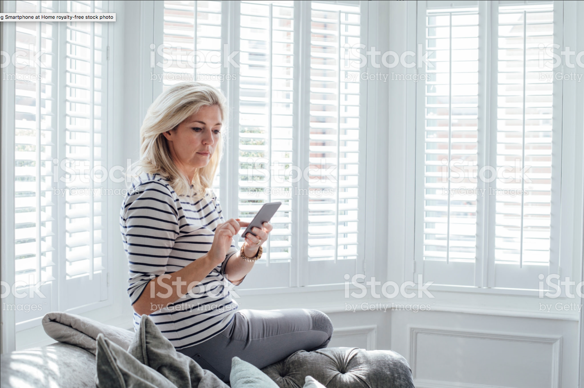
https://www.istockphoto.com/photo/using-smartphone-at-home-gm621601318-108606199
Price: $12
File Type: .png
Largest size: 5170 x 3447 px (17.23 x 11.49 in.) - 300 dpi - RGB
Stock Photo ID: 621601318

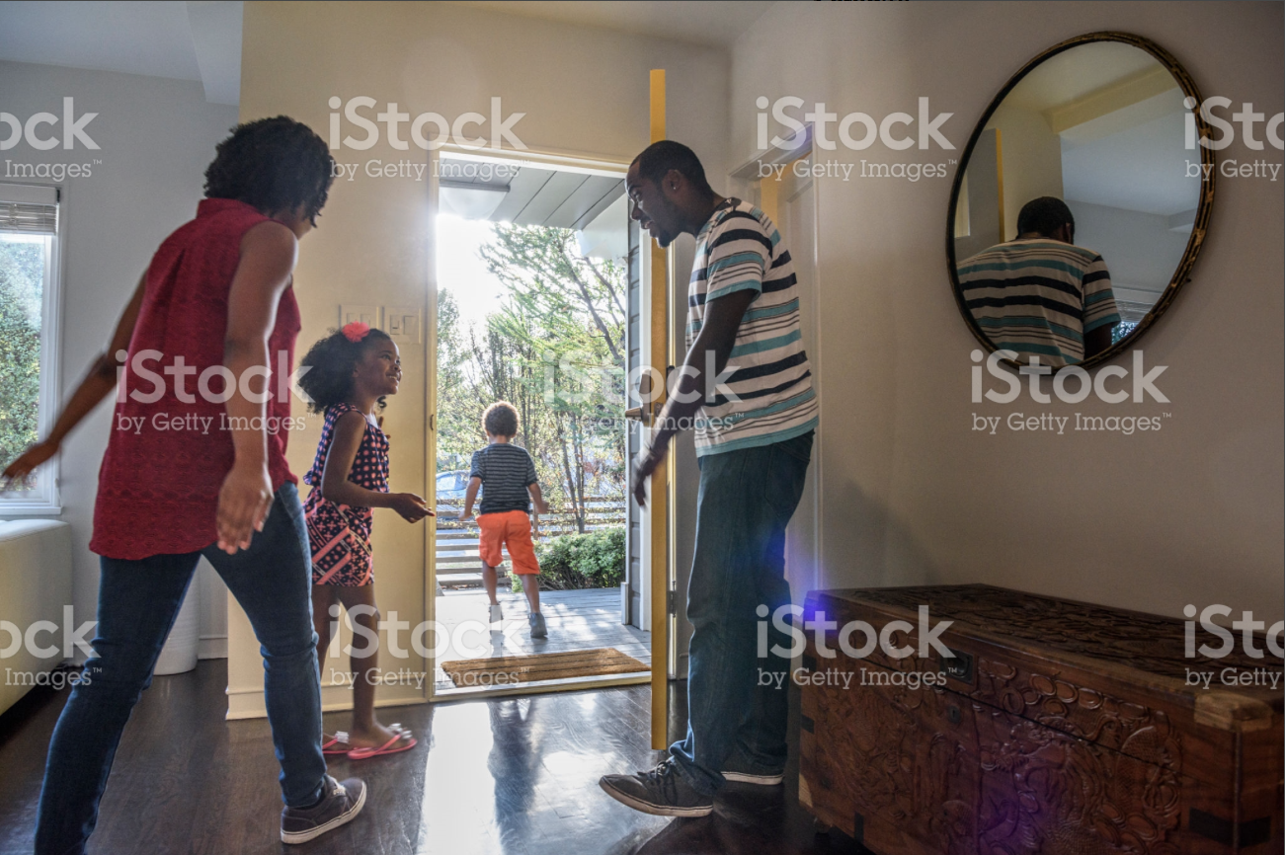
https://www.istockphoto.com/photo/african-american-family-leaving-the-house-father-holding-door-gm623700794-109474645
Price: $33
File Type: .png
Largest size: 7319 x 4885 px (24.40 x 16.28 in.) - 300 dpi - RGB
Stock Photo ID: 623700794

https://www.istockphoto.com/photo/mother-in-bed-with-baby-daughter-checking-mobile-phone-gm628527474-111610423
Price: $12
File Type: .png
Largest size: 6000 x 4000 px (20.00 x 13.33 in.) - 300 dpi - RGB
Stock Photo ID: 628527474

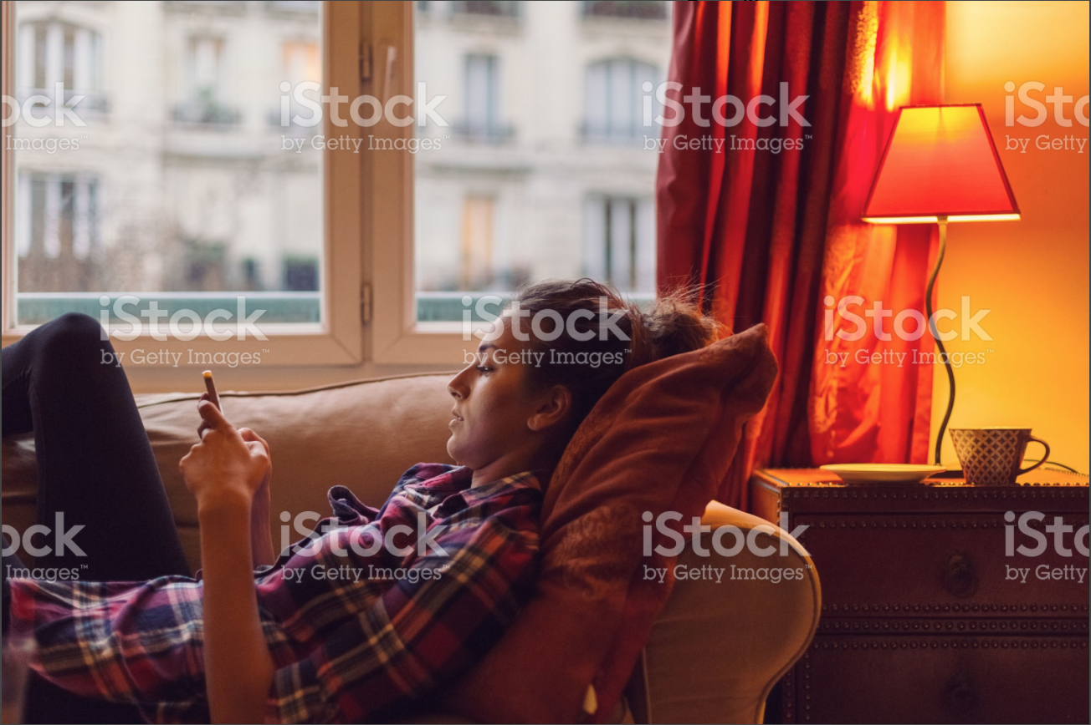
https://www.istockphoto.com/photo/young-woman-spending-the-weekend-at-home-gm638678292-114656757
Price: $33
File Type: .png
Largest size: 5549 x 3699 px (18.50 x 12.33 in.) - 300 dpi - RGB
Stock Photo ID: 638678292

https://www.istockphoto.com/photo/couple-on-the-sofa-in-the-morning-gm644682320-117162435
Price: $33
File Type: .png
Largest size: 4933 x 3283 px (16.44 x 10.94 in.) - 300 dpi - RGB
Stock Photo ID: 644682320

https://www.istockphoto.com/photo/he-could-teach-mom-a-few-moves-gm646474526-119323721
Price: $33
File Type: .png
Largest size: 4938 x 3292 px (16.46 x 10.97 in.) - 300 dpi - RGB
Stock Photo ID: 646474526

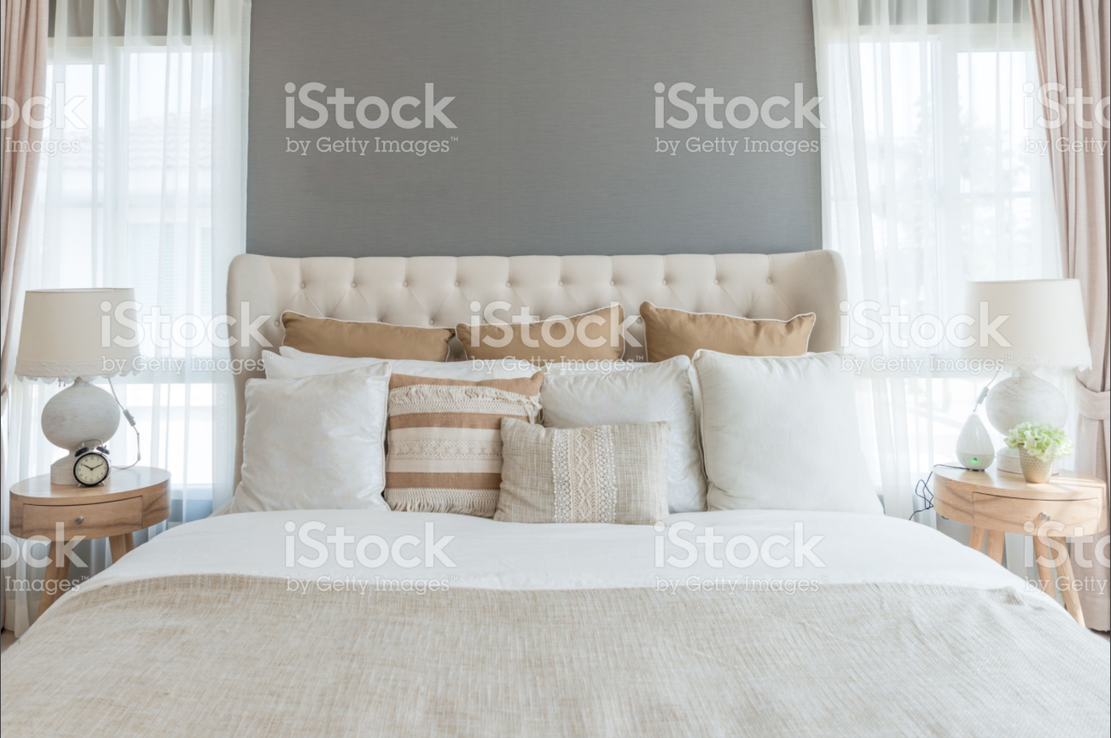
https://www.istockphoto.com/photo/bedroom-in-soft-light-colors-big-comfortable-double-bed-in-elegant-classic-bedroom-at-gm657513812-120023051
Price: $12
File Type: .png
Largest size: 6100 x 4067 px (20.33 x 13.56 in.) - 300 dpi - RGB
Stock Photo ID: 657513812

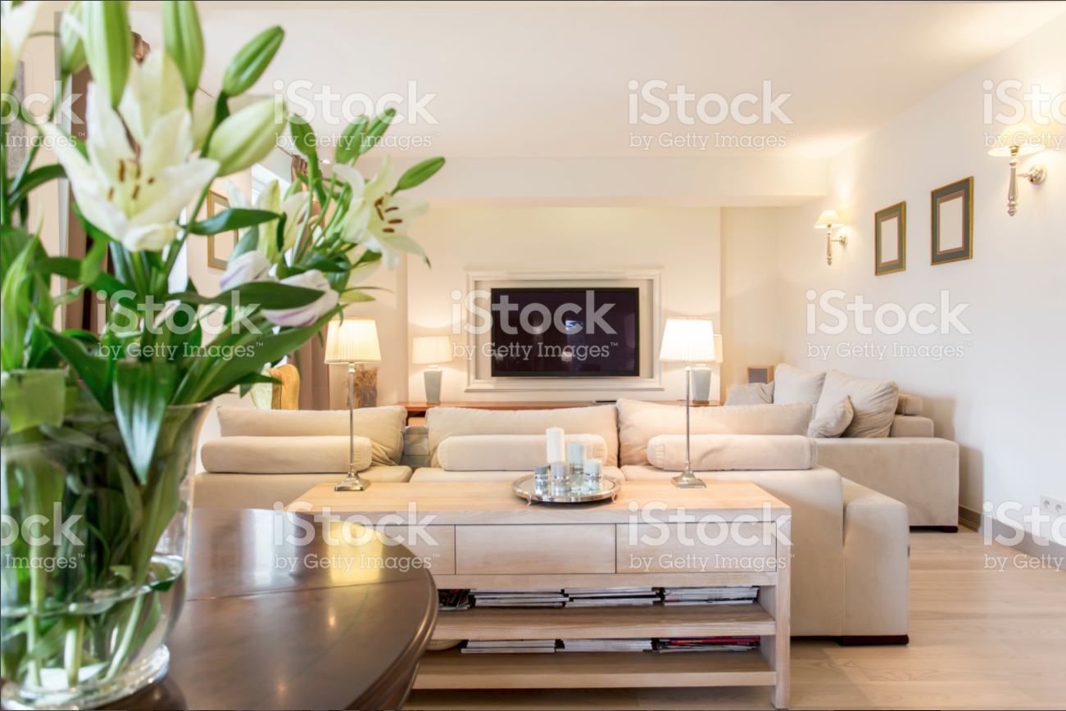
https://www.istockphoto.com/photo/comfortable-living-room-interior-gm665037962-121109585
Price: $12
File Type: .png
Largest size: 5760 x 3840 px (19.20 x 12.80 in.) - 300 dpi - RGB
Stock Photo ID: 665037962

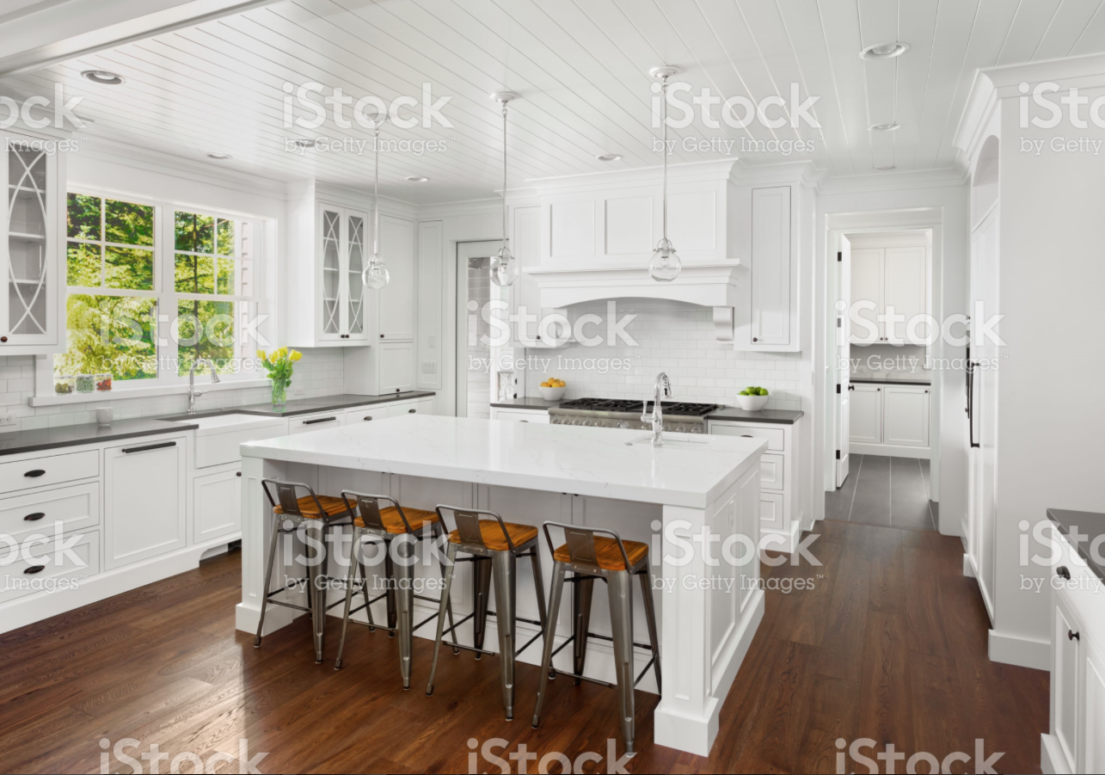
https://www.istockphoto.com/photo/beautiful-white-kitchen-in-new-luxury-home-with-island-pendant-lights-and-hardwood-gm680737956-124766081
Price: $12
File Type: .png
Largest size: 4000 x 2800 px (13.33 x 9.33 in.) - 300 dpi - RGB
Stock Photo ID: 680737956

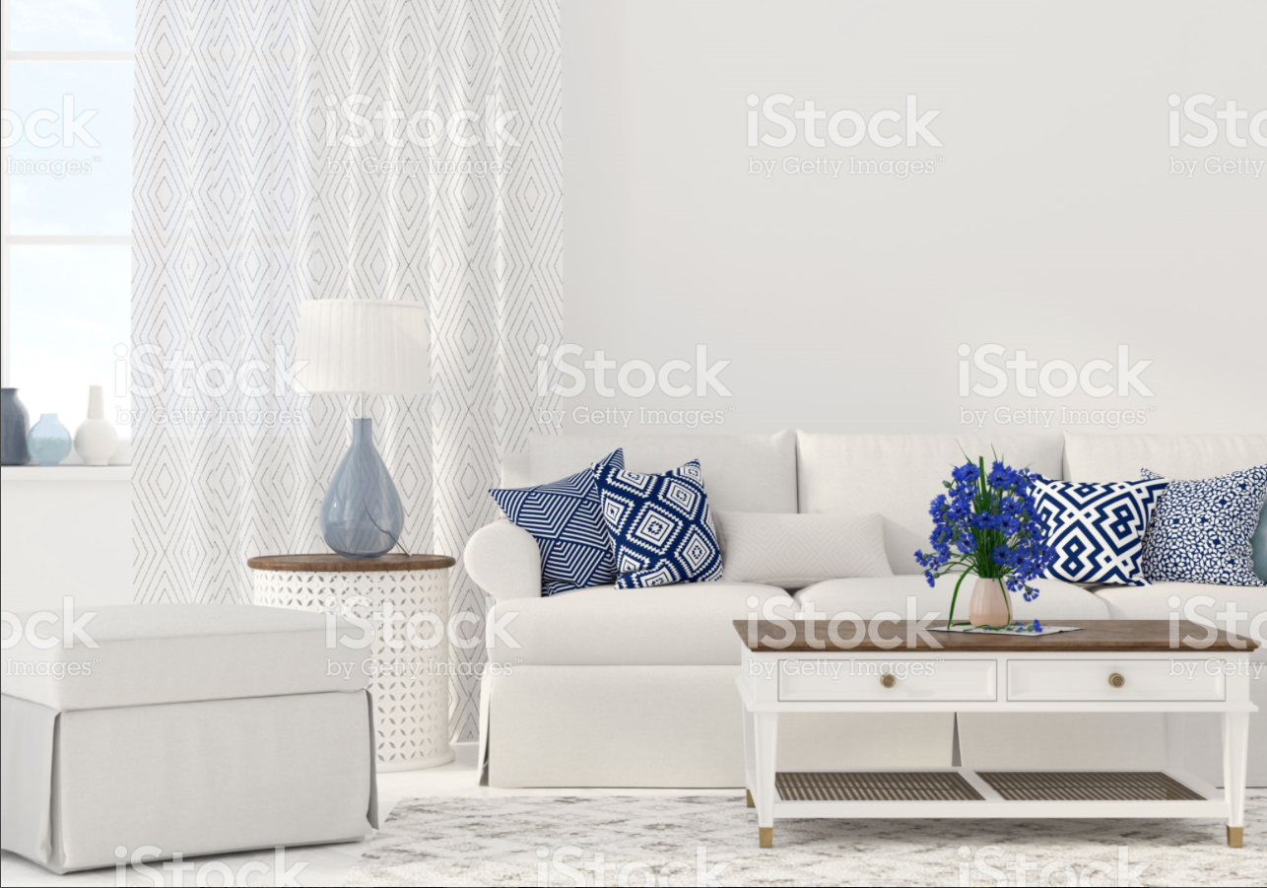
https://www.istockphoto.com/photo/interior-of-the-living-room-gm689015816-126797853
Price: $12
File Type: .png
Largest size: 5000 x 3500 px (16.67 x 11.67 in.) - 300 dpi - RGB
Stock Photo ID: 689015816

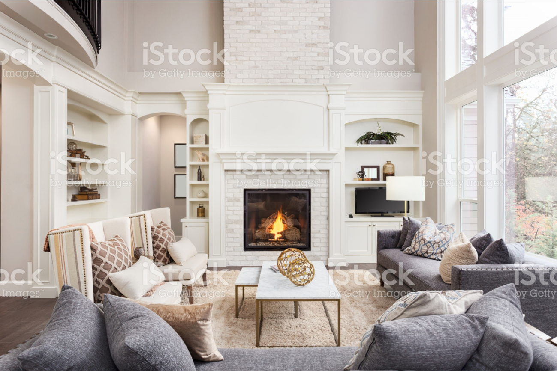
https://www.istockphoto.com/photo/beautiful-living-room-interior-with-tall-vaulted-ceiling-loft-area-hardwood-floors-gm692601408-127818709
Price: $12
File Type: .png
Largest size: 4000 x 2667 px (13.33 x 8.89 in.) - 300 dpi - RGB
Stock Photo ID: 692601408

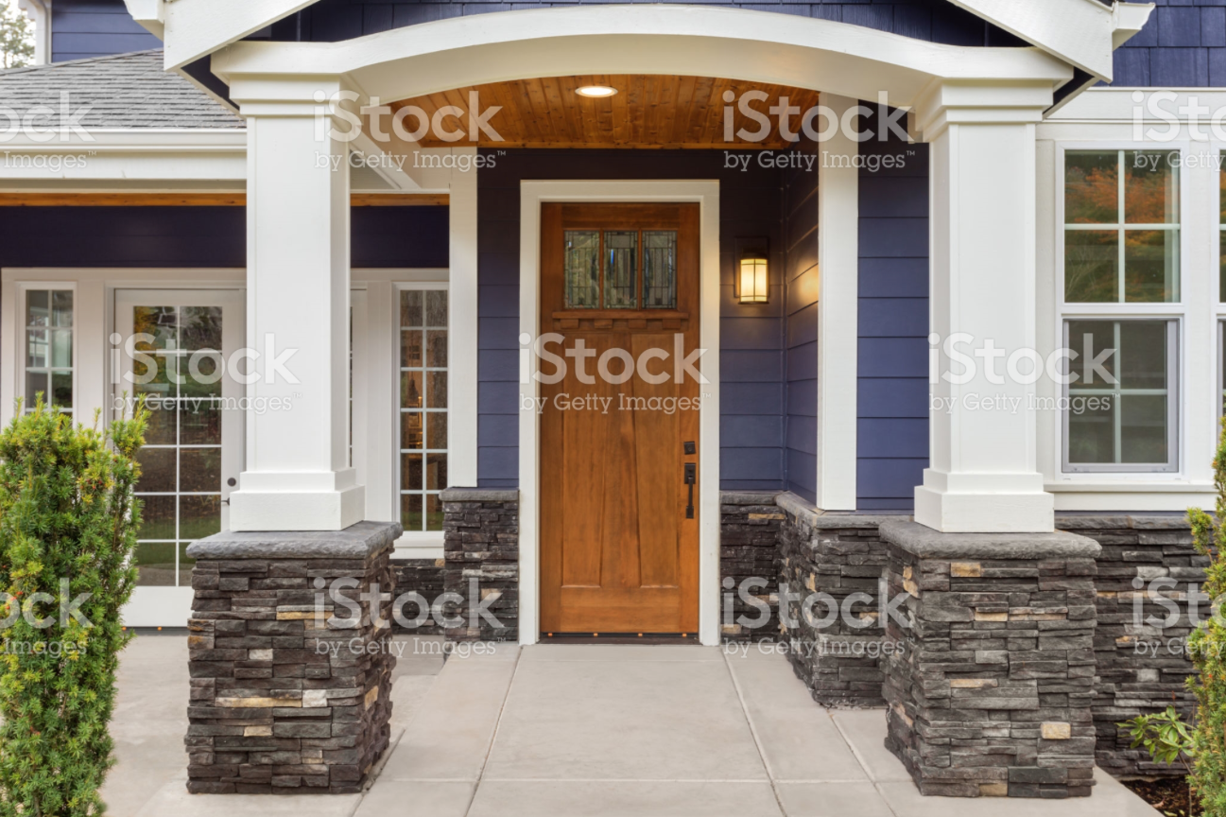
https://www.istockphoto.com/photo/new-luxury-home-exterior-detail-patio-and-front-door-with-arch-and-columns-stonework-gm694552056-128365375
Price: $12
File Type: .png
Largest size: 4000 x 2667 px (13.33 x 8.89 in.) - 300 dpi - RGB
Stock Photo ID: 694552056

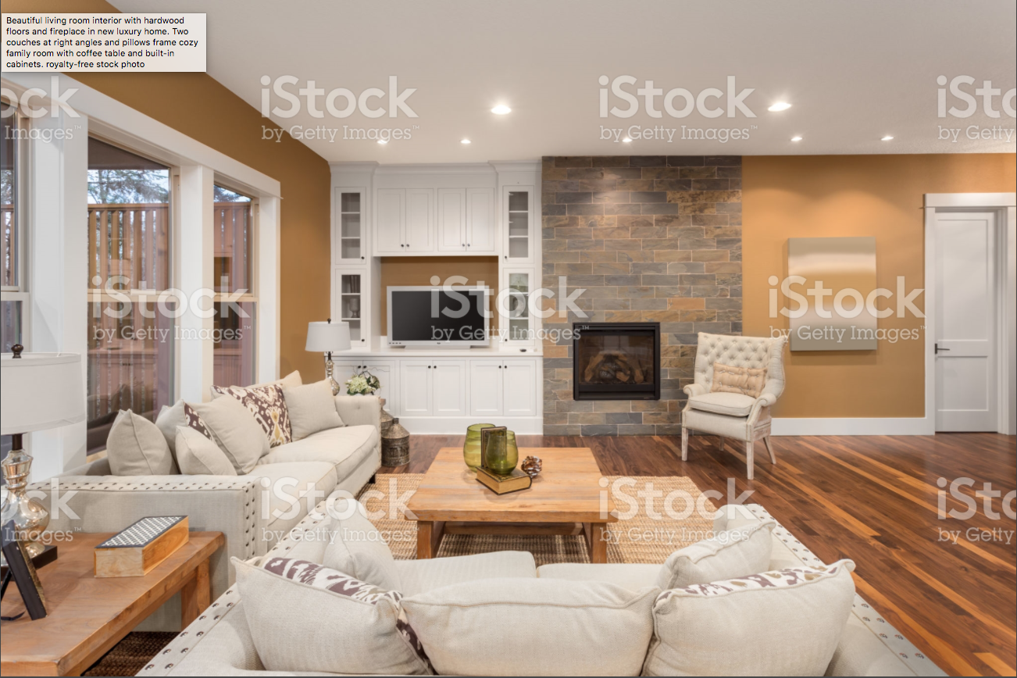
https://www.istockphoto.com/photo/beautiful-living-room-interior-with-hardwood-floors-and-fireplace-in-new-luxury-home-gm697393256-129176633
Price: $12
File Type: .png
Largest size: 4000 x 2667 px (13.33 x 8.89 in.) - 300 dpi - RGB
Stock Photo ID: 697393256

https://www.istockphoto.com/photo/home-is-the-only-place-i-want-to-be-gm697888448-129304811
Price: $33
File Type: .png
Largest size: 5160 x 3150 px (17.20 x 10.50 in.) - 300 dpi - RGB
Stock Photo ID: 697888448

https://www.istockphoto.com/photo/happy-woman-travelling-and-walking-in-airport-gm888767716-246489727
Price: $12
File Type: .png
Largest size: 6410 x 4273 px (21.37 x 14.24 in.) - 300 dpi - RGB
Stock Photo ID: 888767716

