3 To 11 Devonshire Square And Parts Of East India House, 109 To 117 Odd Mid...

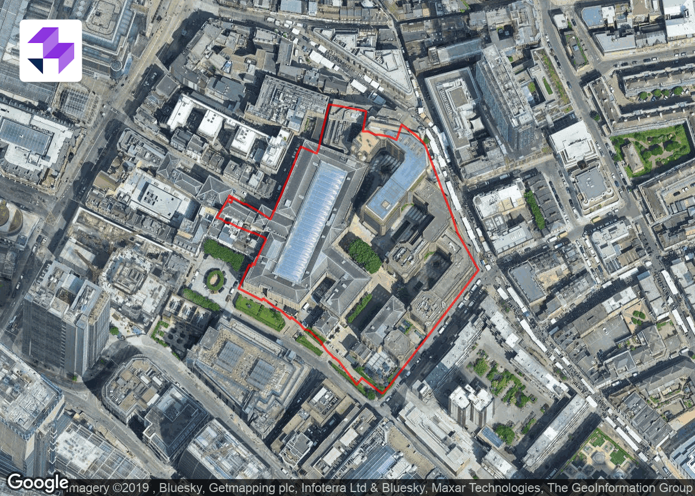
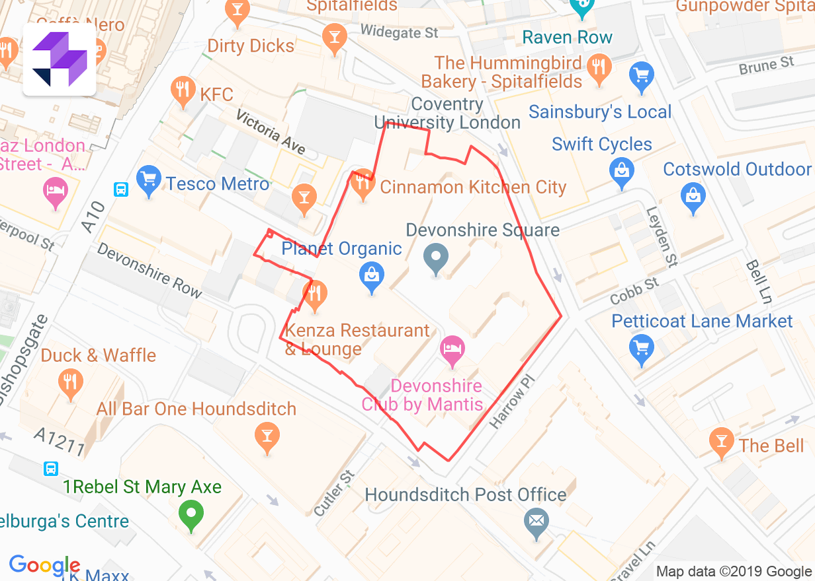

Area: 4.34 acres
Perimeter: 2,101 ft
Local Authority: City of London
PTAL: 6b
Building Height: 101 ft
Current Use: B1, A3, D2, A1, A4, SG, C3, B8
Protected Land: No Risk
Flood area: No Risk
Nearby Listed Buildings: Risk

PLANNING APPLICATIONS
25 planning applications on site
0 apps identified in past 6 months
0 apps identified in past 12 months
Latest planning application:
Submission of details (Planning)
Applicant: SUSD
Details of fume extract arrangements pursuant to condition 10 of planning permission 14/00849/FULL dated 15/12/2014.
Granted 2015-10-29

OWNERSHIP
25 registered titles
Company with most significant ownership:
CG CUTLERS GARDENS (JERSEY) 2 LIMITED

