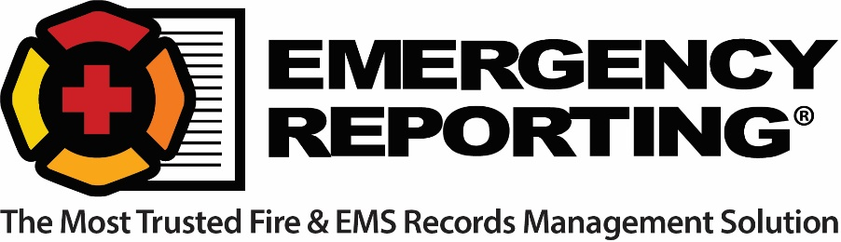

Justification Letter to Attend an Emergency Reporting 2018 Regional Training Academy

Dear Chief ________________,

As a member of our department and frequent user of the Emergency Reporting system, I am interested in being the best that I can be. I would like to further my education and training with ER both to improve my competence and efficiency and to bring lessons learned from the esteemed Regional Training Academy back to the members of our department. This knowledge will help ensure we all get the most out of our investment in the ER software suite.

I would like to attend the RTA in _________________ to have access to:
- A deep dive into the ER system with a focus on best practices
- A detailed look at the key features in each module and how they relate to each other
- Multiple interactive learning sessions that will help enhance and develop our agency.
- Resolving any specific challenges with ER in our department

In a nutshell, this hands-on training with ER's experienced trainers (all active or recently retired public safety professionals with over 200 years of combined firefighting and EMS experience) will enable me to become an ER expert and help us get the most out of our ER records management system.

In addition to all of this, when I get back I will be able to multiply the benefit by sharing all of the information and training with you and other members of the department.

Thank you for considering my request to attend Emergency Reporting’s Regional Training Academy.

Regards,

________________________________

