Documentation

  - Visual Resource Viewer (VRV)

Version: 1.0 | as of 15 April , 2019
NETRONIC Software GmbH
Pascalstr. 15
52078 Aachen
Germany
Tel: +49 (2408) 141 0
Fax: +49 (2408) 141 33
Web: www.netronic.com

Table of contents
1. Technical requirements 2
2. Understanding the VRV 2
3. Open Microsoft Dynamics 365 Business Central dialogs 3
4. View absence information 5
5. Collapsing and expanding 5
6. Capacity information 6
6.1. Set curve aggregation 6
7. Navigation in the VRV 8
7.1. Setting the timeframe 8
7.2. Change the timescale resolution 8
7.3. Scrolling 9
7.4. Fit into view 9
7.5. Adjust the width ratio between table and diagram 10
8. Rescheduling/Reload 10

Technical requirements
Microsoft Dynamics 365 Business Central

Understanding the VRV
Since the VPS is a Gantt chart, it naturally has all its characteristics:
- A timescale at the top.
- A table displaying the resources’ allocations either from the modules.
  - Jobs
  - Assembly
  - Service and, furthermore,
  - Absences
- On the right below the time scale, a chart displaying the different kinds of allocations or the absences as bars that are colored accordingly:
Jobs
Service
Assembly
Absence
- A menu bar, called “Actions ribbon”, allowing to make basic settings that will be explained in detail in the following.
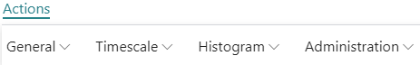

Open Microsoft Dynamics 365 Business Central dialogs
The VRV fully integrates with Microsoft Dynamics 365 Business Central. This means that by double-clicking a Job Planning Line, an Assembly Order Allocation, a Service Order Allocation or an Absence in the diagram or a Resource/Resource Group in the table, you'll directly switch to the according Dynamics 365 Business Central dialogs where you can navigate and make changes as usual:
Double-clicking the Service Order Allocation…
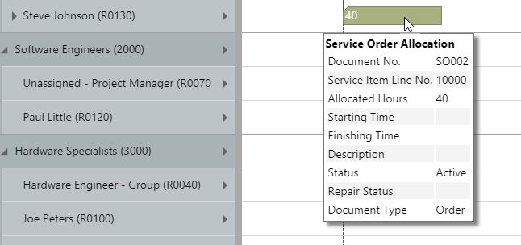

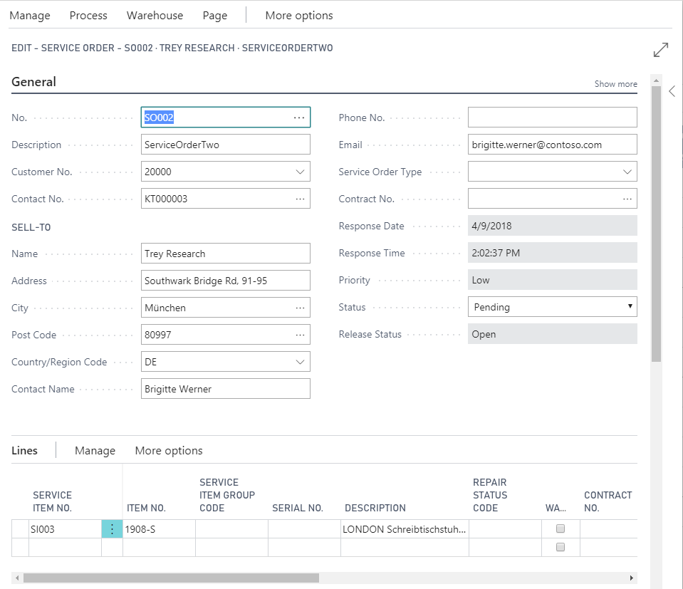
…will call the according dialog:

View absence information
Absences of a resource are visualized in the VRV by way of a grey bar. Hovering over such a bar with the mouse, will cause a tooltip window to open, showing all information specifying the absence of this particular resource at this particular date.
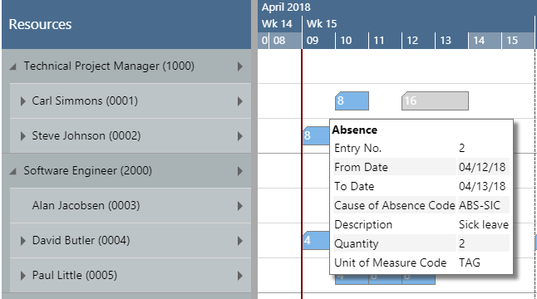

Collapsing and expanding
The VRV allows to view your data from different angles easily and quickly.
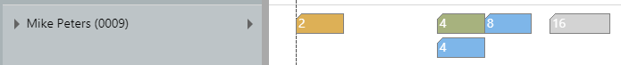
- Collapsed resources show their capacity load in one row

- In expanded resources the resource allocation is shown grouped by Job, Service, Assembly, and Absence
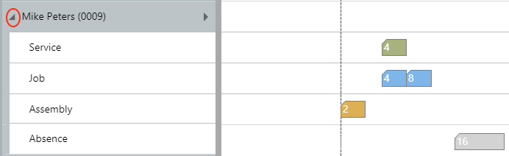

Capacity information
In the VRV, you can show a capacity curve to see free and exceeded capacities, a red box indicating an overload:
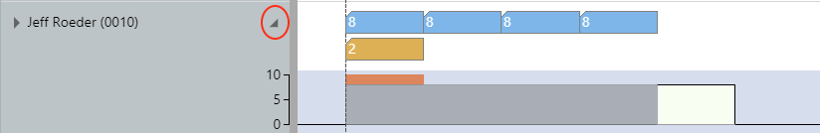
In case the resource (group) line is expanded, the capacity information gets even more detailed:
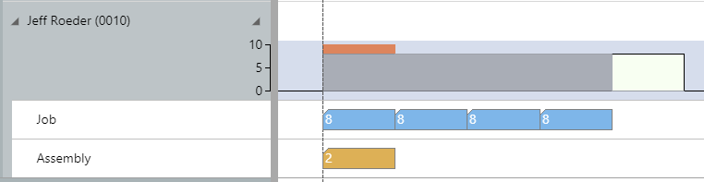

Set curve aggregation
For refining the capacity information, the VRV offers different curve aggregations, to be set by the Actions ribbon:
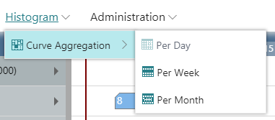
The options in detail:
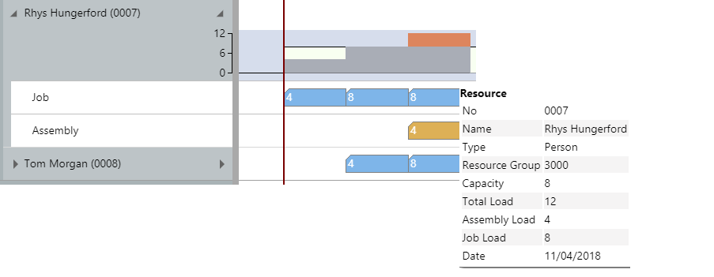
- The daily capacity is calculated based on a resource’s daily working hours minus the daily total load, as in the example shown below: Capacity (=8) – Total Load (=12) = -4. The overload is being represented by the red bar in the capacity curve.

- The weekly capacity is calculated based on a resource’s weekly work hours minus the daily total load, in the example below: 40 – 24 = 16 hours.
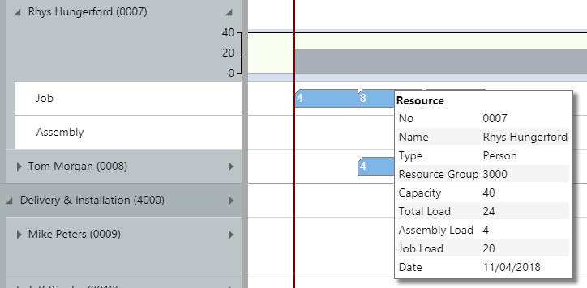

- The monthly capacity is calculated based on a resource’s monthly working hours minus the total load, in the example 168 – 60 = 8.
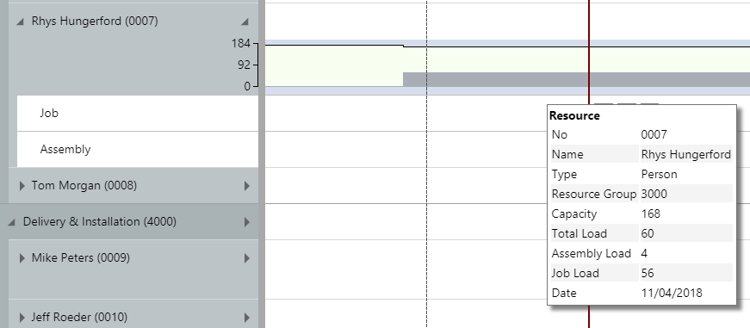

Navigation in the VRV
Navigating in the VRV largely comprises setting the time range for which parts of your plan are shown, modifying the timescale solution and quickly scrolling to certain parts of your plan.

Setting the timeframe
The timeframe specifies the time range covered by the timescale, either fixed by absolute values or relative to the workday. This is done in the “Setup” dialog, to be reached by clicking the “General” item in the “Actions“ribbon.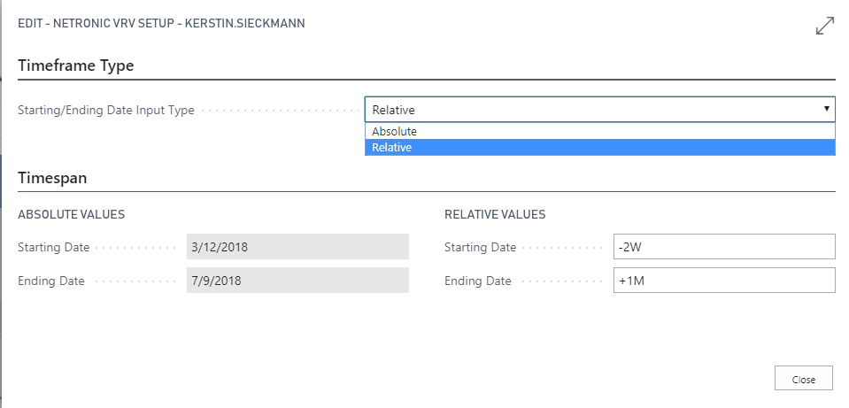

Change the timescale resolution
For zooming in a certain area of your plan or to zoom out for a better overview, you can change the timescale resolution either by
- scrolling the mouse wheel in the timescale area
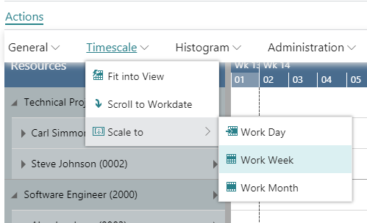
- or, more specifically, by the corresponding items of the “Actions” ribbon, based on the work date as having been specified in the settings of Dynamics 365 Business Central.

Scrolling
The VRV offers the following options for quickly navigating to certain positions in the diagram:
- the common scrolling options by vertical and/or horizontal scrollbar
- dragging the timescale either right or left
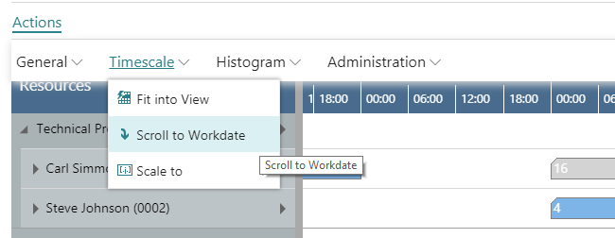
- scroll directly to the Dynamics 365 Business Central work date by selecting the corresponding item from the “Actions” ribbon.

Fit into view
Select this item from the “Timescale” menu in the “Actions” ribbon to switch directly to the timescale as defined in the “Setup” dialog.

Adjust the width ratio between table and diagram
For adjusting the width ration between table and diagram, put the mouse cursor on the sash between the two parts and drag the double arrow appearing then.
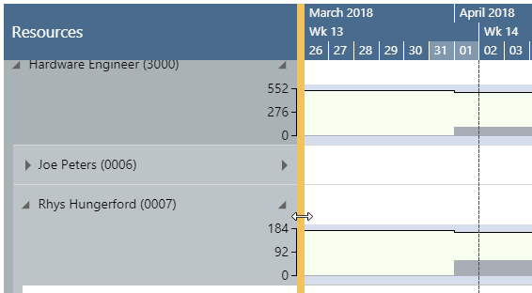

Rescheduling/Reload
Rescheduling in the VRV is actually very simple: Just make your changes and click Reload from the “General” item in the “Actions” ribbon. Due to being fully integrated in Dynamics 365 Business Central, the changes will directly be shown in the VRV
