Municipal Government Representatives (MGR) CoP Call

Attendees
- Jennifer Casorso, City of Kamloops (Chair)
- Lisa Attygale, Tamarack Institute
- Tim Stiles, Federation of Canadian Municipalities
- Mary Allen Bernard, City of Windsor
- Nancy Fisher, City of Peterborough
- Lorna Morin, Prosper Canada
- Dianna Souvenny, City of Red Deer
- Darrell Howard, Vibrant Communities Calgary
- Linda Bernicki, City of Spruce Grove
- Natasha Pei, Vibrant Communities Canada

Regrets: Marlene Chiarotto (Prosper Canada), Andrea Burkhart (Edmonton), Cheryl Smith (London), Jennifer Smith (London), Adaoma Patterson (Peel), Pamela Pacheco (Brantford)

Update on MGR CoP Learning Agenda
During our last MGR CoP group discussion (May 8, 2017), we collaboratively set the learning agenda for this year by doing live-voting, and asking for additional feedback via email from members who were not in attendance. The following learning topics have been the most popular, and will be set-up for future calls throughout the year.

If you would like to speak to one of the below topics, or recommend a speaker or particular focus, please email Natasha@tamarackcommunity.ca with your suggestion(s).

Upcoming MGR CoP Learning Topics:

- Creating Educational Campaigns for Municipal Departments (July 10, 2017)
- Collective Impact – Engaging Influential Champions (September 11, 2017)
- Evaluation – Reporting to City Council and the Community (TBA)
- Financial Empowerment (TBA)
- Food Security (TBA)
- Affordable Transportation (TBA)

Creating Educational Campaigns for Municipal Departments

Recommended reading: Improve Employee Engagement in Your Municipality:
Inspire them with a Compelling Vision! (Source: Norm Baillie-David, Talent Map)

- Key idea: it is incredibly important that for staff to be engaged in their work, they feel connected to the vision – and know how they are contributing to it - no matter their role in the organization. It provides direction, purpose, etc.
  - In our work, we are aiming to connect people to the vision of poverty reduction
- All departments should be able to link their vision/goal/activities back to the overall municipal vision: corporate services, community services, infrastructure services, etc.
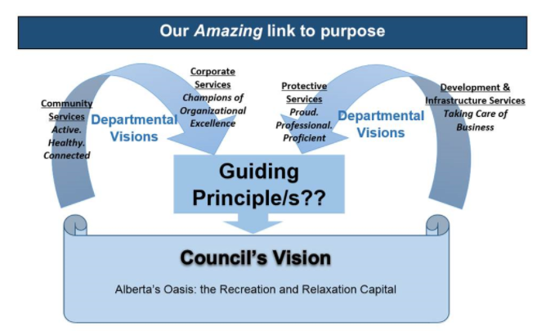

Discussion
- How is your work connected to the vision of your city?
- Each of us also has a responsibility to talk to the organization (municipality) and ask them what the vision means for our individual role.
- Currently working to promote what each person’s job is, but need to do more on connecting this to the broader picture (vision) and all getting on the same page. Esp. looking at roles through a social investment lens, and getting people thinking about how clients interact with all of the different departments, and weave through the system. This gets lost when we work in silos in the day-to-day (ex. Developing a recreation centre).
  - Who’s role is it to be the connector of the silos in this work? Is there motivation at a macro-level from the municipality?
- Everyone in the municipality works with people in poverty. Everyone should be thinking about how we work with people living in poverty.
- People only know what they know. It’s our role to lead our leaders to see through a new lens.
- Do a scan of everything that ties into poverty reduction and prevention in the community; then compare it to the city’s role in each of these areas. Use the information to look at what the community sees as the city’s role vs. what the city sees as the city’s role in poverty reduction.
- What are you currently doing to educate people internally, about poverty reduction efforts?
- Meetings/lunch-n-learns/info-sessions
- Training for corporate/leadership/frontline staff (esp. around language)
  - Plain-language training for communications officers
  - Help staff understand their role in-context, and what all of the resources are that are available – ex. how (a social assistance worker) can practically affect change and support clients to move out of poverty in different ways
- Setting up diverse teams to identify connections between work, and better integrate work
  - Esp. teams that are diverse in focus-area and/or geographic region
  - Senior-level leaders
- Poverty simulation exercise
- Newsletter (internal & external)
- Key staff have focused meetings to inform other municipal department staff about the poverty reduction strategy, and look at their work to help them create links.
*Small groups tend to be most successful for having people learn. Provided there are opportunities to get in front of the groups that need to be educated, this is a good way to go.

- What challenges do you have?
- Competing priorities (and limited capacity)
  - Hierarchy
  - Bias
- Deep silos (esp. other departments are trying to deeply engage on their own issues)
- Different types of employees require different types of education – what is the difference between what each needs to know? (ex. training senior leadership vs. council vs. frontline, etc.)
- Finding one focus or one definition of poverty – it means different things to different people
- Shifting deep seated attitudes
  - Needs to come top-down (an accepted attitude) AND bottom-up (understand when and where people need to be engaged)

- What other ideas do you have for municipal engagement, or have you seen other departments successfully implement?
- Elevating the voice of lived experience, and bringing them into educational efforts (ex. Hamilton Speakers’ Bureau). Including content-experts makes it real. Whenever possible, how can they be part of the education process?
  - Create a video to bring voices of people with lived experience and other community members, to Council during presentations. They are always looking for more community feedback.
- Lunch-n-Learns
- Apply poverty reduction concepts internally. City employees are not immune to poverty. Look at your own practices, and identify how the city can enhance access to resources for city staff. Ex. integrating financial coaching in the Employment Assistance Program.
- Learning Theory: successful organization looks like fun! What can you do to make it an engaging education experience?
- Repetition: once you communicate information one way, how can you hand it back out to people in a checklist, a poster, or other multi-media so that your audience retains the information over time?

