The Dell Reimbursement Process

It's easy!
- Check our events page for programs offered in your area.
- Enroll online. If going through Tuition Assistance, please pay online using your personal debit or credit card. If using cost center budget, please pay online using your corporate AMEX credit card.
- If you are going through cost center budget, your registration is complete. Your local Dale Carnegie Consultant will connect with you prior to the start of your program to answer any questions you may have.
- If going through Tuition Assistance, please fill out the University of Central Missouri Enrollment form and submit to hee-jung.cranford@dalecarnegie.com . A Dale Carnegie representative will connect with you prior to the start of the program to answer any questions you may have.
- Within 30 days from the start of the program, apply in EdAssist. This step can happen after you enroll at dell.dalecarnegie.com. The application is forwarded to your manager for “procedural” approval.
- After graduation, you will receive your grade and receipt from University of Central Missouri.
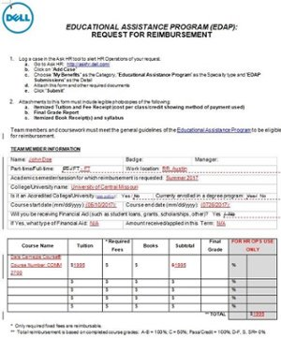
- Go to your Dell intranet.
a. Open the Tuition Assistance Program form (see image at right) using the link below to request reimbursement.
b. Log a case in Ask HR tool to alert HR Operations of your request.
i. Go to Ask HR: http://askhr.dell.com/
ii. Click on “Add Case”
iii. Choose “My Benefits” as the Category, “Educational Assistance Program” as the Specialty type and “EDAP Submissions” as the Detail
iv. Attach this form and other required documents
v. Click “Submit”
c. Submit the request online and attach only the three documents below.
i. University of Central Missouri Final Grade
ii. University of Central Missouri Itemized Tuition Receipt
iii. EDAP Request Form
d. After you submit the request, the Dell payroll team will email you the reimbursement acceptance and tell you what day it will be in your paycheck which depending on the payroll date, can take up to two weeks to receive as an additional pay on your paycheck.

