In order to have a good installation the following tips are recommended:

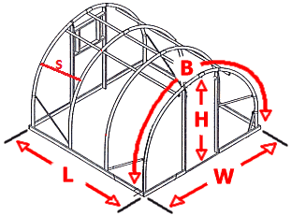

Measure your bow spacing’s: (S) is the distance between the supports.
You should be at 4, 5, 6 feet or 2-meter spacing. If this is not the case, please make adjustments to the bows or add additional perlins to make this possible.
Unevenly spaced bows make your vertical installation difficult, but not impossible.

Measure your longest BOW Length (B) run needed. This section of film spanning the greenhouse should be done in a continuous piece. Keep in mind that you cannot successfully seam the material without the loss of structural strength.
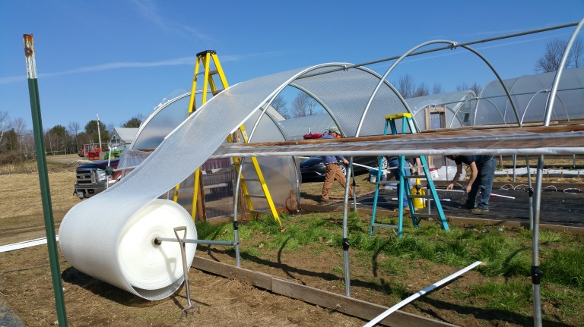

- Install tracks into your frame with self-taping screws (stainless or galvanized is recommended) 1 ¼” to 1 1/2 “ in length. Insert the Solawrap film into the tracks.
- ***Optional for Warmer Climates: It is suggested that a neoprene washer to added to the screw at the assembly to help spread the load and prevent the screw from heating up and melting through the extrusion. Screw spacing recommendation is 12” -24” apart depending on the wind, rain, and snow loads. For low snow load areas, 17” spacing is adequate. In high wind and snow loads, 12” spacing is recommend.

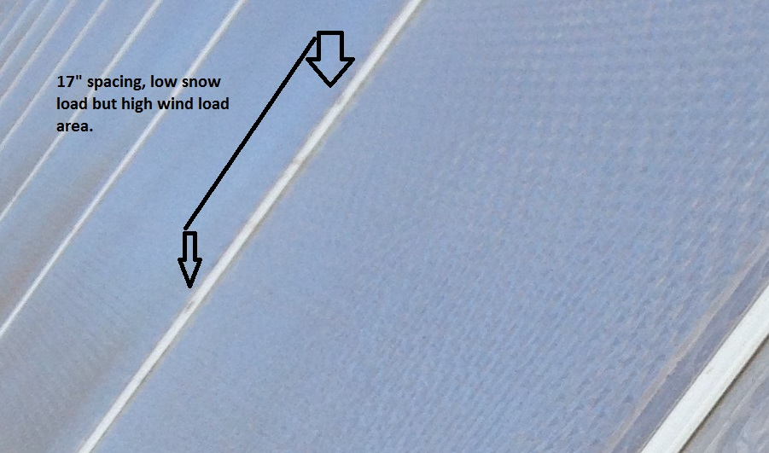

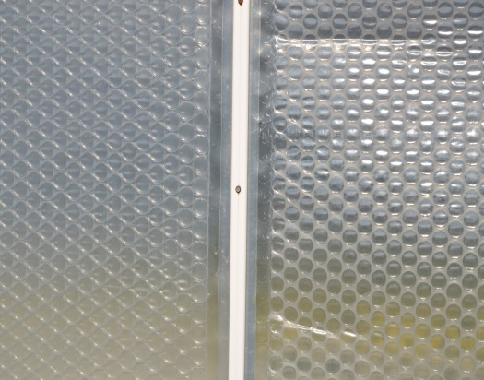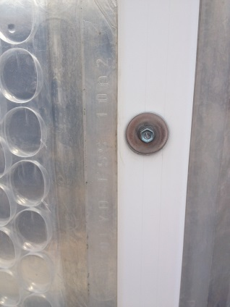

Tracking must be aligned properly or film could get damaged when inserted.

After correct alignment is achieved, seal the joint with weather UV resistant silicone.

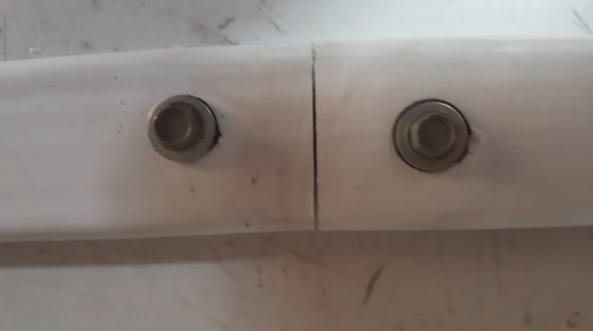
Misaligned, Incorrect

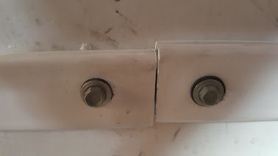

Damage from misaligned connectors.
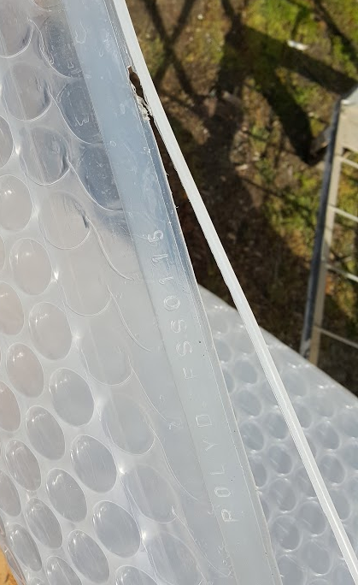

Where the film first enters the extrusion tracking, we recommend that the ends are terminated in a manner to round the sharp corners to prevent cutting as the material slides into place.
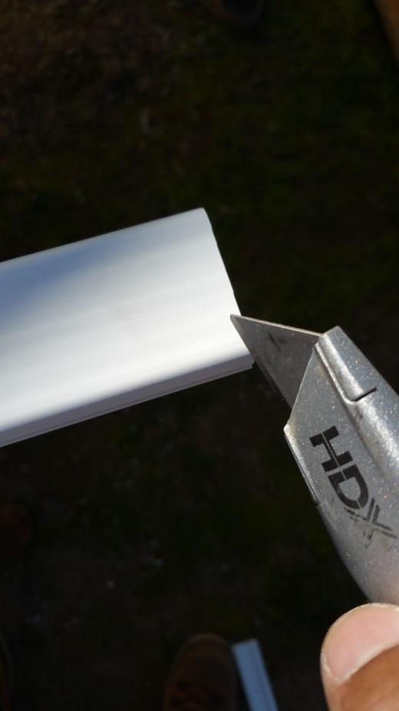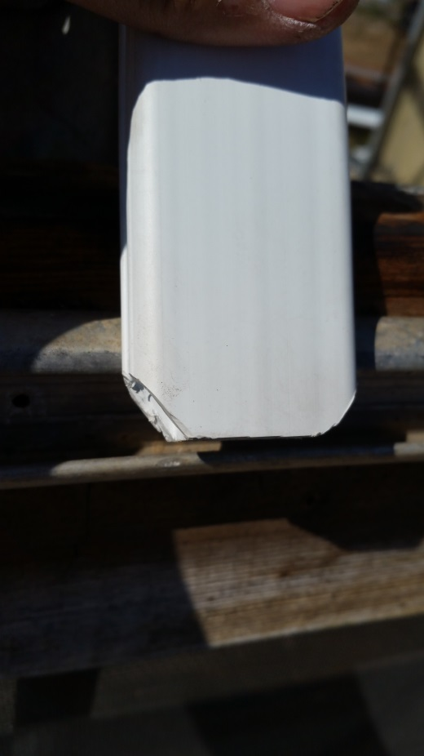

Film Insertion:
Lubricate the channels using soapy water or WD-40 /silicone spray.
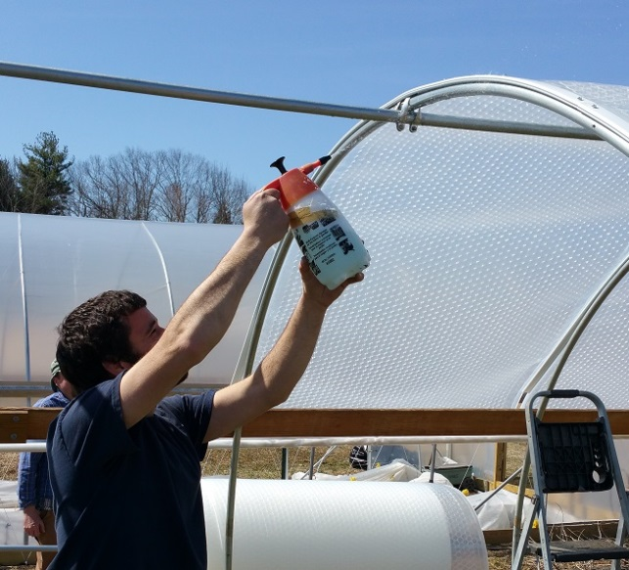
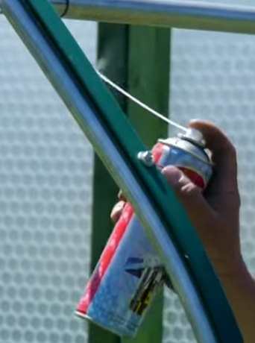

.
  - 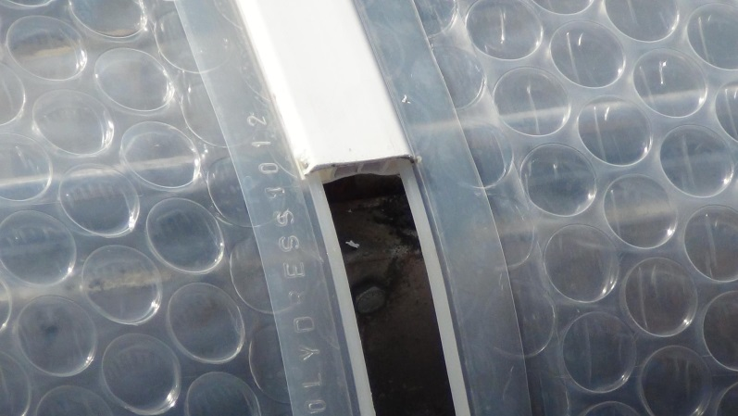

Film Terminations:

Depending on your install type, you should leave a 2” lip for potential water shed above the roll up curtain if you choose this type of installation.

Using a flat strip, either additional extrusion or old wiggle wire track you sandwich the film down creating a tight seal.

End Walls:
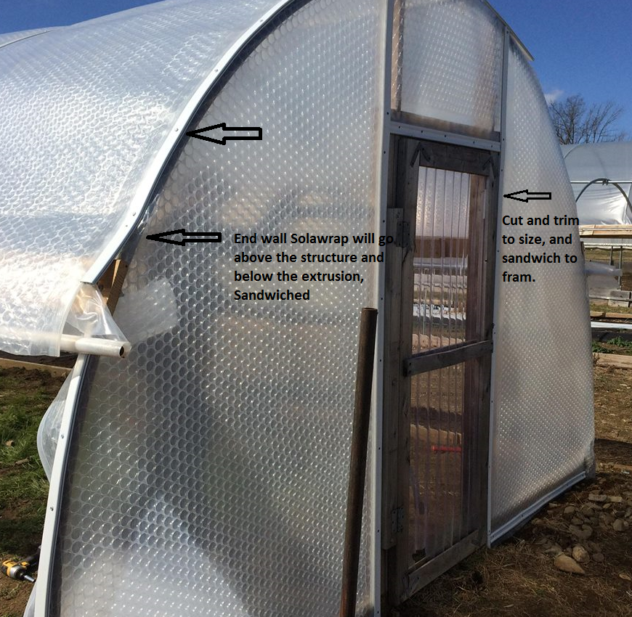

**** When installing the film, put the thick side to the sun. If you feel the film, there is a distinct difference in the film thickness. Thick side out. The underside is coated with an anti-condensation coating.

Tools and Equipment Needed:

- Sharp cutter/blade
- Measuring tape
- Marker
- Self-taping screws (stainless or galvanized is recommended) 1 1/4-1 1/2“in length. ***Optional for warmer climates it is suggested that a neoprene washer be added to the screw at assembly to help spread the load, and prevent the screw from heating up and melting through the extrusion.
- Ladders, and or scissor lifts
- Drill or impact driver with 5/16 bit, or one of your choosing
- Saw
- 2 work horses and a bar (at a minimum 1 foot longer than your film size.
- Clear silicone, outdoor and waterproof (used for the connections between your extrusions.
- Chanel lubricant, WD-40, soapy water etc
