ICON-Idaho Connects Online School
STUDENT INFORMATION SHEET
Legal Last Name: | First Name: | Middle Name:
Time Zone: Mountain Pacific | Date of Birth: | Gender: ___Male ___Female

Student's Physical Address: | Mailing Address, if different:

Student's E-Mail Address:

Home Phone: | Student's Cell Phone:

Last School Attended: | Current Grade Level:

RACE: ____White, Not of Hispanic Origin _____African American _____Asian or Pacific Islander

_____Hispanic _____American Indian/Alaskan _____Other

Primary Household Information: Name of person(s) with whom student is living:
Living with (check one): ____Both Parents ____Mother Only ____Father Only ____Guardian
____Foster Parent ___Mother/Stepfather ____Father/Stepmother ____Relative ____Other

Father or Male Guardian's Name: | Work Phone: | Cell Phone:

E-Mail and Physical Address, if different from student:

Mother or Female Guardian's Name: | Work Phone: | Cell Phone:

E-Mail and Physical Address, if different from student:

Are you currently being served by an IEP or 504 Plan? _____YES _____NO

Are there any circumstances about the custody of your child that we should know about which limit the sharing of records, etc..? _______YES _______NO It is the parent's/guardian's responsibility to keep the school informed of changes in custody by providing the office with currently and complete legal documents each year and after any changes.

PHOTO RELEASE: Your child may be photographed or videotape for inclusion in the district publications and website or in the newspapers or magazine articles or letters relating to school activities. PLEASE CHECK: ____ Yes, I give my permission ____No, I do not give my permission As the parent (or legal guardian), I understand that it is MY responsibility to notify the school of any change in contact information such as: physical address, phone number(s), e-mail addresses, etc...

PARENT/GUARDIAN SIGNATURE: __________________________ DATE: _____________
ICON-Idaho Connects Online School

HOME LANGUAGE SURVEY

Student’s Legal Name:
Last Name First Name Middle

Gender: □ Male □ Female Birth Date: Grade Enrolling in:

What is the primary language spoken in the home?
If English, STOP and sign at the bottom of the page.

If anything other than English, please continue on and answer the questions below.

1. What language is spoken in the home?
2. What was the first language learned by the child?
3. What language do you most often use to speak to your child?
4. What language does the child use most often in the home?
5. What language does the child use most often with friends outside the home?
6. What country was your child born in?
7. When did your child first enter school in the USA? In what state?
8. Is the student attending the school as a foreign exchange student?
9. Has the student ever been in a bilingual educational or an English as a Second language program in a
school in the US?
10. Did the student exit the program? Exit Date:

Parent/Guardian’s Signature: Date:

ICON-Idaho Connects Online School

RESIDENCY SURVEY

Student’s Legal Name:
Last Name First Name Middle

Gender: □ Male □ Female Birth Date: Grade Enrolling in:

This questionnaire is intended to address the McKinney-Vento Act. Your responses will help the administrator determine residency status for enrollment of this student and whether or not additional support and services may be available to the student.

1. Presently, is the student living (circle the appropriate letter)

a) In a shelter, transitional housing, or awaiting foster care
b) With more than one family in a house or an apartment due to loss of housing or economic hardship
c) In a temporary trailer, campground, car, or park
d) In a hotel or motel
e) Choices above do not apply

If “e”, then do not complete the remainder of the questions and no further action is necessary.

The student lives with (circle the appropriate letter):
a) 1 parent
b) 2 parents
c) 1 parent & another adult
d) A relative, friend(s) or other adult(s)
e) Alone with no adults
f) An adult that is not the parent or the legal guardian

Parent/Guardian’s Signature: Date:

ICON-Idaho Connects Online School

STUDENT QUESTIONNAIRE

In order to help us serve you better, please answer the following questions:

- Do you currently have reliable internet in your home? ___YES ____NO

- Are you currently on probation? _____YES ______NO

- Are you on track for your current grade level? _____YES _____NO

- Are you currently employed or participating in a hobby that takes up more than 15 hours per week? _____YES ______NO

- Are you currently expecting a baby? _____YES ______NO

- What are your goals by enrolling with ICON? (i.e. I want to graduate with ICON, I want to get caught up and return to my local school, etc...)

- What are your plans after you graduate?

ICON STUDENT HANDBOOK VERIFICATION

Reading the Student Handbook is a critical component of schooling with ICON We ask that you take a few moments to read the handbook and then sign below as verification that you have read it. The link to the handbook can be found on our website at: www.iconschool.org under the “Learn About ICON” tab in the “Course Catalogs/School Calendar” section.

STUDENT NAME: ____________________________________________________________

STUDENT SIGNATURE: _____________________________________________________

PARENT/GUARDIAN NAME: _______________________________________________

PARENT/GUARDIAN SIGNATURE: __________________________________________

DATE: _______________________________

PRIVACY ACT STATEMENT: This explains how we will use the information you give us. Various federal programs require the information on this form. You do not have to give the information, but if you do not, the charter school may not be eligible for amounts of federal funding calculated using the data. According to federal regulations governing the provision of certain federal programs, a low income percentage is determined from a free and reduced lunch meal program and is used for eligibility purposes. Charter schools that do not operate free and reduced-price lunch programs under the National School Lunch Program must acquire information about the number of students in the school whose families meet the same low income eligibility guidelines in another manner. This form uses free and reduced-price income levels as the threshold to determine your charter school’s eligibility for the various federal programs. We MAY share your eligibility information with education and health programs to help them evaluate, fund, or determine benefits for their programs, auditors for program review, and law enforcement officials to help them look into violations of program rules. All information is highly confidential and must be handled accordingly by all program officers.

INCOME DETERMINATION FORM
For Idaho Charter Schools
Family Name or Foster Child Family Name _____________

INCOME ELIGIBILITY GUIDELINES
Effective FROM July 1, 2016 to June 30, 2017

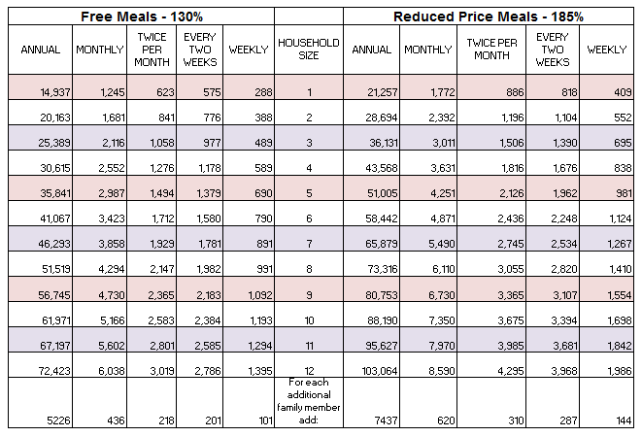

INSTRUCTIONS:

In addition to completing the adult signature, date, and address at the bottom of the page, please complete the section below (A-E) that applies to your household.

STUDENTS WHO ARE FOSTER CHILDREN
- Each Foster Child needs a separate form
- Based on child personal income

ALL OTHER STUDENTS (including emancipated students)
- All household members
- Gross income by person

- Name of Charter School your child(ren) I s(are) attending:_________________________________________________________________

- Number of children attending: ______

C. Name of traditional public school(s) and district that serves the area in which your child(ren) resides:
_____________________________________ _______________________________________

_____________________________________ _______________________________________

D. Number of people living in the household: ________

E. Is your family or foster child’s yearly, monthly or weekly income equal to or less than the amount on the income eligibility chart? ____ Yes ____ No

Please sign, date and return this form to the school office in a sealed envelope:
I certify that all of the information provided is true and correct. I understand that this information is being given for the receipt of federal funds.

__ _____ _______
Signature of Adult Household Member or Foster Parent Printed Name of Adult Household Member or Foster Parent

________________ ________________________
Physical Address City State Zip Code Date Signed

