FOR PEOPLE WHO:
- Don’t have a high school diploma
- Have had challenges completing the GED
- Are any age
- Are interested in enrolling in a career program at [Your School’s Name]
- Are looking for a second chance at a better future

THE BASICS:
- You can earn an accredited high school diploma on [Your School’s Name]’s campus, as a pathway to enrolling in one of our career programs
- Plan to come to our campus 2-3 times a week for high school classwork
- Complete the high school program at your own pace
- You’ll then be a high school graduate and can enroll in [Your School’s Name]

HIGH SCHOOL DIPLOMA BENEFITS:
- Students with a high school diploma earn $708 more per month than those without*
- On average, students who have earn their Bachelor’s Degree earn over $57,500 a year*
- Enhance your career and your future with a college education from [Your School’s Name]

Call an admissions counselor today to learn about the Penn Foster High School Diploma Program <Your Phone Number Here>

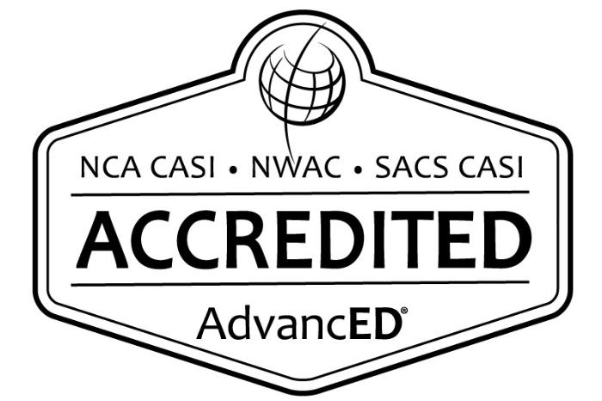

<Your Logo Here>
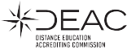
Penn Foster High School
is accredited by

Earn your High School Diploma,
continue your education, and
build your future at [Your School’s Name]!

* Source: https://www.bls.gov/emp/chart-unemployment-earnings-education.htm

