

**Your Logo Here**

# Penn Foster High School +

[School Name] Career Pathways Program

Earn Your High School Diploma and Enroll in [School Name]

Interested in enrolling in [school name] but don’t have your high school diploma? Through our partner, Penn Foster, [school name] is now offering a Career Pathways Program. You can earn an accredited high school diploma on our campus, at your own pace, and at no cost to you, as a pathway to enrolling in one of our career programs.

## THIS PROGRAM IS FOR PEOPLE WHO:

* Don’t have a high school diploma
* Have had challenges completing the GED
* Are interested in enrolling in a career program at [school name]
* Can dedicate a minimum of 12 hours on campus per week
* Are looking for a second chance at a better future

*“Coming to Penn Foster inside of a career school is like another home for me. When I’m here, my classmates are there for me and plus the instructors. I have been other places, walked in other buildings and they were not like this.”*

**Laketa Farris, Penn Foster High School Graduate, Career School Student**

Call today to learn more

about the program **[Admissions phone number]**

# Penn Foster High School +

[School Name] Career Pathways Program

## ABOUT THE CAREER PATHWAYS PROGRAM:

* Transfer in credits you have already earned from either high school or GED work, so you only take the credits you need to earn your diploma
* Plan to come to our campus 2-3 times a week for high school classwork
* Take the Penn Foster High School program made up of short, easy-to-understand lessons with online testing you can complete at your own pace.
* Engage with your dedicated classroom facilitator to help you through the program.
* Complete the high school program in as few as 12 weeks while joining the [school name] community on campus.
* Take [school name] courses in your career field as electives.
* Gain the skills and knowledge to be successful in school and in life
* Receive your high school diploma after successfully completing all requirements. You’ll then be a high school graduate and can enroll in [school name]



*“You finish your high school diploma and you go right into the office and sign papers and now I’m in my 2nd semester.”*

**Nikkiya Gentry, Penn Foster High School Graduate, Career School Graduate**

**HOW TO GET STARTED:**

• Call **[Admissions phone number]**

* Schedule an appointment with an admissions representative
* Prepare for your appointment by collecting your high school transcripts
* Complete [school name]’s requirements and enroll in the high school diploma program

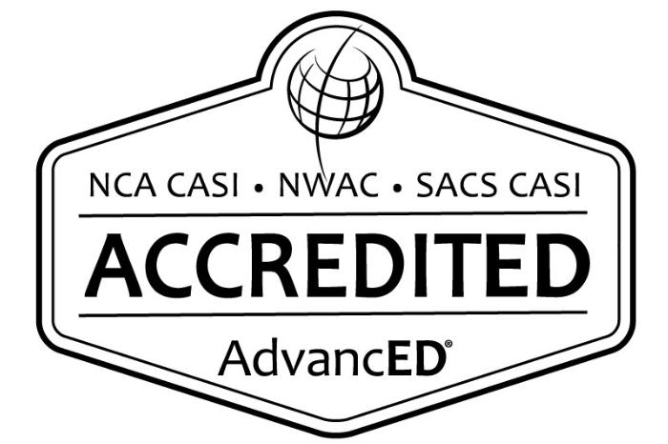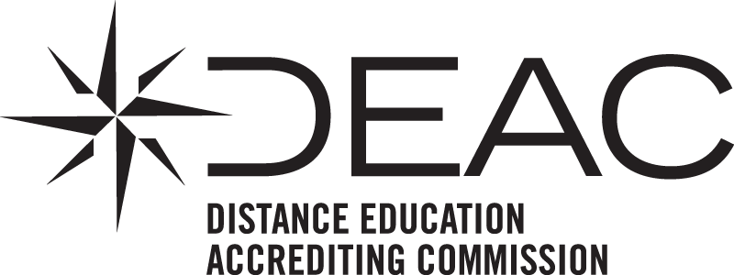

Penn Foster High School is accredited by