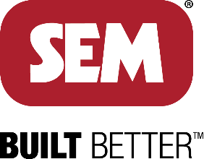

**SEM** is pleased to announce a great new employee benefit! We are partnering with TicketsatWork to provide you access to exclusive savings on movie tickets, theme parks, hotels, tours & more. Be sure to visit often as new products and discounts are constantly being added!

**Company Code:** SEMtastic

HOW TO SIGN UP!

1. Go to TicketsatWork.com
2. Click on “Become a Member”
3. You will then be prompted to create an account with your email address (personal or work email) and company code

*Once enrolled you will have access to discounts on hundreds of offers on theme parks, shows, hotels, attractions and more!*

