**Services Industry Consolidation**

* **Accenture Agencies Consolidation**
* **Agencies consolidation**
* **Certified professionals consolidation**

**Situation Recap**

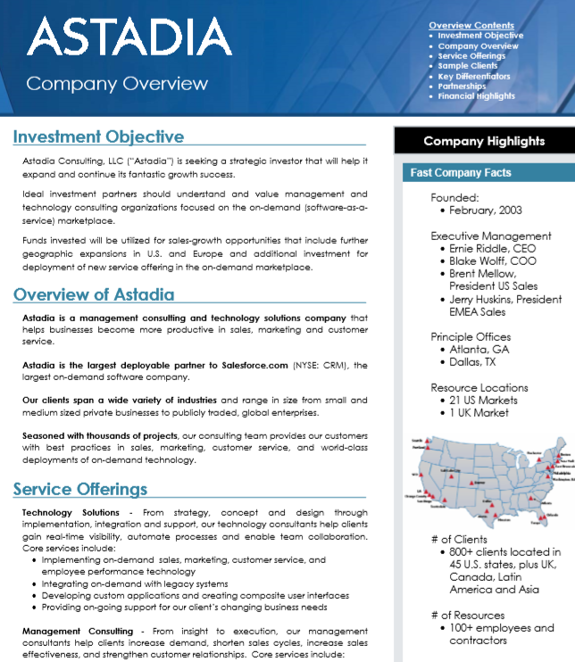Today, the leading Salesforce.com CRM partners are a “who’s Who” of the global consulting and outsourcing firms with the top 20 generating at least $50m annually from SDC implementation project services according to Forester. Each over $1b in ARR and more than 500 SFDC certified professionals.

But in the 2000’s before the cloud and SaaS became mainstream, before Inbound marketing automation or analytics, or BPaaS; back when SFDC struggled to fill its onsite roadshows around the country, the CRM market was a “Wild West” of opportunities.

**Timeline**

* [2004](https://en.wikipedia.org/wiki/Salesforce.com) – SalesForce.com IPOs on the NYSE: CRM.
* [2006](https://www.linkedin.com/in/blakewolff/) – Astadia acquires MW Advisors, SalesForce.com CRM consulting and technology partner.
* [2008](https://www.crunchbase.com/organization/theikos) – Astadia acquires Theikos.
* 2009 – SalesForce.com passes $1b in revenues.
* 2010 – Dreamforce surpasses 20,000 attendees.
* [2012](https://www.crunchbase.com/organization/astadia#section-overview) – The Gores Group acquires and rebrands Astadia. CRM consolidation leads to refocus on cloud solutions beyond the CRM.  
  
* [2012](https://www.crunchbase.com/organization/velteo) – Bluewolf acquires Velteo.
* [2016](https://www.crunchbase.com/organization/bluewolf#section-overview) – IBM acquires Blueworlf for $200m.
* [2016](https://www.crunchbase.com/organization/appirio#section-overview) – Appirio acquired by Wipro for $500m.
* [2018](https://www.astadia.com/news-events/pr/astadia-announces-a-majority-investment-by-spring-lake-equity-partners/) – Growth capital financing to focus on mainframe to cloud modernization across Microsoft, Amazon, Oracle, Micro Focus.
* [2018](https://www.salesforce.com/dreamforce/expo/) – More than 160,000 attendees at Dreamforce across 2700 sessions.

|  |  |  |  |
| --- | --- | --- | --- |
| **SalesForce.com Platinum Partners** [**2007**](https://news.thomasnet.com/companystory/salesforce-com-announces-dreamforce-2007-the-on-demand-conference-of-the-year-520467) **to 2010** [**to**](https://www.salesforce.com/content/dam/web/en_us/dreamforce/resources/DF16Prospectus.pdf) **2018** | | | |
| Appirio, Astadia, Bluewolf,  BMC Software, CA, Callidus, D&B, and Deloitte. | Accenture, Appirio, Astadia, Bluewolf, BMC, CA Technologies, Deloitte, D&B., Eloqua, Marketo, Model Metrics Inc. and Wipro Limited. | | Global BPO, IT, Accounting, Consulting Leaders |
| **SFDC App Partners from 2006 to 2011** | | | Thousands |
| Eloqua  Exactly | JobScience  ServiceMax  Docusign  FinancialForce | Blackbaud  LinkedIn  Ariba  Zuro |

Fractional Outsourced HR Services: tHRive Impact Statement

*From HR Staffing to an award winning HRO model.*

Situation: A staffing provider with $1M in revenues and 10 employees had the idea to **package HR Directors with bundled HR Shared Services** to provide functional HR solutions to small to medium businesses which had outgrown their CPA, Broker, and Payroll service provider.

Results: Improved field level EBITDA from breakeven to double digit profitability and recognized by **Best Places to Wok, INC 5000, Houston Fast 100, and the Texas A&M Aggie Top 100.**

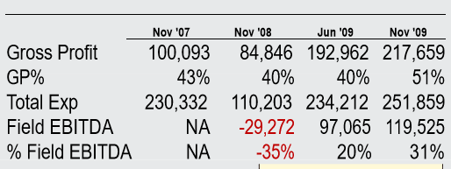

*“While guiding us to much improved performance, your team has performed with extreme diligence, commitment, and professionalism in a very difficult situation. you and your colleagues have installed a viable business plan, developed a fully featured product offering, and developed both operating and customer service tools that were sorely lacking. Your contributions can perhaps best be measured by the dramatic improvement in EBITDA performance since 2008.”* – Arch, Founder and Board Director.

Approach & RESULTS ACCOMPLISHED:

|  |  |  |  |
| --- | --- | --- | --- |
| Function | 2007 | *Change by YE 2009* | Impact |
| Product | Zero product definition | Created 4 “products” to enable consultative sell and facilitate scalable recurring revenue model. | TTM Client > 90% Retention during difficult economy recessions  30% Field level EBITDA  Billable Consultant Productivity up 45% |
| Sales Model | Transactional model | Consultative sales model improved close rates from 5% to 25% and improved cost of MRR $1 from $2 to < $0.60. | Created a Culture of Everybody Sales: Domain and Industry knowledge professionals enabled services driven culture that “Fit” Products to Customer Profile.  Referral partners drove leads to consultants. 3X revenues in < 12 months. |
| Services Model | 50% client churn | Product and Process oriented.  Multiple Client touchpoints and triggers.  Shared Services plays a significant tole.  Career path centric team model | 90% client satisfaction net promoter score  Productivity utilization from 49% to 78% billable. |
| Financial | Non-viable model | Recurring Revenue Centric Model | GP improvement to 46%  Project Revenues > 80% GP  Billable Hours >80% GP |

**HR Reseller Right Sizes from Lifestyle to Institutional Impact Statement**

P&L Impact:

|  |  |
| --- | --- |
|  | * Improved Profitability of the company by product, for Gross Profit by **11%** and EBITDA by **17%.** |

How the Results Were Achieved:

|  |  |  |  |
| --- | --- | --- | --- |
| **4.25X  Profit Improvement Realized** | The Model Change Impact on Profitability was based on the shift from 53% to **64%** Gross Profit. | | **$8,840** average increase in monthly billings for the top 200 customers |
| Increased the number of product, service, technology and HR vendors and partners **bundled into add-on service packages** to increase average contract value **33%** | **Optimized** compensation **from 5% to 26%** variable versus fixed | The impact **improved return on consulting labor 30%** ($40k more per annual billable consultant) by moving to industry practice leader team pod staffing model |
| Improved bottom-line EBITDA from less than 5% to **17%** | | |

Crossing the Chasm to an Optimized Portfolio:

|  |  |
| --- | --- |
|  | Changed from staffing to HRO model  Right sized pricing  Created Account Management for top 20%  Bundled products and services  Added upsell packages |

Impact of Services:

|  |  |
| --- | --- |
| Financial Impact | Resources Impact |
| * Improved profitability from single to double digits * Improved Gross Profit from 53% to 64% * Improved top 200 customer billings by $8840 per month | * Improved revenues per by 30% * Commercialized Direct * Increased monthly billings 300% |

**Impact Statement /** LeadGen

Sales Center Right Sizes its Portfolio

P&L Impact:

|  |  |
| --- | --- |
|  | * Improved Profitability of the company by solution, and improved overall gross profit from <40% to **53%**, and improved EBITDA <9% to **17%.** |

How the Results Were Achieved:

|  |  |  |  |
| --- | --- | --- | --- |
| **4.25X  Profit Improvement Realized** | The Model Change Impact on Profitability was based on the shift from 43% to **53%** Gross Profit. | | **$8,840** average increase in monthly billings for the top 200 customers |
| Increased the number of product, service, technology and vendors, and partners **bundled into add-on service packages** to increase average contract value **33%** | **Optimized** compensation **from 5% to 26%** variable versus fixed | The impact **improved return on labor 30%** (From less than $40k per EE to >$200k – from a staffing center to a solutions model |
| Improved bottom-line EBITDA from less than 9% to **17%** | | |

Crossing the Chasm to an Optimized Portfolio:

|  |  |
| --- | --- |
|  | Changed from staffing center to solution model  Created Account Management for top 20%  Bundled products and services  Added upsell packages |

Impact of Services:

|  |  |
| --- | --- |
| Financial Impact | Resources Impact |
| * Improved profitability from single to double digits * Improved Gross Profit from 43% to 53% * Improved top 200 customer billings by $8840 per month | * Staffing model to tech-enabled solutions * Improved revenues per by 30% per client * Increased monthly billings 300% |