Building Automation

Spring 2019 Analytics Report

Prepared for:

Demo

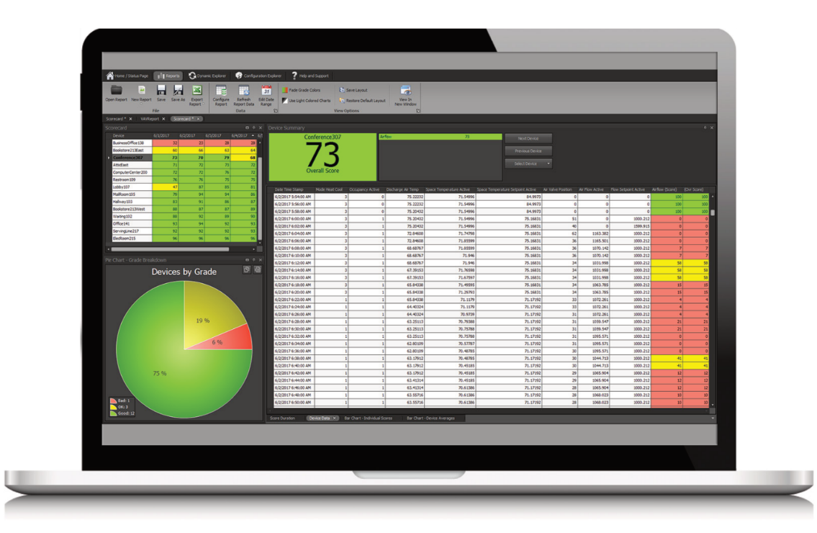

Prepared by:

Melissa TeBockhorst
720-441-9808

LONG Building Technologies, Inc.
5001 S Zuni St
Littleton, CO 80120

Contents

Building Automation 1
Summary 2
Issues Log 3
Zone Comfort Report 5
Air Quality Report 8
Summary Report 10
New Issues 10
Pending Issues 10
Other Notes 11
Your LONG Team – Contact Information 12

Summary

Thank you for choosing LONG Building Technologies, Inc. as your Building Automation System (BAS) Support & Analytics Provider. We are dedicated to providing top building automation and analytics support for your buildings. Our specialized team focuses on the development, installation and maintenance of your BAS system and analytics reporting.

We are committed to working with you to maintain the building automation system that is essential to creating and sustaining the indoor environment conditions that support your organization’s needs. The details of that commitment are provided in the following pages.

This report provides a historical analysis of the BAS data. The information provided in this report can be used to provide insight into hardware and software issues occurring in the BAS system. The information in this report is to point out the major issues and requires further investigation to determine the root cause. The report does not guarantee savings. The total number of operator overrides are demonstrated below. This value should be as close to 0 as possible. An operator override indicates a user has overridden the controls logic to stay at a specific value.

Total Operator Overrides: 10
(As of 8/19/19 – Not including space temperature setpoints or airflow setpoints)

The total equipment, system and sensor faults are listed below. Equipment alarms include any alarm received by the system that is generated from equipment or controls logic. The system alarms provide information about the system health including communication and power issues. The sensor faults alarms indicate if a sensor has failed to read a valid value. These are typically setup on all temperatures.

Total Critical: 11
Total Equipment: 21
- Snowmelt
- GarageCO_2:EMGENSTS
Total System: 502
- JACE backups are failing
- Lots of Ping Failures
- Some alarms are going to default when they shouldn’t be.
Total RoomTempAlarmClass: 62
- L12:Minimum

Issues Log
The Issues Log provides information about the top hardware and software issues. These issues are generated by analyzing the historical data using related pre-built rules. The report provides an estimate cost impact and recommended action items to resolve the issue.

Issue 1: RTU_16’s discharge air temperature setpoint is causing the unit to hunt between a 55ºF setpoint to 100ºF setpoint.

System Effect: Poor performance, decreased energy efficiency and negative impact on occupant comfort.

Recommendations: Verify unit is setup correctly. Check supply air temperature and space temperature setpoints. Check tuning in controller (if applicable).

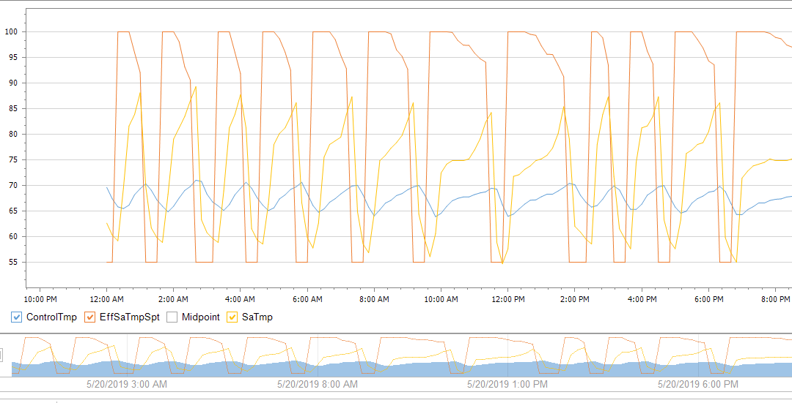

Issue 2: RTU_2’s cooling is enabled and the discharge air temperature is not lowering.

System Effect: Negative impact on occupant comfort.

Recommendations: Check the compressor is operating properly.

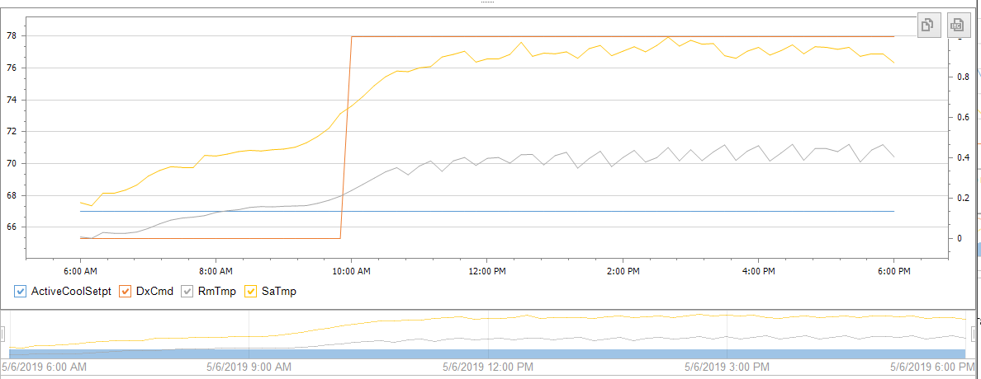

Issue 3: HV – Space Temperature is more than 3 degrees above the effective space temperature setpoint while maintaining discharge air temperature at 55ºF.

System Effect: Poor performance, decreased energy efficiency, negative impact on occupant comfort and negative effect on indoor air quality.

Recommendations: Verify proper airflow to the space. Send technician to investigate potential causes.

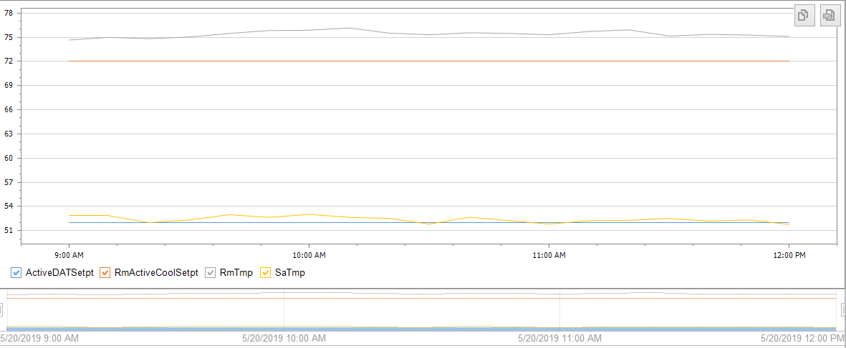

Zone Comfort Report

The BAS system controls the following zone temperatures to a heating and cooling setpoint. Each zone is scored based off of the deviation from these setpoints. The scoring is shown in the table below. The Zone comfort report also indicates the percent of time these zones are cold (below the heating setpoint by 1 degree), satisfied (between the heating and cooling setpoints) and hot (above the cooling setpoint by 1 degree).

Label | Bad | OK | Good
Score | 0 - 39 | 40 - 69 | 70 - 100
Deviation from Setpoint (DegF) | 3.0 - 1.8 | 1.8 - 0.9 | 0.9 - 0.0

Space Temperature Report - FPBs
Zone |  | Score | Cold | Satisfied | Hot | Cold Chart | Hot Chart
FPBP5_02 | OK | 18 | 1 | 16 | 83 | | | |||||||||||||||||||||||||||||||||||||||||||||||||||||||||||||||||||||||||||||||||||
FPB12_05 | OK | 40 | 15 | 32 | 54 | ||||||||||||||| | ||||||||||||||||||||||||||||||||||||||||||||||||||||||
FPBP5_04 | OK | 53 | 0 | 22 | 78 |  | ||||||||||||||||||||||||||||||||||||||||||||||||||||||||||||||||||||||||||||||
FPB4_03 | Good | 53 | 8 | 43 | 49 | |||||||| | |||||||||||||||||||||||||||||||||||||||||||||||||
FPB9_04 | Good | 54 | 1 | 30 | 69 | | | |||||||||||||||||||||||||||||||||||||||||||||||||||||||||||||||||||||
FPBP1_08 | OK | 55 | 55 | 41 | 4 | ||||||||||||||||||||||||||||||||||||||||||||||||||||||| | ||||
FPB12_10 | OK | 56 | 74 | 25 | 1 | |||||||||||||||||||||||||||||||||||||||||||||||||||||||||||||||||||||||||| | |
FPB8_04 | Good | 56 | 28 | 48 | 25 | |||||||||||||||||||||||||||| | |||||||||||||||||||||||||
FPB6_03 | Good | 56 | 9 | 46 | 44 | ||||||||| | ||||||||||||||||||||||||||||||||||||||||||||
FPBP1_05 | OK | 57 | 1 | 52 | 47 | | | |||||||||||||||||||||||||||||||||||||||||||||||
FPB3_03 | Good | 58 | 24 | 46 | 30 | |||||||||||||||||||||||| | ||||||||||||||||||||||||||||||
FPB3_04 | Good | 58 | 60 | 35 | 6 | |||||||||||||||||||||||||||||||||||||||||||||||||||||||||||| | ||||||
FPBP1_09 | Good | 59 | 51 | 46 | 3 | ||||||||||||||||||||||||||||||||||||||||||||||||||| | |||
FPB8_03 | Good | 59 | 8 | 53 | 40 | |||||||| | ||||||||||||||||||||||||||||||||||||||||
FPB5_03 | Good | 59 | 10 | 52 | 38 | |||||||||| | ||||||||||||||||||||||||||||||||||||||
FPB10_03 | Good | 60 | 15 | 54 | 31 | ||||||||||||||| | |||||||||||||||||||||||||||||||
FPB12_11 | Good | 61 | 1 | 49 | 49 | | | |||||||||||||||||||||||||||||||||||||||||||||||||
FPB9_03 | Good | 61 | 10 | 51 | 39 | |||||||||| | |||||||||||||||||||||||||||||||||||||||
FPB4_04 | Good | 61 | 9 | 52 | 39 | ||||||||| | |||||||||||||||||||||||||||||||||||||||
FPB5_05 | Good | 62 | 48 | 50 | 3 | |||||||||||||||||||||||||||||||||||||||||||||||| | |||
FPB5_02 | Good | 62 | 13 | 53 | 34 | ||||||||||||| | ||||||||||||||||||||||||||||||||||
FPBP1_13 | OK | 63 | 37 | 52 | 11 | ||||||||||||||||||||||||||||||||||||| | |||||||||||
FPBP5_06 | Good | 66 | 1 | 61 | 38 | | | ||||||||||||||||||||||||||||||||||||||
FPBP5_05 | Good | 66 | 1 | 61 | 39 | | | |||||||||||||||||||||||||||||||||||||||
FPBP1_06 | Good | 66 | 1 | 61 | 38 | | | ||||||||||||||||||||||||||||||||||||||
FPB11_03 | Good | 66 | 8 | 58 | 34 | |||||||| | ||||||||||||||||||||||||||||||||||
FPBP1_07 | Good | 67 | 20 | 58 | 22 | |||||||||||||||||||| | ||||||||||||||||||||||
FPB4_02 | Good | 67 | 8 | 60 | 33 | |||||||| | |||||||||||||||||||||||||||||||||
FPB9_02 | Good | 68 | 12 | 62 | 25 | |||||||||||| | |||||||||||||||||||||||||
FPB11_02 | Good | 69 | 10 | 64 | 27 | |||||||||| | |||||||||||||||||||||||||||
FPB12_06 | Good | 69 | 3 | 56 | 41 | ||| | |||||||||||||||||||||||||||||||||||||||||

Space Temperature Report - VAVs
Zone |  | Score | Cold | Satisfied | Hot | Cold Chart | Hot Chart
VAVP1_02 | Bad | 13 | 99 | 1 | 0 | |||||||||||||||||||||||||||||||||||||||||||||||||||||||||||||||||||||||||||||||||||||||||||||||||||
VAV5_11 | OK | 31 | 0 | 8 | 92 |  | ||||||||||||||||||||||||||||||||||||||||||||||||||||||||||||||||||||||||||||||||||||||||||||
VAVP3_02 | OK | 43 | 60 | 38 | 2 | |||||||||||||||||||||||||||||||||||||||||||||||||||||||||||| | ||
VAVP3_01 | Bad | 44 | 58 | 38 | 4 | |||||||||||||||||||||||||||||||||||||||||||||||||||||||||| | ||||
VAVP3_05 | OK | 44 | 43 | 40 | 17 | ||||||||||||||||||||||||||||||||||||||||||| | |||||||||||||||||
VAVP1_01 | OK | 45 | 56 | 31 | 14 | |||||||||||||||||||||||||||||||||||||||||||||||||||||||| | ||||||||||||||
VAV4_06 | OK | 45 | 3 | 33 | 64 | ||| | ||||||||||||||||||||||||||||||||||||||||||||||||||||||||||||||||
VAV3_06 | OK | 46 | 2 | 40 | 58 | || | ||||||||||||||||||||||||||||||||||||||||||||||||||||||||||
VAV5_01 | Good | 47 | 0 | 27 | 73 |  | |||||||||||||||||||||||||||||||||||||||||||||||||||||||||||||||||||||||||
VAV9_17 | Good | 48 | 0 | 25 | 75 |  | |||||||||||||||||||||||||||||||||||||||||||||||||||||||||||||||||||||||||||
VAV11_17 | Good | 52 | 0 | 32 | 68 |  | ||||||||||||||||||||||||||||||||||||||||||||||||||||||||||||||||||||
VAV3_11 | OK | 56 | 54 | 42 | 4 | |||||||||||||||||||||||||||||||||||||||||||||||||||||| | ||||
VAV7_03 | Good | 60 | 55 | 43 | 2 | ||||||||||||||||||||||||||||||||||||||||||||||||||||||| | ||
VAV12_16 | OK | 61 | 3 | 58 | 39 | ||| | |||||||||||||||||||||||||||||||||||||||
VAV3_08 | Good | 61 | 41 | 51 | 8 | ||||||||||||||||||||||||||||||||||||||||| | ||||||||
VAV3_16 | Good | 63 | 1 | 54 | 46 | | | ||||||||||||||||||||||||||||||||||||||||||||||
VAV8_17 | Good | 65 | 39 | 51 | 10 | ||||||||||||||||||||||||||||||||||||||| | ||||||||||
VAV5_19 | Good | 65 | 1 | 58 | 41 | | | |||||||||||||||||||||||||||||||||||||||||
VAV8_11 | Good | 66 | 0 | 60 | 40 |  | ||||||||||||||||||||||||||||||||||||||||
VAV3_01 | Good | 68 | 1 | 63 | 36 | | | ||||||||||||||||||||||||||||||||||||
VAV6_14 | Good | 68 | 47 | 49 | 3 | ||||||||||||||||||||||||||||||||||||||||||||||| | |||

Air Quality Report

The BAS system controls the following zone’s airflow to maintain an effective airflow setpoint for the purposes of air quality. Each zone is scored based off the airflow deviation from this effective setpoint. The scoring is shown in the table below. The air quality report also indicates the percent of time these zones are low (10% below), satisfied (at setpoint) and high (10% above).

Label | Bad | OK | Good
Score | 0 - 39 | 40 - 69 | 70 - 100
Airflow from Setpoint (%) | 100 - 20 | 20 - 10 | 10 - 0

Airflow Report - FPBs
Zone | Score | Low | Satisfied | High | Low Chart | High Chart
FPBP1_10 | 4 | 96 | 4 | 1 | |||||||||||||||||||||||||||||||||||||||||||||||||||||||||||||||||||||||||||||||||||||||||||||||| | |
FPBP1_11 | 9 | 24 | 5 | 71 | |||||||||||||||||||||||| | |||||||||||||||||||||||||||||||||||||||||||||||||||||||||||||||||||||||
FPBP1_12 | 10 | 10 | 8 | 81 | |||||||||| | |||||||||||||||||||||||||||||||||||||||||||||||||||||||||||||||||||||||||||||||||
FPBP1_13 | 21 | 80 | 18 | 2 | |||||||||||||||||||||||||||||||||||||||||||||||||||||||||||||||||||||||||||||||| | ||
FPBP1_08 | 27 | 30 | 13 | 56 | |||||||||||||||||||||||||||||| | ||||||||||||||||||||||||||||||||||||||||||||||||||||||||
FPB4_01 | 28 | 37 | 24 | 38 | ||||||||||||||||||||||||||||||||||||| | ||||||||||||||||||||||||||||||||||||||
FPBP1_04 | 41 | 33 | 38 | 29 | ||||||||||||||||||||||||||||||||| | |||||||||||||||||||||||||||||
FPB8_08 | 47 | 21 | 45 | 34 | ||||||||||||||||||||| | ||||||||||||||||||||||||||||||||||
FPBP1_02 | 52 | 29 | 46 | 25 | ||||||||||||||||||||||||||||| | |||||||||||||||||||||||||
FPBP5_04 | 56 | 74 | 22 | 4 | |||||||||||||||||||||||||||||||||||||||||||||||||||||||||||||||||||||||||| | ||||
FPB12_10 | 60 | 33 | 62 | 5 | ||||||||||||||||||||||||||||||||| | |||||
FPB4_05 | 62 | 30 | 65 | 6 | |||||||||||||||||||||||||||||| | ||||||
FPB7_07 | 63 | 15 | 57 | 28 | ||||||||||||||| | ||||||||||||||||||||||||||||
FPB7_06 | 68 | 15 | 65 | 19 | ||||||||||||||| | |||||||||||||||||||
FPB7_02 | 68 | 19 | 61 | 20 | ||||||||||||||||||| | ||||||||||||||||||||

Airflow Report - VAVs
Zone | Score | Low | Satisfied | High | Low Chart | High Chart
VAVP1_02 | 13 | 46 | 9 | 45 | |||||||||||||||||||||||||||||||||||||||||||||| | |||||||||||||||||||||||||||||||||||||||||||||
VAV7_17 | 20 | 78 | 13 | 9 | |||||||||||||||||||||||||||||||||||||||||||||||||||||||||||||||||||||||||||||| | |||||||||
VAV7_04 | 24 | 62 | 21 | 17 | |||||||||||||||||||||||||||||||||||||||||||||||||||||||||||||| | |||||||||||||||||
VAVP3_01 | 29 | 3 | 30 | 67 | ||| | |||||||||||||||||||||||||||||||||||||||||||||||||||||||||||||||||||
VAVP1_01 | 44 | 46 | 40 | 14 | |||||||||||||||||||||||||||||||||||||||||||||| | ||||||||||||||
VAV7_13 | 51 | 29 | 49 | 22 | ||||||||||||||||||||||||||||| | ||||||||||||||||||||||
VAV7_11 | 54 | 27 | 51 | 21 | ||||||||||||||||||||||||||| | |||||||||||||||||||||
VAVP3_02 | 55 | 29 | 47 | 23 | ||||||||||||||||||||||||||||| | |||||||||||||||||||||||
VAV3_13 | 57 | 2 | 60 | 38 | || | ||||||||||||||||||||||||||||||||||||||
VAV8_12 | 60 | 22 | 45 | 33 | |||||||||||||||||||||| | |||||||||||||||||||||||||||||||||
VAV7_05 | 60 | 18 | 53 | 30 | |||||||||||||||||| | ||||||||||||||||||||||||||||||
VAV11_16 | 60 | 3 | 62 | 35 | ||| | |||||||||||||||||||||||||||||||||||
VAV8_13 | 61 | 8 | 42 | 50 | |||||||| | ||||||||||||||||||||||||||||||||||||||||||||||||||
VAV11_11 | 65 | 17 | 65 | 18 | ||||||||||||||||| | ||||||||||||||||||
VAV7_09 | 66 | 20 | 66 | 13 | |||||||||||||||||||| | |||||||||||||
VAV8_18 | 68 | 27 | 56 | 16 | ||||||||||||||||||||||||||| | ||||||||||||||||

Summary Report

New Issues
Description | Responsibility | Date | Status | Quote
Series Fan Speed Too High – The Series fan is running too fast causing the box to pull in too much plenum air. This negatively impacts occupant comfort, and performance.  FPBP5_02, FPB12_05, FPB4_04, FPB12_11, FPB12_06, FPB9_03, FPB5_05, FPB5_02, FPB3_03 | LONG Controls
Low Discharge Air Temperature – The Electric reheat is active and the discharge air temp is less than 80 deg. This negatively impacts occupant comfort, and performance.  FPBP1_13, FPBP1_12, FPBP1_01, FPBP5_09, FPBP1_03 | LONG Controls
Low/High Airflow – See Zones in air quality report that scored poorly. | LONG Controls
Low/High Space Temperature – See Zones in space temperature report that scored poorly. | LONG Controls

Pending Issues
Description | Responsibility | Date | Status | Quote
Issue_1 - RTU_16’s discharge air temperature setpoint is causing the unit to hunt between 55 degree setpoint to 100 degree setpoint. LONG changed setpoints and modes per Daikins recommendation. | LONG Controls |  | Closed
Issue_2 - RTU_2’s cooling is enabled and the discharge air temperature is not lowering. This unit needs a new compressor and has been quoted. | LONG Mechanical |  | Pending
Issue_3 - HV – Space Temperature is more than 3 degrees above the effective space temperature setpoint while maintaining discharge air temperature at 55 degrees. This unit had cardboard in the outside air duct that LONG removed. The return grill had an extremely dirty filter and was also replaced. Graphics were also modified to better represent the unit | LONG Controls |  | Closed
Ping alarms occurring with the BACnet controllers – The server has been switching the network adapter and causing this communication issue. This issue was fixed. | LONG Controls |  | Closed
RTU_18 is overridden off because it is discharging 120 degrees and they can't control the space temperature. This needs to be looked at by LONG mechanical. | LONG Mechanical |  | Open
MAU – Hot Water Valve is overridden closed because it is not controlling to the space temperature. Mechanical service usually shuts off manual valve in summer and opens in the winter. LONG fixed the controls signal output to allow the valve to fully close and fixed the outside air temperature value. | LONG Controls |  | Closed
AHU_06/07 – The hot water and chilled water valves were overridden because they do not operate properly. LONG replaced valves and corrected programming/wiring issues. | LONG Controls |  | Closed

Other Notes

Your LONG Team – Contact Information

Account Manager
Your Account Manager Amy Stones has been instrumental in preparing this proposal and provides overall support and ensures resource availability for your service agreement.
Amy Stones has the final responsibility to make sure your needs are met.

Tel: 720.933.9064

Service Coordinator
Your Service Coordinator Jennifer Ribble schedules work orders and manages priorities.

Tel: 303.975.2149
Email: jribble@LONG.com

Lead Technician
Your Lead Technician professionals Brent Norwood and John Applegate know your building and have primary responsibility for your systems.

Emergency After Hours and Backup Technicians
LONG has a team of 24 control technicians and On-Call Emergency Technicians.

Tel: 303.975.2100

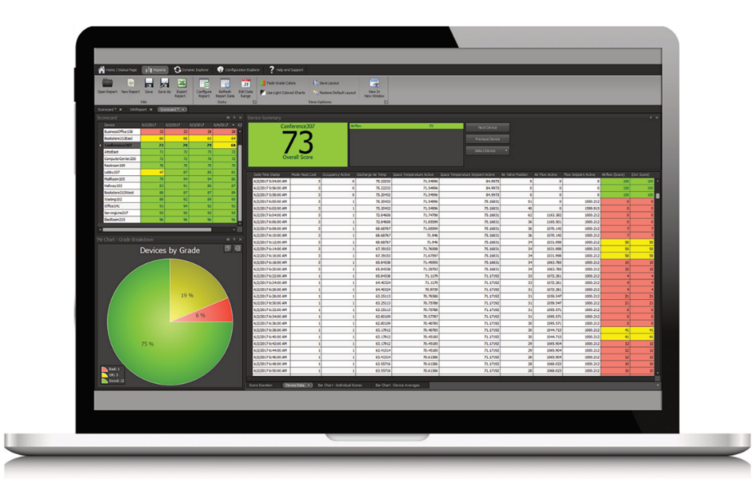
General Contact Information
LONG Building Technologies
5001 South Zuni Street
Littleton, Colorado, 80120

Main Office Phone: 303.975.2100
Main Office Fax: 303.936.2755

We make BUILDINGS WORK for people at every level because we CARE, we RESPOND, and we always deliver CONFIDENCE!

