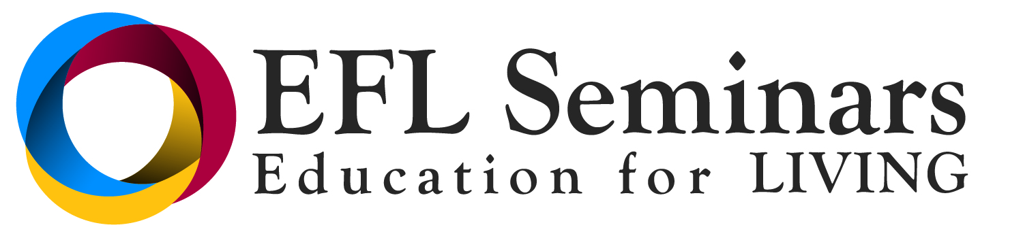
Leadership Essentials
applying ONTOLOGICAL AWARENESS with Karen White

In this three day workshop you will learn the essence of the underlying body of knowledge called Ontological Awareness and how to begin to apply this knowledge in your own personal and professional life. This program is suitable for anyone wanting to expand their relationships or lead others to more effectively observe and increase productivity through communication and coordinating action.

Don't miss this opportunity to work with Karen White with "the Human Connection" from Cape Town, South Africa.
Karen has coached leaders of global companies at Executive and Senior management level in a cross section of functions. Some of the organizations she has worked with are Toyota, British American Tobacco (SA), Microsoft Internationally, Woolworths, @ Home, Old Mutual, KWV, Juta Publishers, The Body Shop, Standard Bank, and senior officials in Government.
She works with Alan Sieler from The Newfield Institute, Australia, and Wendy Palmer from Leadership Embodiment in the USA.
Specialties: Executive Coaching; Leadership Embodiment; Ontological Coaching; Developing Leadership Presence, Leadership and Team Development

Cost: $795

EFL Community 25% discount

UPCOMING COURSE DATES

June 1-3 Friday - Sunday 2018 Baton Rouge, LA

9:00am - 6:00pm / Lunch is provided

This course is open to anyone 18 years of age or older. No previous coursework is required.

To register or for additional information go to www.eflseminars.com or call 888.304.0627

Join us for a profound learning experience that will allow you to:
- Engage in a powerful, highly effective approach to conversations, capable of generating deep positive change
- Greatly increase your own ability and capacity for masterful living and action
- Lead authentically with greater influence and impact
- Develop more constructive and mutually fulfilling relationships in both your personal and professional life

