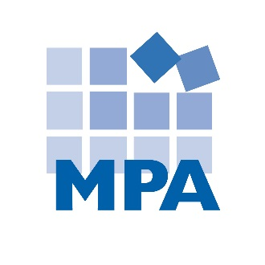
MPA Compliance Update
Margaret Scavotto and Scott Gima
September 3, 2019

CMS Changes SNF Compliance Program Requirements – Again
Ladies and gentlemen, long-anticipated compliance program requirements are changing, one more time. Let’s take a look at what has changed – and what hasn’t.
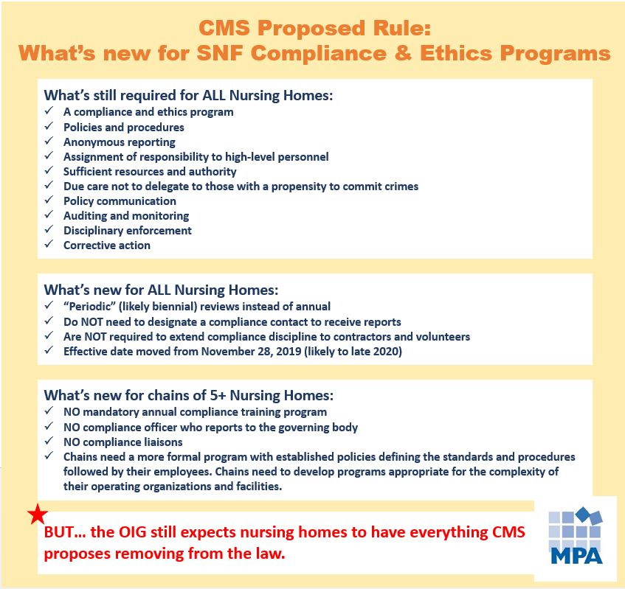

The proposed rule
On July 16, 2019, CMS published a proposed rule that would modify multiple aspects of Phase III of the Long-Term Care Facilities Requirements for Participation (the “Proposed Rule”). The goal of the Proposed Rule is to reduce regulatory burdens and costs, allowing nursing homes to focus resources on providing quality resident care. Some of the most discussed proposed amendments are those to the Compliance and Ethics Program requirements (42 CFR 483.85), which, if finalized, will become effective one year later. With comments from the public due September 16, 2019, our best guess is that enforcement will begin October or November 2020.
Good news: fewer compliance-related F-tags ahead
Nursing homes: LeadingAge (and other associations) successfully lobbied on your behalf. The prior rule required nursing homes to designate specific personnel as 1) compliance officers, 2) individuals to receive compliance reports, and 3) for chains of five or more nursing homes, compliance liaisons. The message conveyed to CMS was that these requirements were too burdensome, and took staff time away from resident care. The Proposed Rule seems to incorporate this message loud and clear.
The Proposed Rule removed more than the designated personnel requirements. Annual review, annual training, discipline for volunteers and contractors, and more requirements are gone. For a complete summary of the proposed changes, see the tables below. What is left is a more general compliance program framework from CMS.
Because the Proposed Rule reduces the number of compliance survey requirements, there are fewer potential F-tags on your survey. These largely new and untested requirements would also have been subjected to variation in surveyor interpretations come November 28, 2019. The bottom line is that the Proposed Rule potentially brings good news for nursing homes: reduced compliance requirements and reduced potential F –Tags.
But don’t forget about the OIG
But, be careful. Everything CMS removed from the Proposed Rule is still recommended by the OIG in its Compliance Program Guidance documents for nursing facilities. For three decades, providers, including nursing homes, have followed this OIG guidance when developing compliance programs – and it’s still the gold standard. CMS’ comments in the Proposed Rule acknowledge this when they recommend that nursing homes refer to the OIG guidance. Nursing homes still need to develop and maintain compliance programs that adhere to the OIG guidance.
What is the difference between survey enforcement and OIG enforcement?
When the Proposed Rule becomes final, the Phase III Compliance and Ethics Program requirements will be enforced through the survey process. The OIG, on the other hand, enforces compliance related laws, such as the False Claims Act, the Anti-Kickback Law, the Stark Law, and the Civil Monetary Penalties Law. OIG enforcement is far more serious: civil monetary penalties, costly settlements, potential jail time, legal expenses, and loss of government reimbursement.
The OIG recognizes that compliance programs prevent and detect the types of misconduct that violate these laws. More than one Assistant US Attorney has told MPA that all providers should have an effective compliance program in place. If the OIG knocks on your door to conduct an investigation, they will look for a working compliance program. If one is not in place, the provider will likely face larger exposure to federal fines and penalties. And, if a provider has a compliance program, that provider is more likely to prevent the type of violations that can lead to an OIG investigation in the first place.
Proceed with caution
While it is OK to celebrate the reduction in regulatory requirements, please be careful.
Everything CMS took out is still recommended by the OIG.
What does this mean?
- CMS will not require you to designate a compliance officer, but the OIG does.
- CMS will not require you to review your compliance program every year, but the OIG does.
- CMS will not require chains of five or more nursing homes to provide compliance training, but the OIG expects all nursing homes to provide annual compliance training.
- CMS will not require chains of five or more nursing homes to designate compliance liaisons, but the OIG expects all nursing home chains to do this.
The bottom line
Under the proposed rule, CMS compliance requirements do not meet OIG expectations for compliance programs.
Enjoy the survey break!
But don’t jeopardize your compliance effort over the Proposed Rule. The OIG should be, and still is, the last word on compliance. Your compliance program should be created to meet OIG expectations. If the OIG shows up at your nursing home, will you be ready?
Coming soon
Stay tuned for more MPA blogs on the CMS Proposed Rule:
- Phase III: Do you need a Compliance Officer?
- Phase III: Do SNFs need to conduct a compliance program annual review?

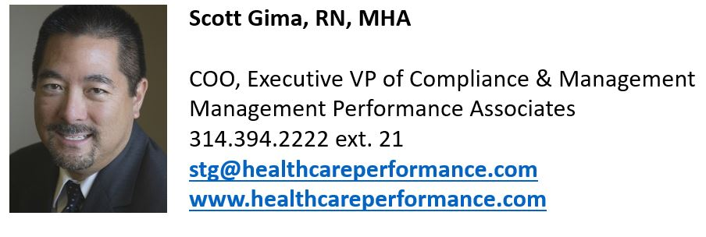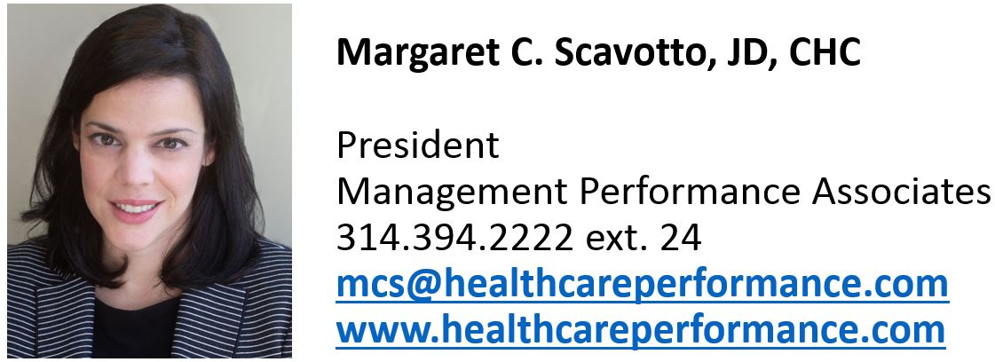

Phase III Proposed Regulation Chart – Summary
This chart shows a summary of the proposed regulatory changes.
- The “Old Rule” column lists a summary of the old rule sections.
- The “Proposed Rule” column lists a summary of the proposed rule sections.
- To see the regulatory changes verbatim, scroll down to the next table.
CITE | OLD RULE | PROPOSED RULE
42 CFR 483.85(a) | EFFECTIVE DATE: November 28, 2019 | EFFECTIVE DATE: One year after the proposed rule becomes final. Comments on the proposed rule are due September 16, 2019. Estimate: Late 2020.
42 CFR 483.85(c) | Each nursing facility must have a compliance and ethics program. | No changes.
42 CFR 483.85(c) | The operating organization for each facility must develop, implement, and maintain an effective compliance and ethics program that contains, at a minimum, the following components: | No changes.
42 CFR 483.85(c)(1) | Written compliance and ethics standards, policies, and procedures that are reasonably capable of reducing the prospect of criminal, civil, and administrative violations and promote quality of care.  These policies should include:  - designation of a compliance contact to receive reports  - another method of reporting non-compliance anonymously without fear of retribution  - disciplinary standards with consequences for staff, contractors, and volunteers | - CMS took out the reference to quality of care.  - CMS took out the requirement to designate a compliance contact to receive reports.  - CMS took out the requirement to have another method of reporting – but added it back in separately: see (c)(9).  - CMS took out the discipline standards for staff, contractors and volunteers. Discipline is addressed at (c)(7), but SNFs are no longer required to extend compliance discipline to contractors and volunteers.
42 CFR 483.85(c)(2) | Assignment of high-level personnel with responsibility to oversee compliance.  Examples: CEO, board members, directors of major divisions. | - CMS removed the list of examples. In the comments, CMS leaves it to the SNFs to determine who should be responsible for compliance oversight.
42 CFR 483.85(c)(3) | Designate sufficient resources and authority to the high-level personnel overseeing compliance to reasonably assure compliance with the program. | No changes.
42 CFR 483.85(c)(4) | Due care not to delegate substantial discretionary authority to individuals who the facility knew, or should have known through the exercise of due diligence, had a propensity to engage in criminal, civil, and administrative misconduct. | No changes.
42 CFR 483.85(c)(5) | Communicate compliance standards, policies, and procedures to staff, contractors, and volunteers, consistent with the volunteers' expected roles.  Options include:  - Mandatory training, or  - Disseminating information | No changes.
42 CFR 483.85(c)(6) | Reasonable steps to achieve compliance with standards, policies, and procedures.  Steps include:  - Monitoring and auditing systems to detect non-compliance by staff, contractors or volunteers  - An anonymous reporting system without fear of retribution  - A process for ensuring the integrity of any reported data | - CMS removed the word “anonymous” from the reporting system; but CMS address anonymity in (c)(9).  - CMS removed the requirement for a process to ensure the integrity of reported data.
42 CFR 483.85(c)(7) | Consistent enforcement through discipline, including discipline for failing to detect or report non-compliance. | No change.
42 CFR 483.85(c)(8) | The organization must respond to compliance violations appropriately and take steps to prevent future violations. | No change.
42 CFR 483.85(c)(9) |  | SNFs must have an alternate method of reporting violations anonymously.
42 CFR 483.85(e) | All nursing homes must conduct an annual review of their compliance programs and revise their compliance programs accordingly. | All nursing homes must conduct a “periodic” review of their compliance programs and review their compliance programs accordingly. “Periodic” is not defined in the regulation; however CMS refers to a “biennial” review in the regulation comments. Hopefully this will be clarified in the final rule.
42 CFR 483.85(d) | REQUIREMENTS FOR SNF CHAINS OF 5+ FACILITIES
42 CFR 483.85(d) | Chains of 5+ SNFs were required to have a mandatory annual compliance and ethics training program. | This is no longer required.
42 CFR 483.85(d) | Chains of 5+ SNFs were required to designate a compliance officer who reported to the governing body. | This is no longer required.
42 CFR 483.85(d) | Chains of 5+ SNFs were required to designate compliance liaisons at each facility. | This is no longer required.
42 CFR 483.85(d) |  | Chains of 5+ SNFs will need to have a more formal program with established written policies defining the standards and procedures followed by their employees.
42 CFR 483.85(d) |  | Chains of 5+ SNFs will need to develop compliance and ethics programs appropriate for the complexity of their operating organizations and facilities.

Phase III Proposed Regulation Chart - Verbatim
This chart shows the proposed regulatory changes, word for word.
- The “Old Rule” column lists the language from the old rule.
- The “Proposed Rule” column lists proposed changes to the regulation in red.

CITE | OLD RULE | PROPOSED RULE
42 CFR 483.85(a) | Compliance and ethics program means, with respect to a facility, a program of the operating organization that—  (i) Has been reasonably designed, implemented, and enforced so that it is likely to be effective in preventing and detecting criminal, civil, and administrative violations under the Act and in promoting quality of care; and  (ii) Includes, at a minimum, the required components specified in paragraph (c) of this section. | NO CHANGES.
42 CFR 483.85(a) | High-level personnel means individual(s) who have substantial control over the operating organization or who have a substantial role in the making of policy within the operating organization. | NO CHANGES.
42 CFR 483.85(a) | Operating organization means the individual(s) or entity that operates a facility. | NO CHANGES.
42 CFR 483.85(b) | General rule. Beginning on November 28, 2019, the operating organization for each facility must have in operation a compliance and ethics program (as defined in paragraph (a) of this section) that meets the requirements of this section. | NO CHANGES. [Note: While CMS did not change the date, CMS commented that the effective date will be one year from the date the rule becomes final]
42 CFR 483.85(c) | Required components for all facilities. The operating organization for each facility must develop, implement, and maintain an effective compliance and ethics program that contains, at a minimum, the following components: | NO CHANGES.
42 CFR 483.85(c)(1) | Established written compliance and ethics standards, policies, and procedures to follow that are reasonably capable of reducing the prospect of criminal, civil, and administrative violations under the Act and promote quality of care, which include, but are not limited to, the designation of an appropriate compliance and ethics program contact to which individuals may report suspected violations, as well as an alternate method of reporting suspected violations anonymously without fear of retribution; and disciplinary standards that set out the consequences for committing violations for the operating organization's entire staff; individuals providing services under a contractual arrangement; and volunteers, consistent with the volunteers' expected roles. | Established written compliance and ethics standards, policies, and procedures to follow that are reasonably capable of reducing the prospect of criminal, civil, and administrative violations under the Act and promote quality of care, which include, but are not limited to, the designation of an appropriate compliance and ethics program contact to which individuals may report suspected violations, as well as an alternate method of reporting suspected violations anonymously without fear of retribution; and disciplinary standards that set out the consequences for committing violations for the operating organization's entire staff; individuals providing services under a contractual arrangement; and volunteers, consistent with the volunteers' expected roles.
42 CFR 483.85(c)(2) | Assignment of specific individuals within the high-level personnel of the operating organization with the overall responsibility to oversee compliance with the operating organization's compliance and ethics program's standards, policies, and procedures, such as, but not limited to, the chief executive officer (CEO), members of the board of directors, or directors of major divisions in the operating organization. | Assignment of specific individuals within the high-level personnel of the operating organization with the overall responsibility to oversee compliance with the operating organization's compliance and ethics program's standards, policies, and procedures, such as, but not limited to, the chief executive officer (CEO), members of the board of directors, or directors of major divisions in the operating organization.
42 CFR 483.85(c)(3) | Sufficient resources and authority to the specific individuals designated in paragraph (c)(2) of this section to reasonably assure compliance with such standards, policies, and procedures. | NO CHANGES
42 CFR 483.85(c)(4) | Due care not to delegate substantial discretionary authority to individuals who the operating organization knew, or should have known through the exercise of due diligence, had a propensity to engage in criminal, civil, and administrative violations under the Social Security Act. | NO CHANGES.
42 CFR 483.85(c)(5) | The facility takes steps to effectively communicate the standards, policies, and procedures in the operating organization's compliance and ethics program to the operating organization's entire staff; individuals providing services under a contractual arrangement; and volunteers, consistent with the volunteers' expected roles. Requirements include, but are not limited to, mandatory participation in training as set forth at § 483.95(f) or orientation programs, or disseminating information that explains in a practical manner what is required under the program. | NO CHANGES.
42 CFR 483.85(c)(6) | The facility takes reasonable steps to achieve compliance with the program's standards, policies, and procedures. Such steps include, but are not limited to, utilizing monitoring and auditing systems reasonably designed to detect criminal, civil, and administrative violations under the Act by any of the operating organization's staff, individuals providing services under a contractual arrangement, or volunteers, having in place and publicizing a reporting system whereby any of these individuals could report violations by others anonymously within the operating organization without fear of retribution, and having a process for ensuring the integrity of any reported data. | The facility takes reasonable steps to achieve compliance with the program's standards, policies, and procedures. Such steps include, but are not limited to, utilizing monitoring and auditing systems reasonably designed to detect criminal, civil, and administrative violations under the Act by any of the operating organization's staff, individuals providing services under a contractual arrangement, or volunteers, having in place and publicizing a reporting system whereby any of these individuals could report violations by others anonymous within the operating organization without fear of retribution, and having a process for ensuring the integrity of any reported data.
42 CFR 483.85(c)(7) | Consistent enforcement of the operating organization's standards, policies, and procedures through appropriate disciplinary mechanisms, including, as appropriate, discipline of individuals responsible for the failure to detect and report a violation to the compliance and ethics program contact identified in the operating organization's compliance and ethics program. | NO CHANGES.
42 CFR 483.85(c)(8) | After a violation is detected, the operating organization must ensure that all reasonable steps identified in its program are taken to respond appropriately to the violation and to prevent further similar violations, including any necessary modification to the operating organization's program to prevent and detect criminal, civil, and administrative violations under the Act. | NO CHANGES.
42 CFR 483.85(c)(9) |  | (9) The facility has an alternate method of reporting suspected violations anonymously.
42 CFR 483.85(e) | Annual review. The operating organization for each facility must review its compliance and ethics program annually and revise its program as needed to reflect changes in all applicable laws or regulations and within the operating organization and its facilities to improve its performance in deterring, reducing, and detecting violations under the Act and in promoting quality of care. | Program review. The operating organization for each facility must periodically review and revise its compliance program to identify necessary changes within the organization and its facilities.
 | REQUIREMENTS FOR SNF CHAINS OF 5+ FACILITIES
42 CFR 483.85(d) | Additional required components for operating organizations with five or more facilities. In addition to all of the other requirements in paragraphs (a), (b), (c), and (e) of this section, operating organizations that operate five or more facilities must also include, at a minimum, the following components in their compliance and ethics program: | Additional required components for operating organizations with five or more facilities. In addition to all of the other requirements in paragraphs (a), (b), (c), and (e) of this section, operating organizations that operate five or more facilities and facilities with corporate level management of multi-unit nursing home chains must comply with these additional requirements must:
42 CFR 483.85(d) | - A mandatory annual training program on the operating organization's compliance and ethics program that meets the requirements set forth in § 483.95(f).  - A designated compliance officer for whom the operating organization's compliance and ethics program is a major responsibility. This individual must report directly to the operating organization's governing body and not be subordinate to the general counsel, chief financial officer or chief operating officer.  - Designated compliance liaisons located at each of the operating organization's facilities. | - A mandatory annual training program on the operating organization's compliance and ethics program that meets the requirements set forth in § 483.95(f).  - A designated compliance officer for whom the operating organization's compliance and ethics program is a major responsibility. This individual must report directly to the operating organization's governing body and not be subordinate to the general counsel, chief financial officer or chief operating officer.  - Designated compliance liaisons located at each of the operating organization's facilities.  (1) Have a more formal program that includes established written policies defining the standards and procedures to be followed by its employees.  (2) Develop a compliance and ethics program that is appropriate for the complexity of the operating organization and its facilities.

https://www.federalregister.gov/documents/2019/07/18/2019-14946/medicare-and-medicaid-programs-requirements-for-long-term-care-facilities-regulatory-provisions-to
OIG Compliance Program Guidance for Nursing Facilities, March 16, 2000, available at https://oig.hhs.gov/authorities/docs/cpgnf.pdf; and OIG Supplemental Compliance Program Guidance for Nursing Facilities, September 30, 2008, available at https://oig.hhs.gov/compliance/compliance-guidance/docs/complianceguidance/nhg_fr.pdf

