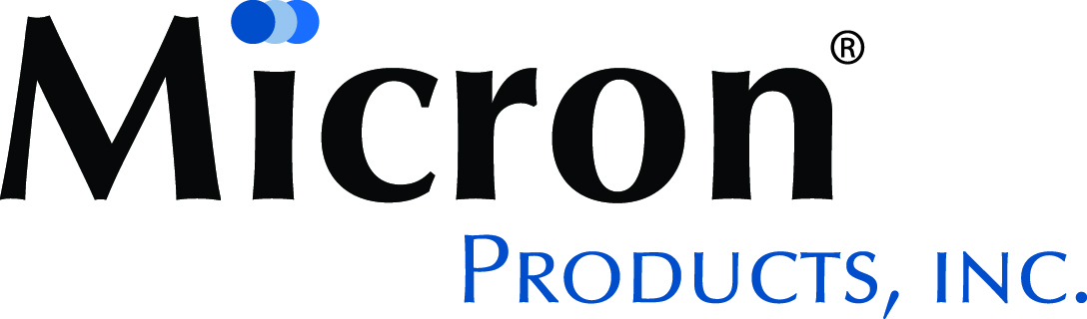
Mold Technician – 2nd Shift

Micron Products is a world class contract manufacturer for the Medical Device, Defense and Life Sciences markets. Established in 1978, we are located in Fitchburg, Massachusetts. Our specialties include Precision Machining, Thermoplastic Injection Molding, Mold Making and Sensors.

JOB PURPOSE

Provide all aspects of plastic injection molding support. This person is also responsible for continuous improvement in manufacturing

KEY ACCOUNTABILITIES

Job Specific Responsibilities:
- Ability to install molds
- Ability to start and troubleshoot molding machine, respond to alarms
- Assure that documentation and process records are complete, accurate, and reflect current systems
- Must adhere to all company policies
- Must have a basic understanding of QMS related to ISO 13485
- Must have a basic understanding of Work Instructions and their related data collection documents (e.g. run sheets)
- Participate in safety activities, and alert management of any unsafe conditions
- Perform and document specific tests such as material testing and process/product validations
- Provide technical assistance to Manufacturing as needed
- Provides technical support for non-routine issues
- Statistical Process Control
- Support Clean Room operations

JOB QUALIFICATIONS

- Minimum of 3 years’ experience in injection molding process troubleshooting.
- Ability to program molding machine robots
- Experience with medical device molding and documentation.
- Familiarity with clean room operations.
- Understanding of Scientific Molding
- Experience with Quality Management Systems ISO 13485

Micron Products, Inc. is an equal opportunity employer and considers qualified applicants for employment without regard to race, color, religion, national origin, sex, sexual orientation, gender identify, age, disability, genetic information, veteran status, or any other characteristic protected by law.

Apply

