LEADERSHIP DEVELOPMENT
Building Leaders for Performance
and Potential
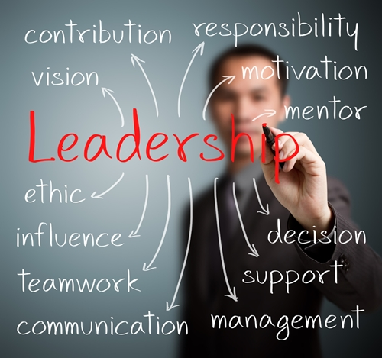

BUILDING LEADERS
Leadership is the cornerstone of success in every pursuit and organization. In many companies, the strategy and growth are constrained by a lack of effective leaders and/or a shallow bench of future leaders. CMP helps companies meet this leadership imperative through an extensive leadership curriculum that is customized for each company.

COMPETENCY DRIVEN  Training and development is focused on the skills and behaviors needed to effectively lead within a specific environment. Competencies are used to develop the curriculum, and create a common language and framework for leaders. | LOCAL LEADER SPONSORSHIP  The credibility of the training and application back on the job needs to be supported by senior leadership. This ensures real and symbolic support with accountability for application.

OUTCOME FOCUSED | STRATEGICALLY ALIGNED
To gauge and reinforce the impact of the training investment, CMP introduces key measures to assess and reinforce the use of the competencies. This is done through both process and outcome measures. | The development curriculum is customized to reinforce the unique priorities and desired culture of a company. This includes the use of relevant examples and activities.

ALIGNED APPLICATION AND ACCOUNTABILITY
For the newly acquired competencies to “stick”, they need to be used soon after a session. To facilitate this, CMP curriculum is designed to promote application of the new behaviors immediately back on the job.

CMP marries decades of leadership development experience with contemporary adult learning approaches to build the “right” solution for each client.
CMP is a talent and transition firm in the business of developing people and organizations across the full talent life cycle – from talent acquisition and leadership development, to organization development and career transition support. To learn more, give us a call today at 800.680.7768 or request more info.

