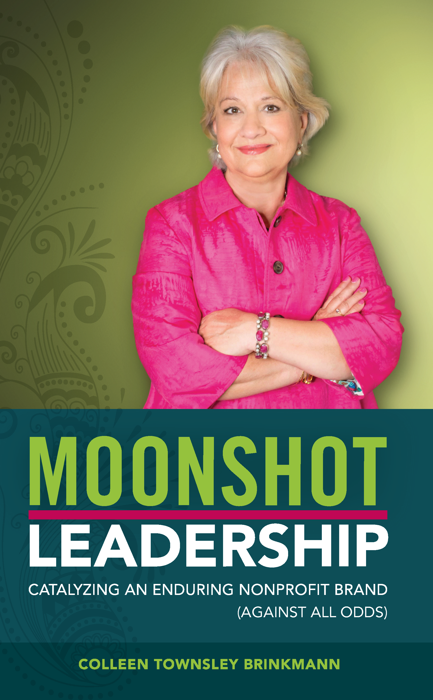

MOONSHOT LEADERSHIP: Catalyzing an Enduring Non-Profit Brand (Against All Odds)

Colleen Townsley Brinkmann, a highly regarded non-profit industry strategist and former Chief Philanthropy Officer for North Texas Food Bank (NTFB), has authorized a new book titled, Moonshot Leadership: Catalyzing an Enduring Non-Profit Brand (Against All Odds). This book offers an inside look at the rise and sustained success of NTFB, highlighting key lessons and insights that are applicable to all leaders with a vision and need to mobilize others. The book includes Reflection Discussion exercises.

Recently, Brinkmann joined CMP as the Senior Consultant, Purpose-Driven Strategy, and Brand. In this role, she provides strategic service to purpose-driven non-profits, businesses, and corporations.

CMP is a talent and transition firm in the business of developing people and organizations across the full talent life cycle – from talent acquisition and leadership development, to organization development and career transi- tion support. To learn more, give us a call today at 800.680.7768 or request more info.
MOONSHOT LEADERSHIP WILL BENEFIT:  Nonprofit CEOs and executives  - Development leaders & gift officers  - Marketing & Communications leaders  - Grant writers  - Volunteer program leaders  - Non-profit board members  - Prospective non-profit board members  - Social entrepreneurs  - Corporate Social Responsibility leaders  - Businesses with non-profit clients & partners  - Students & anyone driven to achieve transformational impact  The Moonshot Leadership, practiced and exhibited by NTFB, led to a 588% increase in public support between 2004-2018 (2.6 million-17.9 million), a successful capital campaign realizing over $55 million, and, most importantly, the reduction of food insecurity in a region larger than many countries. | TESTIMONIALS:  Jan and Colleen’s combined talents grew the North Texas Food Bank (NTFB) into a leading impact organization which currently provides over 70 million nutritious meals annually and aims to provide 92 million by 2025. Colleen's journey, as explained in her book, is intimate and engaging, and explains the source of her passion for both helping those at the front lines as well as inviting others to join the mission.  -Katherine Perot Reeves, Civic Leader  A must-read for anyone in business or nonprofit…What happened at the North Texas Food Bank is as remarkable as planting your flag on Everest without the aid of a compass.  -Anurag Jain, Chairman, Access Healthcare  Colleen is a natural-born leader, communicator, and connector with a background that exhibits inclusion, diversity, and tremendous concern for others. It was an honor to work with her at the North Texas Food Bank…  -Preston Pearson, Five-time Super Bowl Participant with two Championships, Baltimore Colts, Pittsburgh Steelers, Dallas Cowboys

