EMPLOYEE CULTURE ANALYSIS
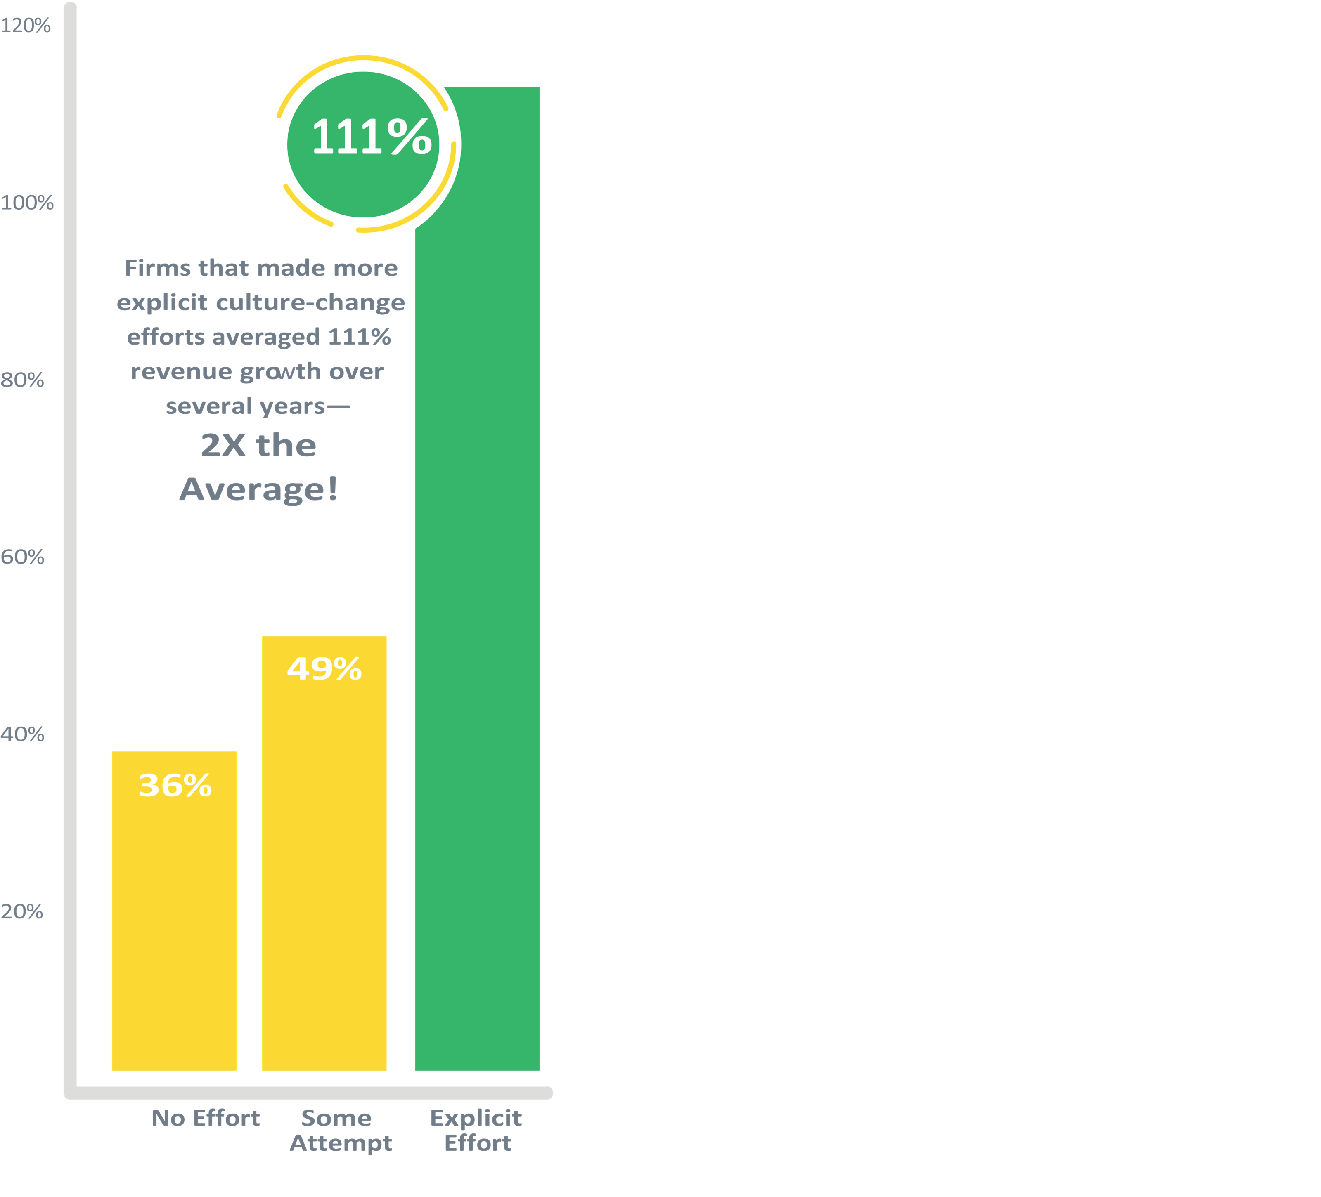

Strengthen Predictive Solutions for Culture and Employee Engagement

OVERVIEW

An analytics solution that helps companies understand and hire based on their unique culture as well as improve employee engagement. The technology benchmarks an organization’s culture by gathering critical input on how employees view the company’s core values, as well as their own motivators, and then measures candidates against that data to gauge culture fit. By continually engaging the process, companies can better understand their culture and consistently improve it to enhance performance.

QUANTITATIVE
Culture is the pattern of behavior that is reinforced by people and systems over time.
- Culture is a social control system that already operates within your organizations.
- If you don’t manage it, this control system can undermine your ability to effectively execute your strengths.
- You can diagnose and manage the culture in your company.
- Quantify cultural strength on both boards.
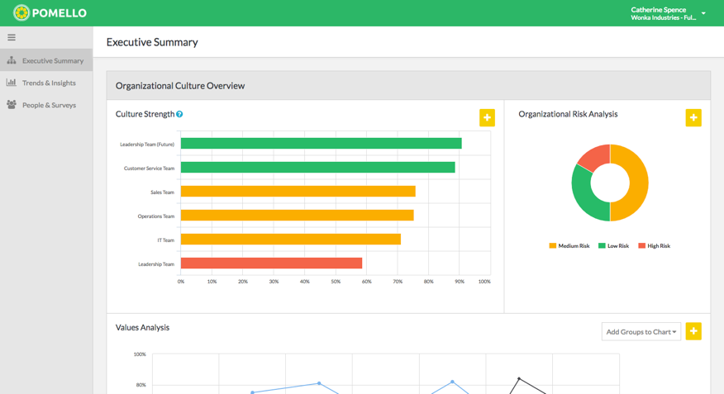

- Compare desired values vs. existing values.
- Set cultural strength goals & track progress.
- Empower a cohesive board with deep cultural insights.
- Surface underlying cultural issues.
- Improve board engagement.
- Measure the ROI of culture initiatives.
- Transform culture to meet the desired state.
- Align new board around cultural gaps & needs.

CMP is a talent and transition firm in the business of developing people and organizations across the full talent life cycle – from talent acquisition and leadership development, to organization development and career transition support. To learn more, give us a call today at 800.680.7768 or request more info.
Statistics indicate that actively managed company can lead to twice the average revenue growth when compared to companies that are not actively managing their culture.

