CMP is a talent and transition firm in the business of developing people and organizations across the full talent life cycle – from talent acquisition and leadership development, to organization development and career transition support. To learn more, give us a call today at 800.680.7768 or request more info.
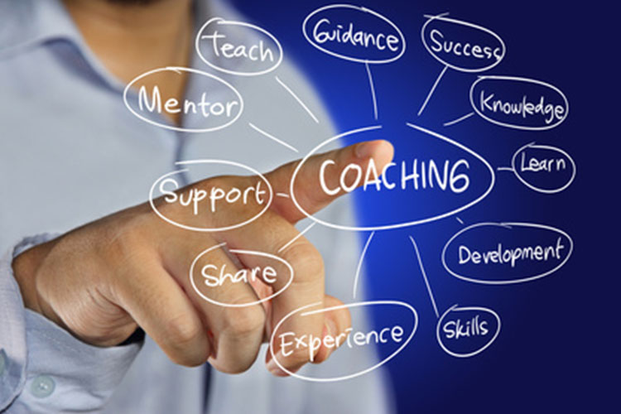

TABLE COACHING

Leverage the focus of coaching

and the strength of the group
DESIGNING FOR HIGH IMPACT

Table coaching provides a uniquely impactful development experience if designed correctly. The design of a table coaching solution needs to meet the unique requirements of a company within the following design principles:

Start small and learn – have some early successes with a manageable number of Table Coaching participants.  Limited resource burden – The approach needs to be effective, efficient, simple, and scalable with success.  Apply best practices to a formal program – the best practices from other companies need to be leveraged to minimize the company learning curve. | Develop a strong cohort of connected future leaders – design of interactions and learning builds bridges and facilitates cross-functional collaboration.  Make it “stick” through accountability-paired learning and follow-up support the embedment of learning and individual development commitments.  Migrate capability inside the company – the tools and practices need to be taught and transferred to people within the company.

LEVERAGE FOR ORGANIZATION IMPACT
The reach of Table Coaching solutions can also be leveraged to drive broader organization learning and change. When designed and implemented effectively, companies have realized measurable results in retention, performance, succession readiness, employee engagement, and process product innovation.
.

