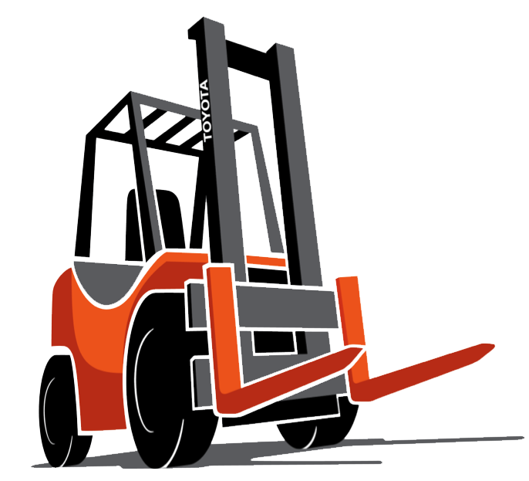
Forklift Training Outline

Operator training
  - Safe operation- The employer shall ensure that each powered industrial truck operator is competent to operate a powered industrial truck safely, as demonstrated by the successful completion of the training and evaluation.

  - Prior to permitting an employee to operate a powered industrial truck (except for training purposes), the employer shall ensure that each operator has successfully completed the training required.
Training program implementation.
Trainees may operate a powered industrial truck only:
- Under the direct supervision of persons who have the knowledge, training, and experience to train operators and evaluate their competence; and
- Where such operation does not endanger the trainee or other employees.
Training shall consist of a combination of
- Formal instruction (e.g., lecture, discussion, interactive computer learning, video tape, written material),
- Practical training (demonstrations performed by the trainer and practical exercises performed by the trainee)
- Evaluation of the operator's performance in the workplace.
All operator training and evaluation shall be conducted by persons who have the knowledge, training, and experience to train powered industrial truck operators and evaluate their competence.
Training program content.
Powered industrial truck operators shall receive initial training in the following topics, except in topics which the employer can demonstrate are not applicable to safe operation of the truck in the employer's workplace.
Truck-related topics:
- Operating instructions, warnings, and precautions for the types of truck the operator will be authorized to operate;
- Differences between the truck and the automobile;
- Truck controls and instrumentation: where they are located, what they do, and how they work;
- Engine or motor operation;
- Steering and maneuvering;
- Visibility (including restrictions due to loading);
- Fork and attachment adaptation, operation, and use limitations;
- Vehicle capacity;
- Vehicle stability;
- Any vehicle inspection and maintenance that the operator will be required to perform;
- Refueling and/or charging and recharging of batteries;
- Operating limitations;
- Any other operating instructions, warnings, or precautions listed in the operator's manual for the types of vehicle that the employee is being trained to operate.
Workplace-related topics:
- Surface conditions where the vehicle will be operated;
- Composition of loads to be carried and load stability;
- Load manipulation, stacking, and unstacking;
- Pedestrian traffic in areas where the vehicle will be operated;
- Narrow aisles and other restricted places where the vehicle will be operated;
- Hazardous (classified) locations where the vehicle will be operated;
- Ramps and other sloped surfaces that could affect the vehicle's stability;
- Closed environments and other areas where insufficient ventilation or poor vehicle maintenance could cause a buildup of carbon monoxide or diesel exhaust;
- Other unique or potentially hazardous environmental conditions in the workplace that could affect safe operation.
Certification. The employer shall certify that each operator has been trained and evaluated as required by this paragraph (l). The certification shall include the name of the operator, the date of the training, the date of the evaluation, and the identity of the person(s) performing the training or evaluation.

