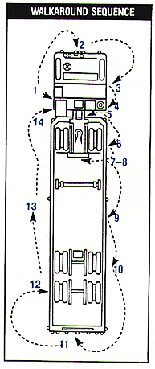
Pre-Trip Inspection Procedure
Stations 1, 3, 6, 10 and 12 Wheels and Brakes
- Inspect wheels for cracks, bent rims and broken studs, clamps and lugs. Check the inflation and valve stems, look for cuts, bulges, tread wear and signs of misalignment.
- Inspect wheel bearing and hub for leaking.
- Dual wheels should be evenly matched with the same type of tires.
- Check the condition of the brake drums, hoses, air chamber mounting and slack adjusters.
Station 2 Front Cab
- Check steering wheel system for damaged parts, inspect windshield and wiper blades, check lights, signal indicators and reflectors.
Stations 4 and 14 Saddle Tanks
- Fuel tanks and caps should be secure and not leaking.
- Check for leaks from the rear of the engine, transmission, drive shaft and exhaust system.
- Air lines and electrical wiring should be secure.
- Check frame and cross members for damage
- Battery and battery box should be secure: check battery fluid and cell caps.
Station 5 Trailer Front
- Glad hands should be properly mounted, undamaged and not leaking.
- Check the seating and safety catch on electrical plugs and secure air and electrical lines against tangling, snagging and chafing, with sufficient slack for turns.
Station 7 Rear of Tractor
- Cross members should not be bent or cracked.
- Lights and reflectors should be clean and operating.
- Secure air lines to frame.
Station 8 Fifth Wheel
- The fifth wheel should be securely mounted to the frame with no missing or damaged and no visible space between the upper and lower fifth wheel.
- Locking jaws should secure the shank, not the head of the kingpin, and the release lever should be properly seated and the safety lock engaged.
Stations 9 and 13 Trailer Sides
- Landing gear and dollies should be raised.
- Check for air or hydraulic leaks.
- Check the spare tire rack for damage and secure the wheel after checking its inflation level.
- Lights should be clean and operating.
- All placards should match.
Station 11 Trailer Rear
- Cargo and tailboard should be secured and canvas or tarp lashed down.
- Latch and lock rear doors and check the underguard.

