|  |  |  |  |  |  |
| --- | --- | --- | --- | --- | --- |
| |  | | --- | |  | | No automatic alt text available. | | | **PASTORAL CLINICAL MENTAL HEALTH COUNSELING**  **NEUMANN UNIVERSITY October, 2018**    PCMHC  PCMHC News  PCMHC  PCMHC  **PASTORAL CLINICAL MENTAL HEALTH COUNSELING**  **NEUMANN UNIVERSITY**  **PASTORAL CLINICAL MENTAL HEALTH COUNSELING**  **NEUMANN UNIVERSITY**  **PASTORAL CLINICAL MENTAL HEALTH COUNSELING**  **NEUMANN UNIVERSITY**  New Look New Content New Style News Journal  Grad School is CallingNeumann Graduate Admissions Grad School is Calling  **See Inside for**  **World Renowned Speaker and Family Practitioner To Give Lecture on Impact of Systems Work P. 2**  **Faculty Share on Conferences, Panels and Other Achievements**  **P. 3**  Familiar Face for Counselors-in-Training Accepts Position as Clinical Coordinator P. 4  Honor Society Spearheads Collection for Nearby School  P. 5  Ph.D. Student Speaks to her Journey to and in Pastoral Counseling P. 6  New Space, New Look in the RAB in Pictures P. 8 | |
|  | | C:\Users\MAYERS\Downloads\Monica McGoldrick guest lecture.jpg  Creator of Genogram  **Coming to Campus for November 3 Lecture**  *Family systems . . . Genograms . . . Multicultural influences . . . Family heritage . . . Ethnicity . . . Therapy with family issues . . .*  *Intergenerational trauma . . . Reconnecting . . . Attachment . . .*  All of words and terms floating across the lines above capture just some of the work of the woman whose warm face with its obvious Celtic roots head the parade of just a few of her publications. The author, therapist, lecturer, clinical director, guru of Irish history and heritage is Monica McGoldrick.  Currently, she heads the The Multicultural Family Institute [MFI] a center in Piscataway, NJ that developed from a family systems training program in 1972 to its status today as a clinical training site and therapeutic intervention center known throughout the world. As noted in an online review, “from its inception MFI has been devoted to postgraduate family therapy training, research and consultation to community institutions from a multicultural systemic perspective. We are committed to promoting social justice and countering societal forces that undermine people because of race, gender, culture, class, sexual orientation, religion or disability.”  Along with her administrative, teaching and innovative family systems and diversity hats, McGoldrick is also known for many of her publications. Many of them, as the line-up along the column demonstrates, detail her many systems techniques, theories and themes. Probably most notable among these is her place as creator and facilitator of the place of the genogram in family therapy.  Another side of McGoldrick will loom large in the November 3 lecture; namely, her insights and perceptive use of the Celtic heritage among those who come from “the old sod” to search for meaning in the world of America. As a woman who has written prolifically on this, McGoldrick was invited and graciously assented to write the Introduction to a book compiled by Gail Corso, Ph.D. of Neumann University with chapters on various aspects of the stories of Irish American author Alice McDermott’s culturally rich novels. A panel presentation by the three contributing professors, Gail, Dr. Claudia Kovach, and Suzanne Mayer, ihm, Ph.D., who have discussed the positives and negatives of Irish heritage, will focus on these in an afternoon session.  https://images-na.ssl-images-amazon.com/images/I/51pd81Z8jZL.jpg  Ethnicity and Family Therapy, Third Edition  Genograms: Assessment and Intervention (Third Edition) (Norton Professional Books (Paperback))  You Can Go Home Again: Reconnecting with Your Family    **Faculty Feats**  **Dr. Tim Hanna** has been appointed to chair the Strategic Planning Committee for the newly forming Pennsylvania branch of the Association for Spiritual, Ethical, and Religious Values in Counseling (PASERVIC). Over the summer, Dr. Hanna co-presented with Emory’s Dr. Emmanuel Lartey at the Society for Pastoral Theology’s annual conference in Atlanta an interdisciplinary workshop entitled, “Teaching and learning empathy, interpathy and communiopathy for social transformation in times of cultural trauma.” In early November, Dr. Hanna will be presenting a workshop titled, “A spirit of advocacy: Exploring the narrative intersectionality of religion/spirituality and social justice in counselor formation,” at the Maryland Counseling Association (MCA) Conference in Baltimore. A week later, he will also be presenting a similar poster presentation at the Pennsylvania Counseling Association (PCA) Conference in Pittsburgh, along with a workshop co-led with pastoral practitioner, Dr. Dayna Pizzigoni, entitled, “An Essential Thread in Counseling Practice: Addressing the Role of Religion and Spirituality in Clients’ Emotional Health.”  Over the summer and in the weeks since, **Sr. Suzanne Mayer, ihm,** has traveled, published and edited. From September 5 through 9, she went for a week to Mt. Grace Monastery in St. Louis, MO to present a five-day workshop on “The Underside of Grace” to the Pink Sisters, a contemplative community. Continuing her work as part of the editorial board for the *Journal of Counseling, Leadership and Advocacy* of the CSI international honor society, she has reviewed four articles in the past several months to date in March, May, August and September, 2018. She is also appearing on a panel at Neumann following the Monica McGoldrick presentation on November 3 to discuss with Drs. Corso and Kovach her chapters in the Alice McDermott book.  **Dr. Sophia Park** has been recently published in the preeminent publication, *Journal of Pastoral Theology,* a peer-reviewed journal of the Society for Pastoral Theology. The article, “Theological Reflection: A Franciscan Perspective,” which she wrote with S. Suzanne, was the product of an invited contribution coming from a presentation at the annual national conference for American Association of Pastoral Counseling*.*  Dr. Park also traveled to give two scholarly presentations: one at the Minnesota Association for Children’s Mental Health entitled “In-between cultures: Navigating adolescent years for immigrant families,” and another at the Association of Franciscan Colleges and Universities in Joliet, IL, on “Seeing the ‘Underside of Grace’: Integration of Franciscan Values in a Theological Reflection Processes.”  From July 23 to 25, **Sr. Diane Tomkinson, OSF**, presented a 3-day class on St. Angela of Foligno for the Franciscan novices, at Our Lady of Angels Convent, Aston. | |
|  | Photo of Sophia S. Park  Familiar Face in New Role  **Dr Sophia Park Clinical Coordinator** | | | |
| **A**  **L**  **PHA**  **O**  **M**  **E**  **G**  **A**  **N**  **U** | Two Major Events  **Mark Honor Society’s Fall Calendar**  As the Fall calendar fills with activities, personal, professional and academic, dates have been set for two major events for Alpha Omega Nu, Neumann’s chapter of the international honor society, Chi Sigma Iota for counselors and counselors in training. In landmarking each of these, the local chapter is fulfilling the basic mission of the society as stated in its goals [on CSI website]: “Our mission is to promote scholarship, research, professionalism, leadership and excellence in counseling, and to recognize high attainment in the pursuit of academic and clinical excellence in the profession of counseling.  The first of the events concerned the service outreach that each local chapter is committed to accomplish over the course of a year. The outgoing officers, President Kasey Seltner, Vice-President Lori Heeney, and Secretary-Treasurer Jennifer Pope, decided to come to the aid of Our Lady of Angels School in Morton. Having been devastated by a fire in July and now housed in Cardinal O’Hara’s one floor, the school stood in need of a number of supplies for its daily use. When the officers contacted them and found out the needs, they determined this was to be the recipient of the Fall collection. As one member noted, “It only makes sense as we are connected in so many ways: both with Franciscan roots, both in this area, both with a heritage of name – Our Lady of Angels.” The collection of needed supplies is currently ongoing and will run until the feast of St. Francis of Assisi.  The second important process that has just occurred for the membership of AONu is the annual elections. A slate of three candidates was recruited by the current officers from upcoming students, all members of AONu. The slate consists of Lori Heeney, past Vice-president, now nominated for President; W. Carl Lathon, nominated for Vice-President for the coming year; and Renee Cecil, named as Secretary-Treasurer. A survey was conducted which closed on September 24. At that time all three of the candidates received 100% selection for the office for which they ran. An open question asking for suggestions for the honor society did not receive any new ideas.  The Community Learning Experience for the PCMHC program will take place on November 20, the Tuesday before Thanksgiving. ”That evening seems a perfect time to induct the new officers, and so it will be held at 5:00 in the Multipurpose Room with all students invited to attend as well as friends and family of the new Executive Team,” noted S Suzanne Mayer, Co-CFA [Chapter Faculty Advisor].Chi Sigma Iota | | | |
|  | ***An Upclose Look at a Woman***  ***Who Graces Neumann’s Ph.D. Pastoral Program***  *Sharon Dana Banks is a student in the PC, Ph.D. program, now in her second year of study. Asked to share something of her journey to Neumann, she writes the following:*  Blessings to all! The youngest of three daughters, I was born to the late Samuel Jr. and Shirley M. Banks.  Born and raised in Weymouth, Massachusetts, I graduated with a Bachelor of Arts degree in Psychology from Concordia College in St. Paul, Minnesota (May 1991).  Then I completed the Master of Science degree in General Counseling at Springfield College in Springfield, Massachusetts (December 1993).  In addition, I obtained a Master of Divinity degree in Theology from the Virginia Union University (May 2008).  I am a licensed counselor and ordained member of the clergy within the Baptist faith. God has honored me with the privilege of serving in ministry (youth, young adults, grief/loss) for over 21 years.  As a professional in the fields of mental health and social work, I have been afforded the opportunity to assist youth, adults, and families.  **What brings me to Neumann University is the determination to stretch myself beyond my knowledge base.**  What brings me to Neumann University is the determination to stretch myself beyond my knowledge base in the fields of psychology and ministry, so that I might serve individuals in a more healing way.  At present, I serve as an Associate Minister of the Good Shepherd Baptist Church in Richmond, Virginia. Purposefully, I minister to the young adult and senior populations in addressing the universal problems of life (i.e., career, relationships, death and dying). It is my hope that I not only discover more of the spiritual gifts that God has instilled within me, but that I add to the journey of my classmates. I seek to learn from all who cross my path in return.  I am humbled to be a student of Neumann University.  May God continue to enrich your lives with the beauty of grace and peace!  **Pastoral Clinical Mental Health Newsletter**  **Neumann University**  **One Neumann Drive**  **Aston, PA 19014-1298**  **October 2018**  **The Pastoral Clinical Mental Health Counseling Newsletter is a department publication issued three times during the academic year. Written by and for the members of the PCMHC Department, it contains articles, reviews, interviews and forms of reflective material of interest to these members submitted in advance to the editor of the publication.**  **Editor: Suzanne Mayer, ihm, Ph.D.**  **Contributors: Faculty and Staff of PCMHC** | | | | |
|  | C:\Users\MAYERS\Downloads\Monica McGoldrick guest lecture.jpg  *Dr. McGoldrick’s presentation is from 10:00 a.m. until noon. Following her talk, there will be time for light refreshments. From 12:30 until 2:30 a panel will offer insights into chapters of an edited book on the novelist Alice McDermott, whose subjects and settings trace the heritage and history of the sort of which McGoldrick in Irish American family systems. Authors of various chapters within the book, Gail Corso, Claudia Kovach, and Suzanne Mayer, ihm, will explore McDermott’s themes from various novels. Both the morning and afternoon sessions are covered by the $25.00 fee. Contact hours from NBCC are available.* | |

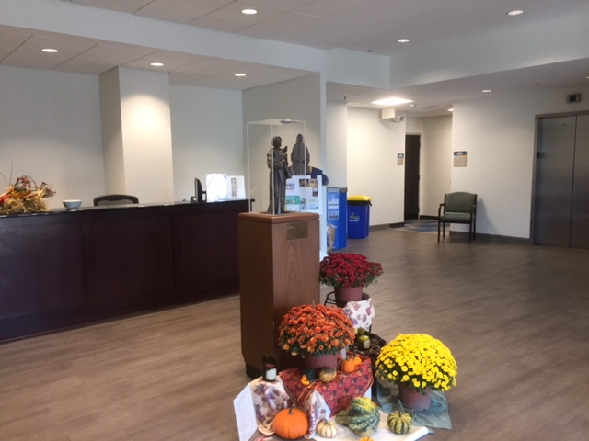 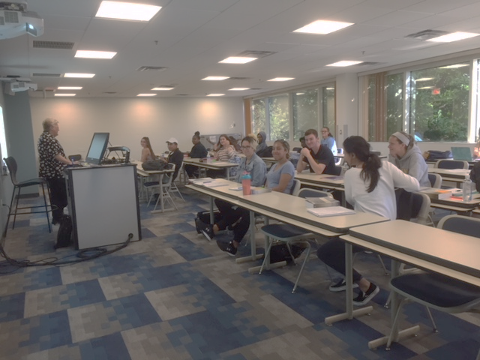

w SpaceNe

New Space,

New Look!

Over the summer months, major changes have been made at the Rocco Abessinio Building [RAB] on Neumann’s campus. While the new building next door, the Health Science Building, took shape with clinical medicine labs and a new stadium seating auditorium grew with each day, the inside of the RAB took on a very revised look. The small kiosk for food and drink on the second floor became the TWELVE at the RAB, a food area that will be open whenever the RAB is. It has a number of selections in both eats and beverages and is open for suggestions as it sets up for customers.

The rest of the second floor and all the third have been redone with brighter colors and new academic areas. The Canticle Room can now accommodate more than 60 students, the former Bachman Room will soon become the new home for the Graduate Admissions, and the Lobby has been transformed with a closed ceiling and new design.

The goal is in the future to house the majority of Graduate activities and offices, along with a relaxation area, will be centered in the RAB.

**RAB**

The new lobby features a closed ceiling and bright open space to greet visitors along with the Neumann community. Here it is pictured decorated for St. Francis’ feast.

The second floor Canticle Room can now seat over 60 students and provides a home for classes from multiple disciplines. Here Susan Vadas lectures on theology.

**The RAB**

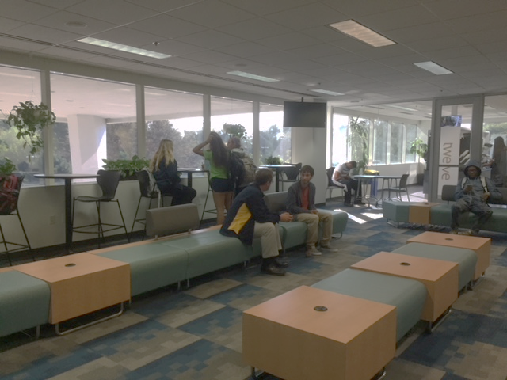 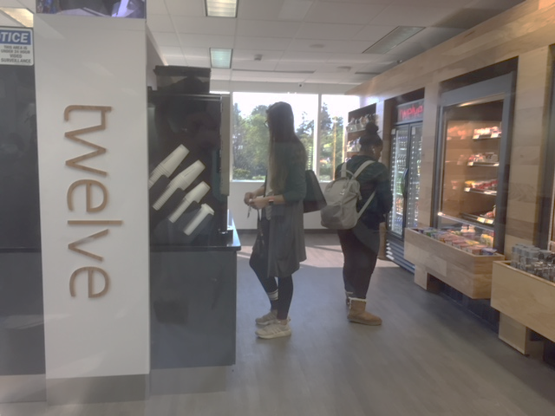

A major change on the second floor is the open lounge where students gather to talk, eat, and enjoy each other.

The food options also on the second floor are a new Aramark concept called Twelve available whenever the RAB is open.

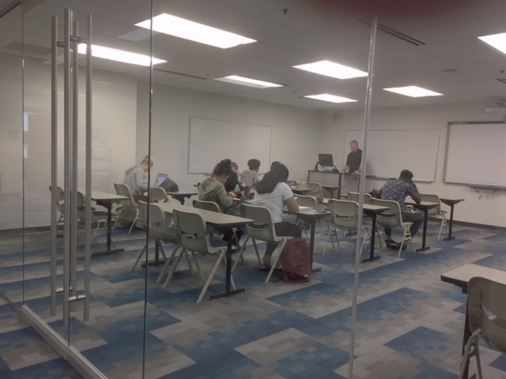 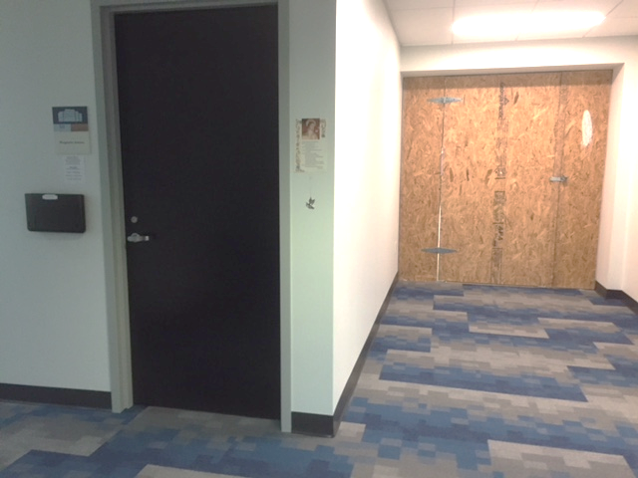

The Data Analysis Lab will soon feature technology to enhance the Business Department’s students’ ability to record analyze and dissect data, and to present findings in an understandable format.

The locked door on the right signals the next major renovation as it connects the corridor that will run from the RAB to the new Health Sciences Building going up next door.