What happens when all course modules in a library are complete?
We get this question a lot – some users need to complete courses in order to get a certificate for record keeping, while other plants are more interested in sharing an account to replay the course multiple times. This document covers a scenario and what options are available, including what actions to take.
- On the final screen after completing the quiz and exiting the course, the user is given the option to click “OK” to advance. 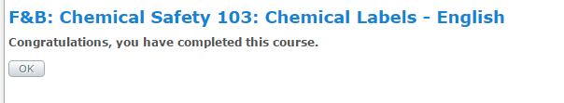
- If the user clicks OK:
  - The user is then allowed to print a certificate of completion
  - However they cannot re-take the course unless they contact SupportEcolab@alchemysystems.com to reset the enrollments.
- If the user does NOT click OK:
  - The user can either close the browser window, or click on the Catalog.
  - They can re-launch any of the completed modules again, and choose to start from the beginning, however they cannot print a certificate of completion.

Scenario:
John has just recently completed Chemical Safety 101 and Chemical Safety 102. John is at the very end of Chemical Safety 103 (the final course module in the library).
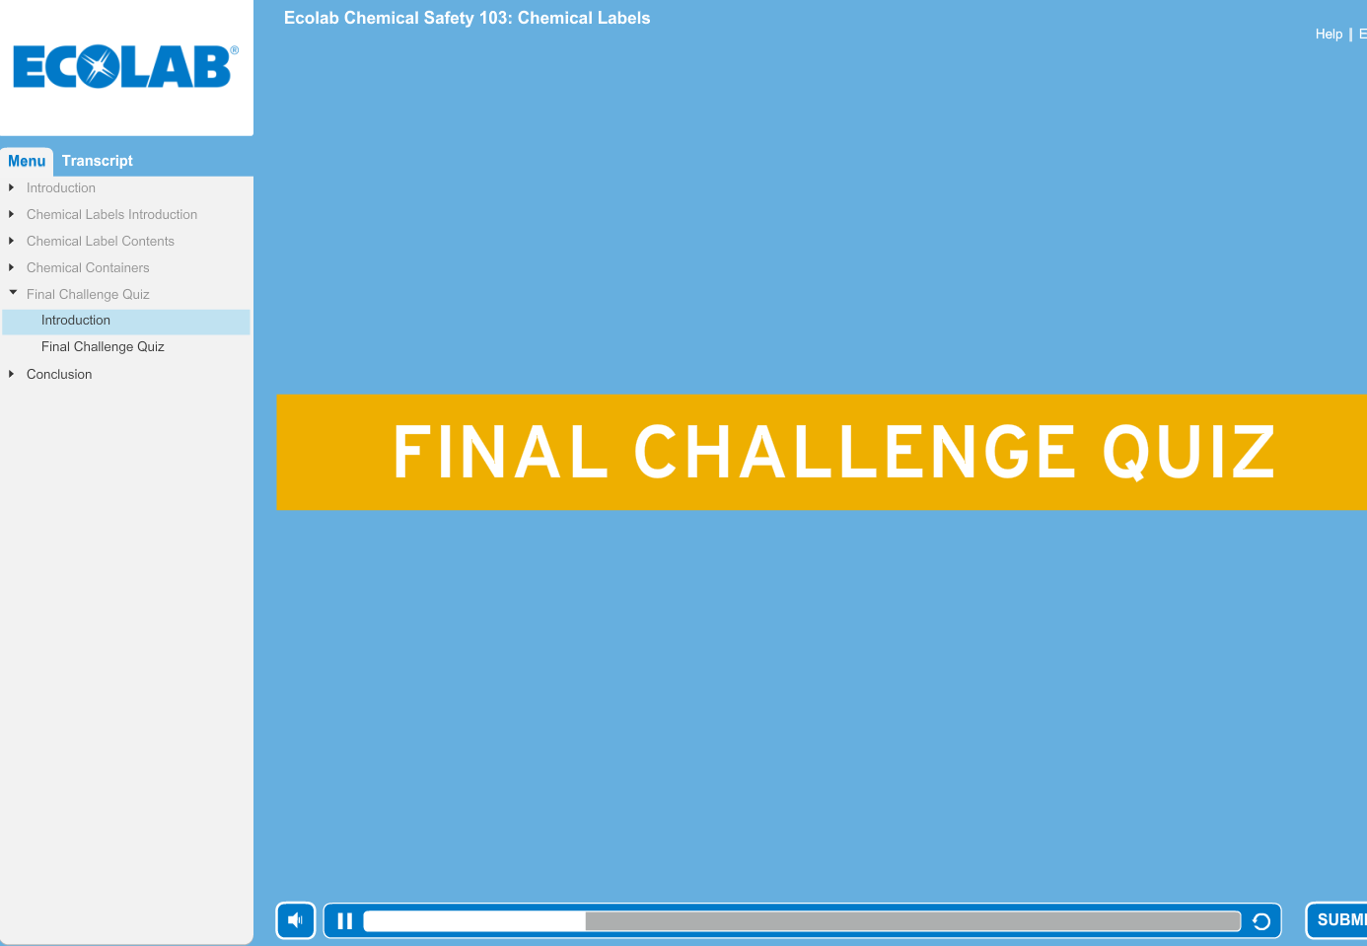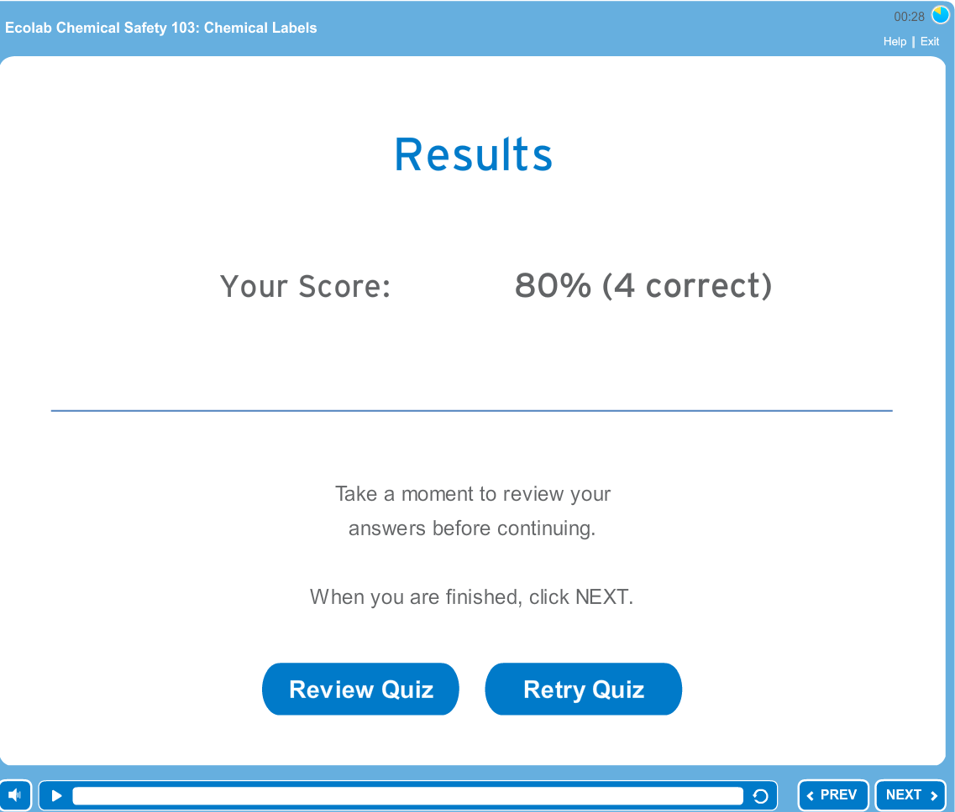
John completed the quiz and scored an 80%. Satisfied with his results, he clicks “Next”. Depending on John’s needs, he now has two options.

Option #1: John wants to be able to re-take the course multiple times.
John makes it to the final slide of the presentation – the “Congratulations”. As Instructed, John clicks Exit to close the presentation and then closes the window.
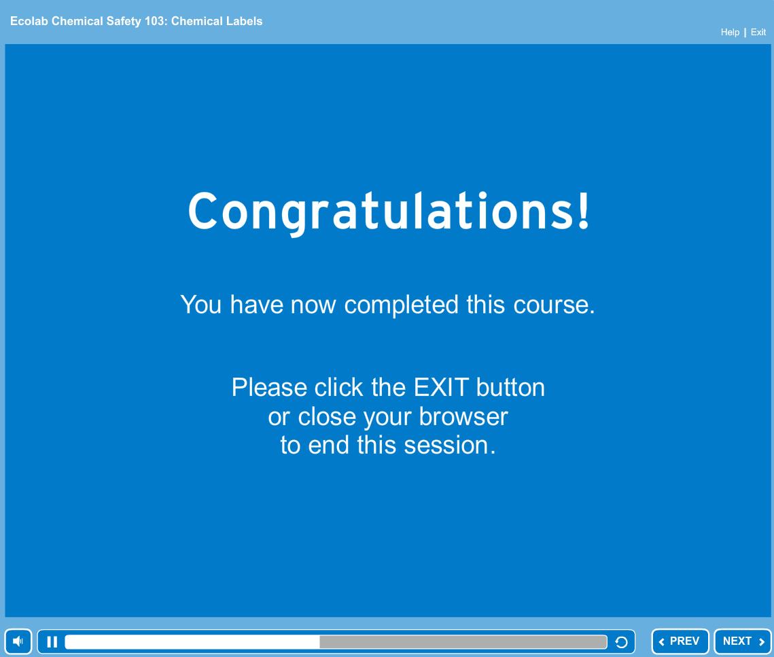
John is sent to the eLearning site and sees this prompt:
John’s company doesn’t require a certificate of completion and John would like to re-take the course again in the near future. Therefore John should NOT click “OK” and instead, return to the Catalog.
The catalog shows that all three of the Chemical Safety courses can be Launched.
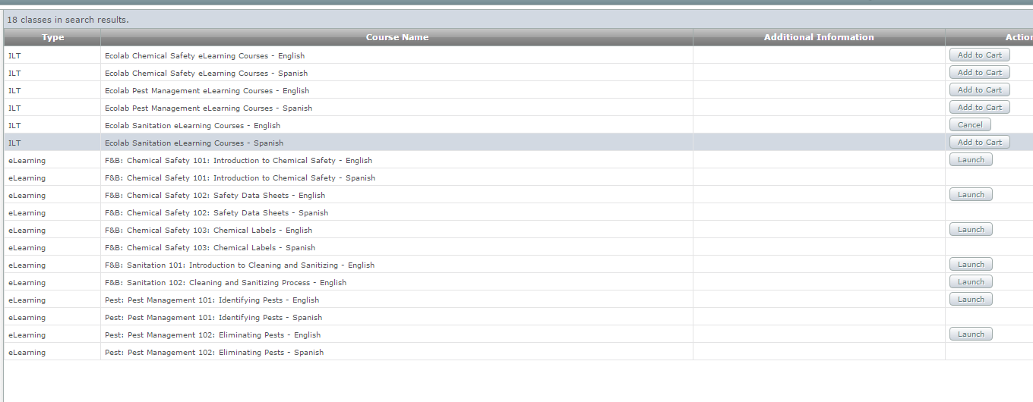
John can re-launch any of the three Chemical Safety modules, and choose to start from the beginning. However John may NOT print a certificate of completion.

OPTION 2: John needs a Certificate of Completion
John’s company requires all users to print a certificate of completion after finishing all modules in a course library. Following the Congratulations screen, John clicks to Exit the course.
John clicks OK on the next screen, and is brought to the Transcript screen.

The Transcript screen shows all completed course modules and he can now print the certificate for the Chemical Safety course library since he completed the entire series.
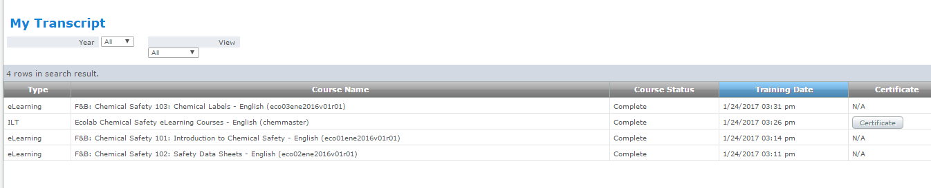
However, on the Catalog screen, the courses may no longer there. If this happens, John has the option of contacting Ecolab Support (SupportEcolab@alchemysystems.com) to reset the course enrollments. This will invalidate John’s certificate, but he can repeat the process and get a new certificate if so desired.

