CDX Distance Learning
Exercise #3
Relay Circuits

Learning Objectives:
LO1: Describe relay function
LO2: Identify relay components
LO3: Predict voltages in relay circuits
LO4: Analyze possible causes of relay circuit faults

Figure 7-2 MAST Advanced Electricity and Electronics
A relay is an electrical component that uses a small current to control a larger current. You know that many automotive circuits require more than 5 amperes (amps) to operate. For example, note how many fuses located in the average vehicle are rated from 10–30 amps, with several fusible links higher than that. The high current required for many circuits, like the headlights, fuel pump, and rear window defogger, would require switches and wiring capable of carrying the necessary current. This would increase wire and switch size, thereby increasing the cost and weight of the components. Vehicle engineers often use relays in circuits that require a high current. The relay coil usually only requires about 200 milli-amps, so a light duty switch or the ECU can control the relay. The relay can be located close to the high load component in some cases. This reduces the amount of larger wiring required, which reduces vehicle weight and cost.

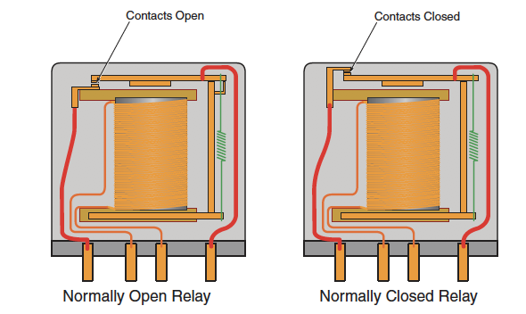
Modified Figure 7-4 MAST Advanced Electricity and Electronics

This lesson will focus on four pin relays. These relays may be normally open or normally closed. The relay uses two pins to connect the coil to a switched power source. The switch may be mechanical, or it may be ECU controlled using a transistor. The relay coil is made of very fine insulated wire wrapped around an iron core. Energizing (turning ON) the coil creates a magnetic field that operates the switch contacts. A normally open relay has switch contacts that are open, or OFF, when the coil is not energized. Energizing the coil creates the magnetic field, and the switch contacts close. The contacts control source or ground paths for a load, such as the fog lights. A normally closed relay has contacts that are ON when the relay coil is OFF. Energizing the relay opens the relay contacts and turns the high current load OFF.

Relays can be bench tested. The relay coil can be tested for resistance, and it is usually between 70–125 ohms. Remove the relay from the junction block. Connect the DMM to pins 1 and 2 for our fog light example (other relays may use different pin numbers). If the resistance value is OK (most service information will list it as the resistance specification), you can use fused jumper leads to connect the relay coil to the source voltage (special relay test tools are also available that allow you to test the relay while it is mounted to the junction block). The relay usually clicks when energized. There should now be very close to 0 ohms of resistance on the switch contact side of the relay (pins 5 and 3 in this example). A relay that fails any of these tests is defective and should be replaced.

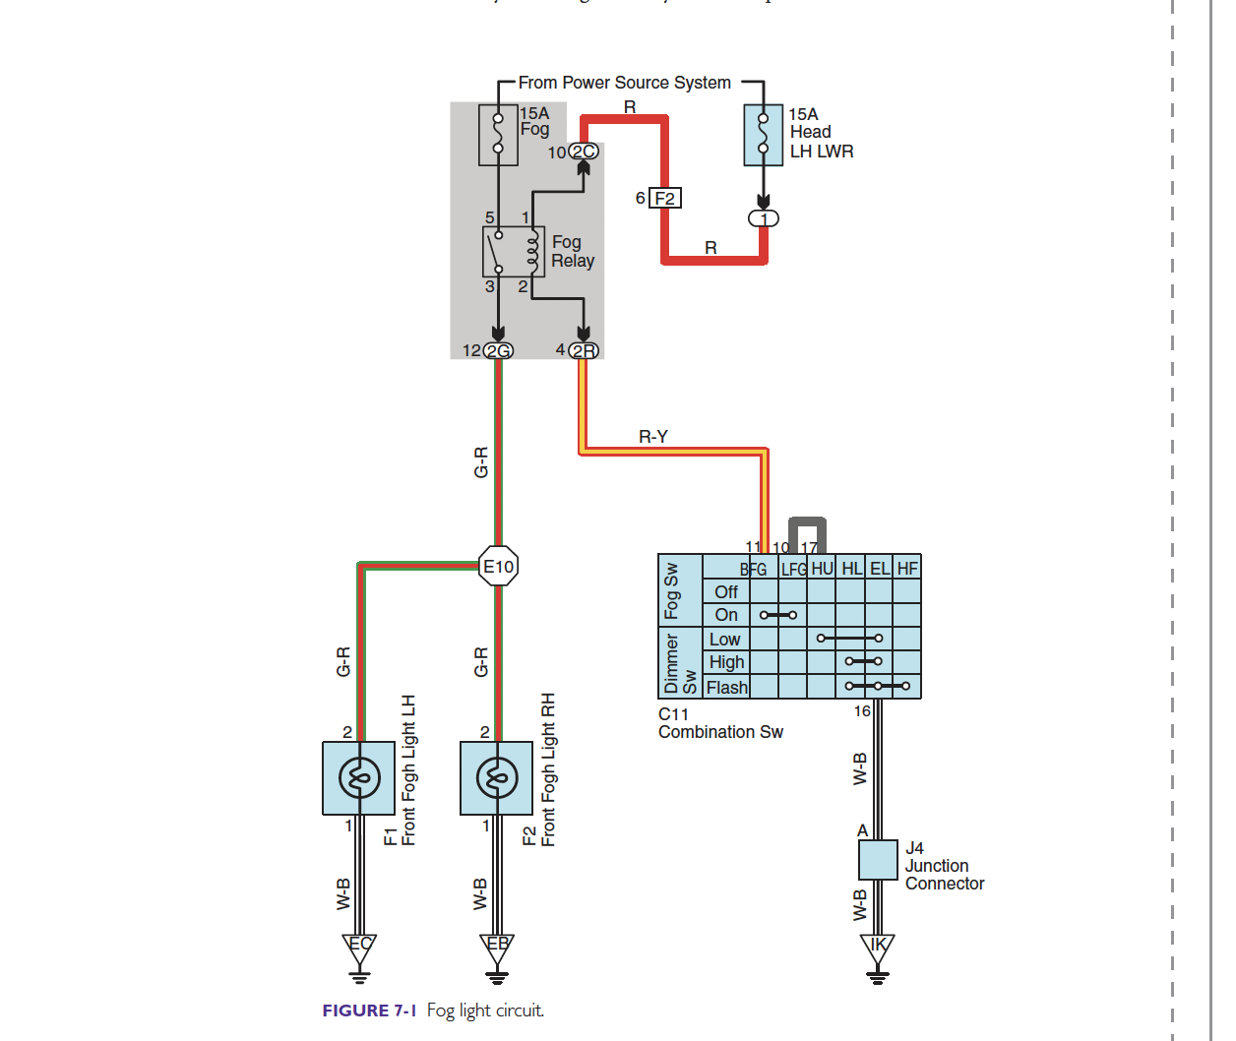

The following questions refer to the relay circuit shown. The ignition is in the ON/RUN position:

- What are the voltages at each relay pin location when the fog light switch is in the OFF position? Note that the combination switch that controls the fog lights is on the ground side of the relay coil.
  - PIN 5 Click or tap here to enter text.
  - PIN 1 Click or tap here to enter text.
  - PIN 3 Click or tap here to enter text.
  - PIN 2 Click or tap here to enter text.
- What is the voltage at pin 2 of each fog light? Click or tap here to enter text.
- The fog light switch is turned to the ON position. What are the voltages at the relay?
  - PIN 5 Click or tap here to enter text.
  - PIN 1 Click or tap here to enter text.
  - PIN 3 Click or tap here to enter text.
  - PIN 2 Click or tap here to enter text.
- What is the voltage at pin 2 of each fog light? Click or tap here to enter text.
- What is the voltage at pin 11 of the combination switch when the fog lights are OFF? Click or tap here to enter text.
- What is the voltage at pin 11 of the combination switch when the fog lights are ON? Click or tap here to enter text.

Relay Diagnostic Practice.

The following questions allow you to apply your relay circuit knowledge to diagnose the cause of a circuit fault.

- The customer states that the fog lights do not turn ON. The technician has the following voltage test results:

- Relay pins 5 and 1, source voltage (12V).
- Relay pin 2, source voltage (12V)
- Relay pin 3, 0V
- Combination switch pin 11, switch in the fog light ON position: source voltage (12V)
- Combination switch pin 16, switch in the fog light ON position: source voltage (12V)
- J4 junction connector pin A, 0V
- Ground IK, 0V
- Relay coil resistance, 87 ohms (pins 1 and 2)
- Relay switch resistance OL (pins 5 and 3) with relay OFF
- Relay switch resistance 0 ohms (pins 5 and 3) with relay ON

What is the cause of this fault? Click or tap here to enter text.

- The customer states that the fog lights do not turn ON. The technician has the following voltage test results:

- Relay pins 5 and 1, source voltage (12V).
- Relay pin 2, 0V
- Relay pin 3, 0V
- Combination switch pin 11, switch in the fog light ON position: source voltage (0V)
- Combination switch pin 16, switch in the fog light ON position: source voltage (0V)
- J4 junction connector pin A, 0V
- Ground IK, 0V
- Relay coil resistance OL (pins 1 and 2)
- Relay switch resistance OL (pins 5 and 3) with relay OFF
- Relay switch resistance OL (pins 5 and 3) with relay ON

What is the cause of this fault? Click or tap here to enter text.

- The customer states that the fog lights do not turn ON. The technician has the following voltage test results:

- Relay pins 5 and 1, source voltage (12V).
- Relay pin 2, source voltage (12V)
- Relay pin 3, 0V
- Combination switch pin 11, switch in the fog light ON position: source voltage (0V)
- Combination switch pin 16, switch in the fog light ON position: source voltage (0V)
- J4 junction connector pin A, 0V
- Ground IK, 0V
- Relay coil resistance, 87 ohms (pins 1 and 2)
- Relay switch resistance OL (pins 5 and 3) with relay OFF
- Relay switch resistance OL (pins 5 and 3) with relay ON

What is the cause of this fault? Click or tap here to enter text.

- The customer states that the fog lights do not turn ON. The technician has the following voltage test results:

- Relay pins 5 and 1, source voltage (12V).
- Relay pin 2, source voltage (12V)
- Relay pin 3, 0V
- Combination switch pin 11, switch in the fog light ON position: 0V
- Combination switch pin 16, switch in the fog light ON position: 0V
- J4 junction connector pin A, 0V
- Ground IK, 0V
- Relay coil resistance, 87 ohms (pins 1 and 2)
- Relay switch resistance OL (pins 5 and 3) with relay OFF
- Relay switch resistance 0.03 ohms (pins 5 and 3) with relay ON

What is the cause of this fault? Click or tap here to enter text.

